**Lamark (naturalist)**

**Offspring inherit traits from their parents. The parents acquire these traits from use and disuse of an organ**

**Malthus (economist/ mathematician)**

**Population growth will tend to out run food supply and habitat. Population numbers are limited by available food and space.**

**Cuvier**

**Believed all animals acquired traits aka became new species after a catastrophic flood wiped out previous Species.**

**Buffon**

**Biogeography**

**Since similar environments had slightly different species they must be somehow related**

**Lyell & Hutton: (geologist)**

**Uniformitarianism- The earth is very old and the geological processes that shaped it are still happening today.**

**Charles Darwin: (NATURALIST)**

**formed the theory of evolution through natural selection and survival of the fittest.**

**Wrote “Origin of Species” Naturalist proposed the idea that populations change over long periods of time as a result of competition for available resources, in which individuals with the characteristics best suited to their environment will survive and reproduce.**

**Alfred Wallace:**

**Came up with a similar idea to Darwin but did not write a publication so received little credit. He encouraged Darwin to write “the origin of species”**

***CHEMICAL EVOLUTION***

**Oparin and Haldane:**

**Hypothesis for chemical evolution: That the atmosphere and weather of early earth Would cause inorganic molecules to form into Organic compounds called macromolecules.**

**Miller and Urey (Chemists 1953) :**

**Performed an experiment to simulate early earth to form organic compounds**

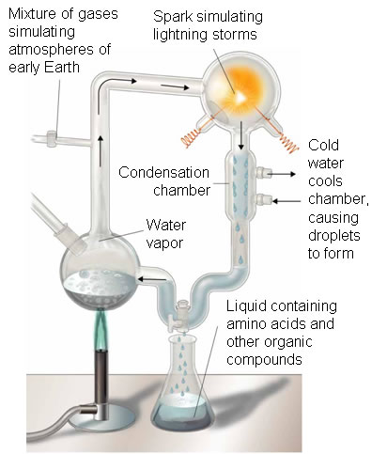

**Sydney Fox**

**Heated amino acids that formed into proteinoids that form membrane like spheres when placed in water**

**Cuvier**

**Believed all animals acquired traits aka became new species after a catastrophic flood**

**Buffon**

**Biogeography**

**Since similar environments had slightly different species they must be somehow related**