C:\STOCKLAYOUTS\CURRENT PROJECTS\FN99801-PL\FN99801-IMG04.emfC:\STOCKLAYOUTS\CURRENT PROJECTS\FN99801-PL\FN99801-IMG05.emfC:\STOCKLAYOUTS\CURRENT PROJECTS\FN99801-PL\FN99801-IMG04.emfC

**Leland Career and Technical Center**

Career and Technical Education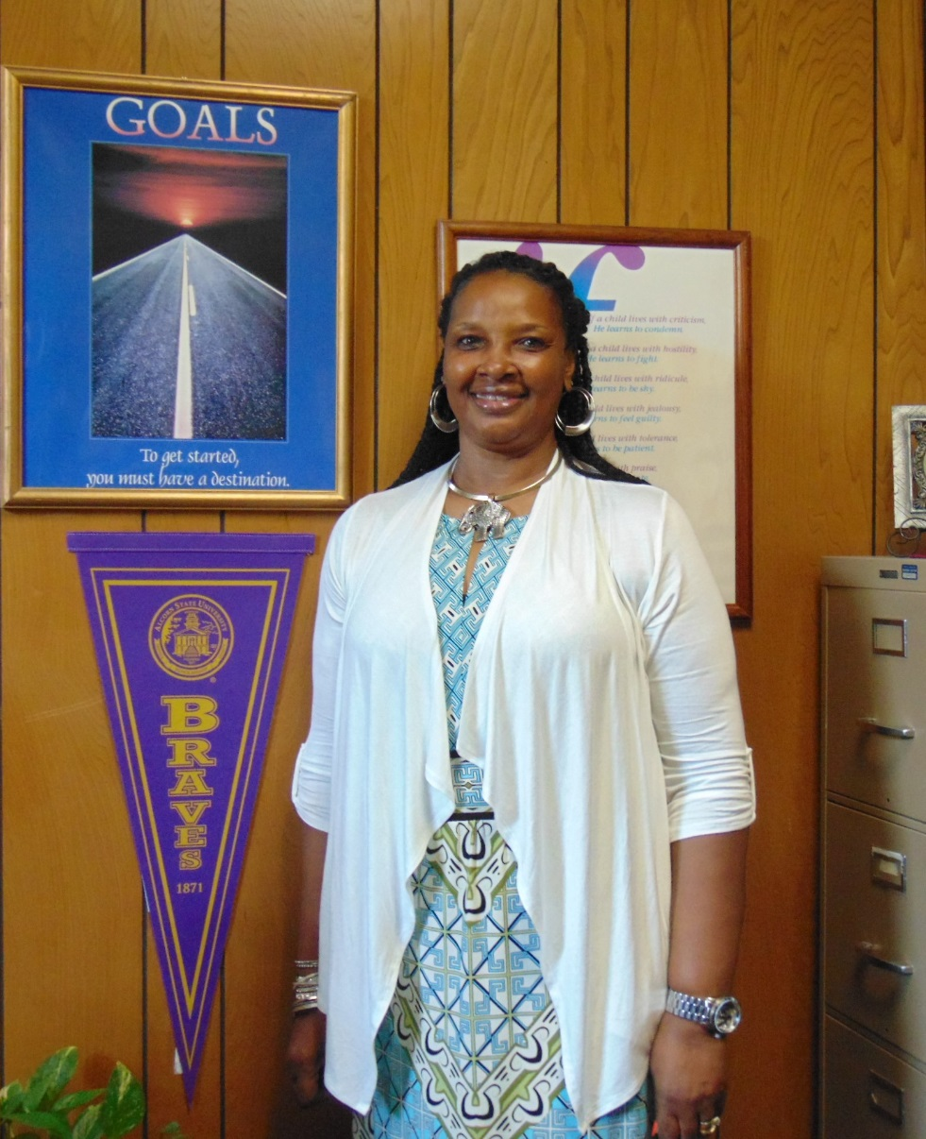

**Programs Offered at the**

**Leland Technical Center**

**AEST -** Agricultural Environmental Sciences Technology I & II

* Concepts of Agriscience
* Science of Agricultural Plants
* Science of Agricultural Environment
* Science of Agricultural Mechanization

**AST** - Automotive Service Technician I & II

BF – Business Fundamentals/Management I & II

BF – Business Fundamental/Marketing I & II

**CTC** - Construction Technology: Carpentry I & II

EE - Early Childhood Education I & II

MFMF – Manufacturing Fundamentals and Metal Fabrication I & II

Other Resource

Special Populations

**This school district will not discriminate in its operation on the basis of race, color, creed, national origin, sex, marital status, age, religion, or handicapping condition in accordance with federal and state laws.**

Jacqueline S. McDavis, CTE Counselor

402 South Deer Creek West

Leland, MS 38756

(662) 686-6025 phone

(662) 686-5024 fax

JacquelineMcDavis@lelandk12.org

**Leland Career and Technical Center**

**TIPS FOR PARENT CONFERENCES**

Parent conferences are an important way to learn about your child. Here are tips to help you have a more successful parent-teacher conference.

**Plan for it**

Before you come to your conference, write out questions you would like to ask. Here are a few suggestions:

*Does my child get along with others?

*How is my child’s behavior in class?

*Does my child read at the level you would expect?

*Is my child able to do the math that you would expect?

*What are my child’s strengths and weaknesses?

**Keep an open mind**

Your goal is to work for cooperation with your child’s teacher. Even if the teacher says something with which you disagree, try and listen to what she or he has to say.

**Ask to see your child’s work**

There is no better way to see how your child is progressing.

**Ask for suggestions**

If your child is doing well, ask what you can do to keep things on a positive track. If there are problems, ask what you can do to help.

**Clarify and summarize as you go**

Teachers sometimes may use educational terms you or your child do not understand. If this occurs, just ask for clarification.

C:\STOCKLAYOUTS\CURRENT PROJECTS\FN99801-PL\FN99801-IMG08.emf

Jacqueline S. McDavis, CTE Counselor

C:\STOCKLAYOUTS\CURRENT PROJECTS\FN99801-PL\FN99801-IMG04.emf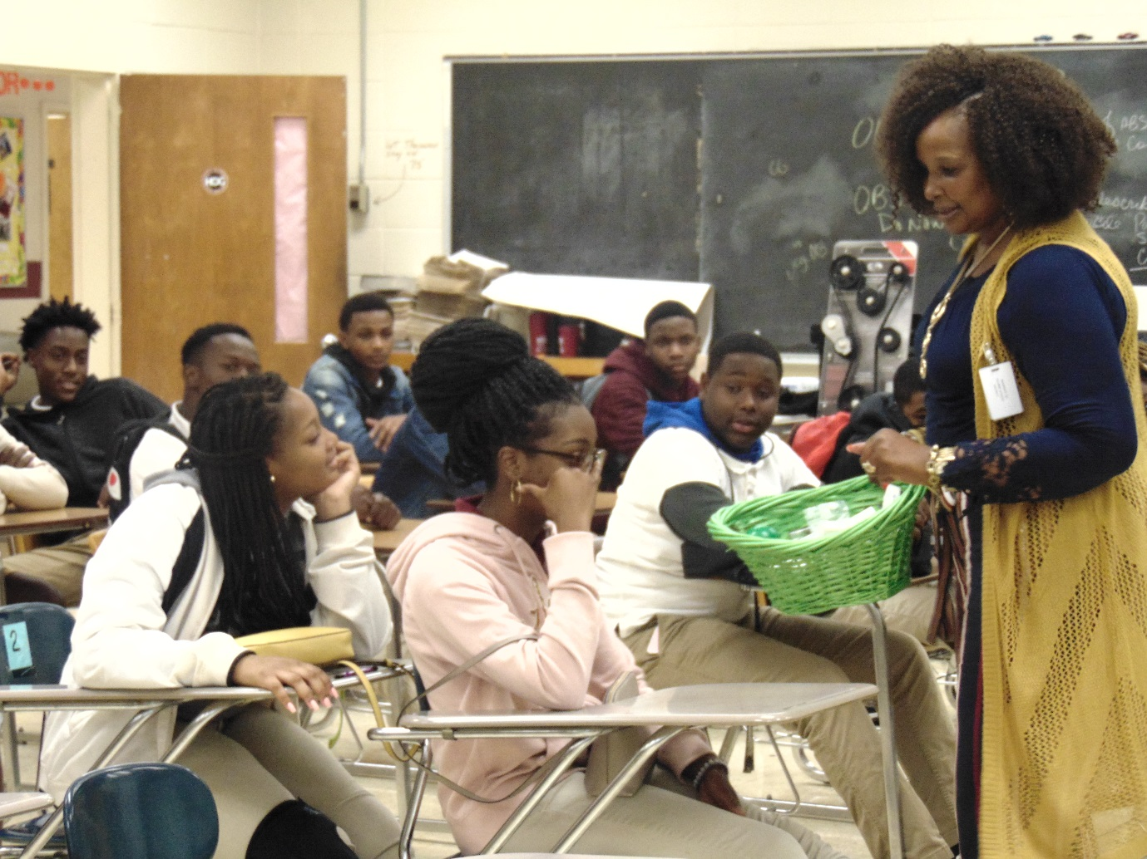

**Career and Technical Education**

**Comprehensive**

**Guidance Services**

**Educational Planning -** Students are provided opportunities for academic planning, goal setting and career exploration.

**Responsive Services -** Small-group experiences for students with specific concerns are provided during the school day. Individual short term counseling is provided as needed. Students may self-refer, or be referred by parents and school staff.

**Partnerships -** Counselors collaborate with parents, peers, teachers and community agency specialists to provide services to students and families.

The Career and Technical Education Counselor is concerned with helping students make the occupational choices, educational choices, and career evaluations that will lead them to meaningful, successful, and rewarding work. Career and technical guidance services focus on assisting students in determining their interests and aptitudes, selecting a program that meets their career/occupational goals, and expanding their individual options.

[](http://www.google.com/url?sa=i&rct=j&q=&esrc=s&source=images&cd=&docid=5Lodc4pPohjQnM&tbnid=4H13WkkAcSWuAM:&ved=0CAUQjRw&url=http://duvalschools.org/Page/7208&ei=EEn7U-zyKeHfsATBr4LgAg&bvm=bv.73612305,d.cWc&psig=AFQjCNEWUbzCPNxXFtx_yFlwOIZlGcngsQ&ust=1409063232804858)

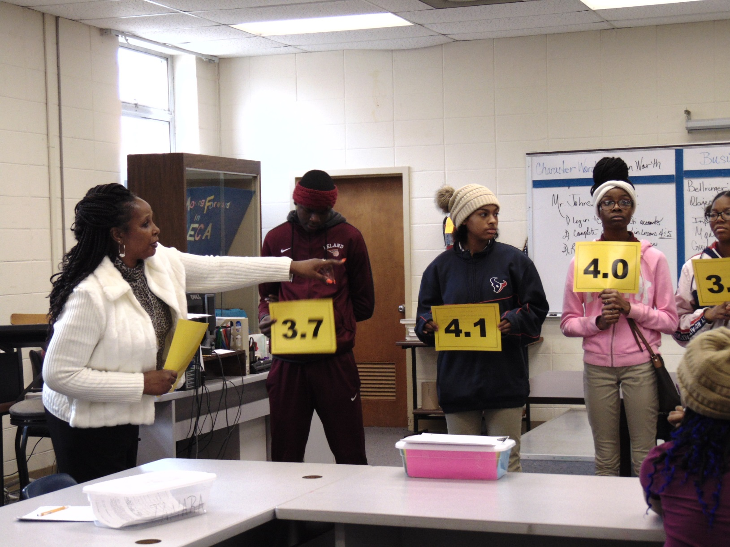

 Scholarships

 Educational Planning

 Community Partnerships

* Crisis Intervention
* Special Services Support
* Parent and Teacher Resource

**Community Involvement**

The counselor is a liaison between the student and community resources. The counselor sponsors job shadowing, field trips, and industry speakers to increase community and parental involvement

**Emergency Response Management**

The counselor provides emergency care when necessary and participates in emergency response trainings regularly

**Dropout Prevention**

The counselor reviews student records for poor grades, low attendance, failure to be promoted and classroom disengagement to better provide services to these students.

**Recruitment**

The counselor provides students, parents and community members with information pertaining to Career and Technical Education. Events are planned to garner an interest in the career areas provided.

**Professional Development**

The counselor engages in professional growth and periodically updates knowledge and skills in the field of CTE Counseling.

**Counseling Services**

**Counseling –** Individual and group counseling is provided to students to help them develop relationship, conflict resolution and decision making skills.

**Coordinating and Consulting –** Counselors provide consultation, resources, and support services to parents and teachers

**Appraisal –** The Counselor prepares students for standardized testing and interprets the results to students, parents, and teachers

**Program Accountability**

The counselor maintains student records, a calendar of events, and holds yearly program needs assessment and evaluations.

Role of the Career and Technical Education Counselor