

**Q: How do students log**

**in to Schoology?**

A: Students will log in to

Schoology through Clever.com using their district log-ins.



**Q: Do parents have access to Schoology?**

A: Yes, parents will have an account using the credentials collected from registration or the child’s teacher. The parent account is a view only account, but parents have options to receive notifications about student account activity and when course material is added.

**Q: If I have multiple children can I see all of their courses in the parent account?**

A: Yes, parents will be able to add multiple children to their account and access each child’s courses.

Schoology 101

A Guide for Parents and Students

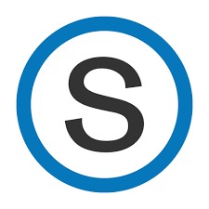

**Q: Will my teacher be taking daily attendance during remote learning?**

A: Yes. Teachers will check each day to see that each student has signed in to complete work and attend instruction.

**Q: How do I contact my**

**teacher when I have a**

**question?**

A: You can message your teacher using the envelope icon at the top right of the Schoology screen. You can also use the email address listed on your teacher’s homeroom page.



**Q: Where do I find my assignments?**

A: In each course, teachers will have a weekly folder for the current week and inside that will be daily folders. Each daily folder will have resources and assignments. You can also see assignments that are due on the right of your screen in each course.

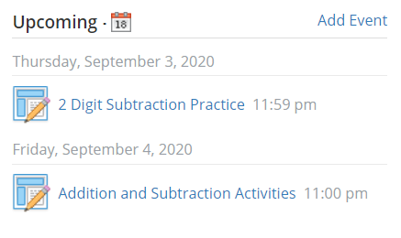

**Q: Who do I contact when I need help?**

A: First contact your teacher for help. You can also reach out to Beth Fields for support at 221-1529 or bfields@mcpss.com. An additional resource is the MCPSS help line: 221-7777, option 1.