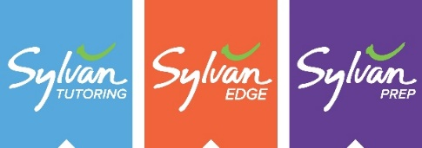
Sylvan Learning of Prattville
2046 Fairview Avenue
Prattville AL 36066
28 July 2020
It has become cliché to say, but it is certainly true—these are trying and challenging times we are now in. The Covid-19 environment has caused us all to think differently, to act differently, and, certainly, by default, to learn differently. Who would have thought a year ago that our traditional brick and mortar school system—the same system that generations of Americans have attended and graduated from—would be so dramatically changed? But it has and we, as leaders, must create an answer, a solution, to help our families adjust to the changing dynamics they now face in schooling their children.
As a member of the community, Sylvan Learning of Prattville is here and ready-willing-and able to help provide solutions for schools and families. In addition to our portfolio of academic skills enhancement programs, including SylvanSync, Academic Coaching, College Prep, and Homework Help, we are thinking outside the box to assist families during these trying times. Plans include:
- For families who opt for the online school options, but do not have access to either computer resources or an internet connection, we are here to help. For a modest fee, students can come into the Sylvan Center and use our online access and iPads to complete their necessary online schoolwork. In addition, our highly qualified and certified teachers will be on hand to provide learning assistance if needed.
- For families who are considering the online school options but looking for structure for their child while they work, we are here to help. For a modest fee, families can sign their child up to come into the Sylvan Center for however long they need to each day. Here, again, they can engage in their online learning and have access to our qualified staff if the need arises.
- As always, we are also here ready to help any student who needs academic reinforcement, skills development, or merely a place to effectively study.
In each of the areas above, the Sylvan Center will be adhering to all the necessary and precautionary measures mandated by prudence. As a minimum, protective face masks will be highly encouraged, hand sanitizers are available, and careful cleaning of the facility and equipment will be ongoing. Social distancing protocols will be adhered to and the Center population will be controlled through appointment-only scheduling.
We look forward to being a part of the new academic landscape as we strive to continue learning in a forward direction during these trying and challenging times. I ask that you please provide this information to families if they are looking for assistance in implementing and navigating the online learning process.
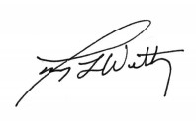
Sincerely,

Terry Lee Wettig,
Terry Wettig, Ph.D.
Executive Director
Sylvan Learning of Prattville
Ph: 334-212-8448

