BAKER HIGH SCHOOL Seniors
Cap and Gown Spirit Pack
$180
+ shipping & tax

Cap and Gown only $85 + tax Total $93

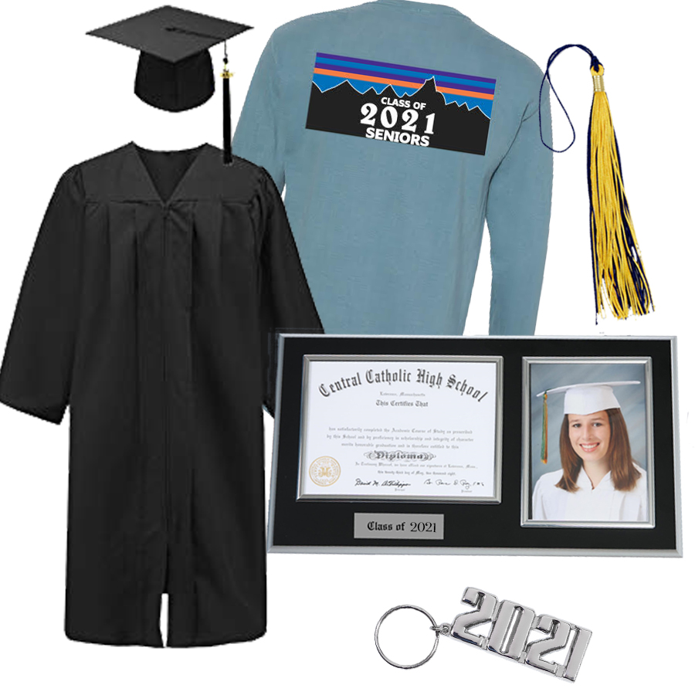
ALL PACKAGES INCLUDE CAP AND GOWN. PACKAGE COST:

SPIRIT PACK - $180 + pkg/handling & Tax
MASCOT PACK - $250 + pkg/handling & Tax
DELUXE PACK - $285 + pkg/handling & Tax

Order online at JDRGrad.com

Order in person at our Balfour office or by phone

Balfour – 600 Bel Air Blvd. suite 131 – Mobile 36606
251.476.5203 email: mobilebalfour@bellsouth.net

