[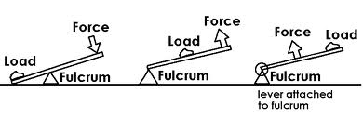](http://www.google.com/url?sa=i&rct=j&q=&esrc=s&source=images&cd=&cad=rja&uact=8&ved=0ahUKEwiWt93araXLAhXHHT4KHa02CnoQjRwIBw&url=http://scioly.org/wiki/images/6/6e/&psig=AFQjCNGyFiojGkfXnjMiYfkxjd60GayT9A&ust=1457123081492330)

[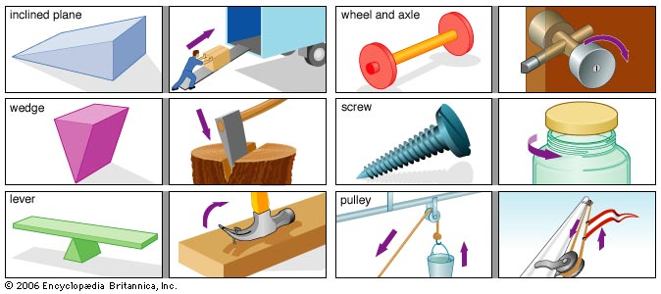](http://www.google.com/url?sa=i&rct=j&q=&esrc=s&source=images&cd=&cad=rja&uact=8&ved=0ahUKEwjB45S5raXLAhXJ8j4KHeWQB3oQjRwIBw&url=http://kids.britannica.com/elementary/art-89981/The-six-basic-simple-machines-are-used-in-a-variety&psig=AFQjCNGyFiojGkfXnjMiYfkxjd60GayT9A&ust=1457123081492330)

[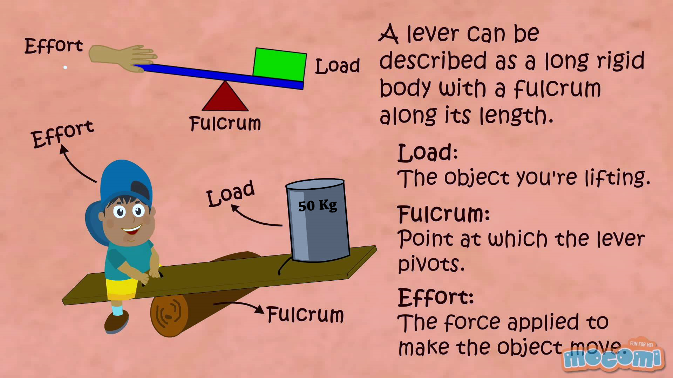](https://www.google.com/url?sa=i&rct=j&q=&esrc=s&source=images&cd=&cad=rja&uact=8&ved=0ahUKEwi0mYLRrKXLAhUBHT4KHXjsC3YQjRwIBw&url=https://www.youtube.com/watch?v%3DE8RA9Kw_IaE&psig=AFQjCNGyFiojGkfXnjMiYfkxjd60GayT9A&ust=1457123081492330)

A machine is any device that helps people do work. The 6 simple machines are singular designs that allow us to push or pull over a distance.

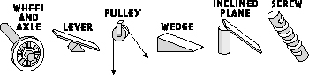

**1 2 3 4 5 6**

**Simple machines**

**11 FACTS YOU MUST BE ABLE TO EXPLAIN!**

**1**. Regardless of their complexity, **all machines** are in some

Way based on **simple machines.**

**2. Simple machines** are all around us and make work **easier**.

**3.** Simple machines are “simple” because most only have one

moving part.

**4**. Gravity, friction, and inertia **affect** simple machines.

**5**. A **complex/compound** machine is made up of **two or more**

simple machines.

**6**. **Simple machines** change the way (direction) force is applied.

**7**. **Work** transfers energy. It Is the ability to use force to move an

object over a distance.

**8**. Output work is **always** less than input work.

**9.** **Efficiency** is how equal the output and input work are (will

never be 100%)

**10.** We recognize **6 simple machines**: lever, wheel and axel,

pulley, inclined plane, wedge, and screw.

**11**. The **mechanical advantage** is the number of times the

machine multiplies the input force. Divide output force by

input force to get mechanical advantage.

**MISCONCEPTIONS**

1. Some people think machines reduce the amount of work and energy required. **WRONG**. Machines reduce the effort required by changing the size or direction of the force.
2. Some people think that machines can be 100% efficient. **WRONG**: Machines will always lose a certain amount of energy through heat, friction, sound, or light.

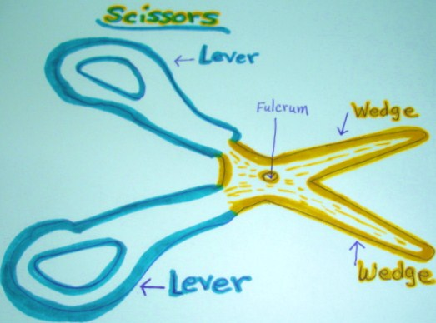**Compound machines** (modern technology) use combinations of simple machines. It doesn’t matter how small it is (nanotechnology); it is still a machine.

