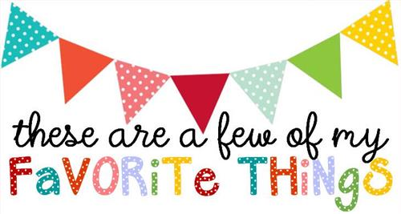

Name: Kelly Edwards
T-shirt Size: 2x (xl if comfort colors)
Birthday: March 9
Monogram: kEs
Favorite Color: yellow
Favorite Flower: hydrangea
Favorite Scent: lemon and linen
Favorite Candy: caramel, milk chocolate
Favorite Drink: coffee and sweet tea
Favorite Food: Chinese and Mexican
Favorite Snack: cheetos (puffy or crunchy), doritos
Favorite Fruit: watermelon, strawberries, cantaloupe
Favorite Restaurant: Chickfila, Taco Bell, Mr. Chens, Cracker Barrel
Favorite Places to Shop: TJ Maxx, Hobby Lobby, Tanger
Things I collect: Willow Tree figurines
Favorite Author/Book Series for my own personal reading: Sophie Kinsella or Madeline Wickam
Wish List for Classroom: color copy paper for center games, scotch thermal laminating sheets for center games, erasers for dry erase boards, AA and AAA batteries, Lysol spray. My amazon classroom wish list is: https://www.amazon.com/hz/wis
hlist/ls/FHSL0MX28U6S?ref_=wl_share

