**Instructional Focus**:

**Reading**- Story for week- Tippy – Toe Chick, GO!

Reading Skill: Character, Setting, and Plot

**Phonics Skills**: Diphthongs ow, ou

Final Syllable -le

**Grammar Skill:** Imperative Sentences

**Math** – Topic 13 – Telling Time

**Science/ Social Studies** – Finishing up State of Alabama Unit

**Leader in Me** – Habit 7 “Sharpen the Saw”

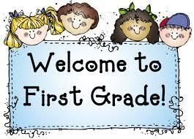 Week of May 3rd – May 7th

Mrs. Lyness’ Newsletter

Spelling Words:

1. how

2. now

3. clown

4. growl

5. town

6. brown

7. frown

8. down

9. cow

10. crowd

*Test on Friday

**Important Dates Coming Up**:

May 6th – Progress Reports

May 24th and 25th – Field Day

May 31st – No School; Memorial Day Holiday

June 4th – Last Day of School!

*If you can send in some Clorox Wipes and Paper towels that would be greatly appreciated.

High – Frequency Words:

1. along

2. never

3. behind

4. pulling

5. eyes

6. toward

*On Reading Test