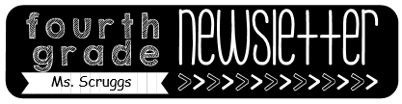

Reminders

-**Masks** need to be worn at school.

-Please send a **water bottle** every day.

-**Timed test**: multiplication/division facts 3 min.

-October 1: breast cancer awareness **(wear pink)**

-October 5: Bullying Awareness day **(wear blue)**

-October 21: National Bullying Prevention day

**(wear orange)**

-October 26-30: Red Ribbon Week

Mon. **Team Jersey Day** Tues. **P.J Day**

Wed. **Hawaiian Day** Thurs. Western Day

Fri. **Book Character Day**

**Dismissing Every Friday at 1:10-** Starting September 25th- December 18th DCS will be having a **70% day** for students every Friday. Please be aware of the new dismissal time!

Sept. 28th – Oct. 2nd

Homework

Monday:

* Area model multiplication worksheet
* Study the study guide

Tuesday:

* Traditional multiplication worksheet
* Study math facts

Wednesday:

* Traditional multiplication worksheet

Thursday:

* Area model multiplication worksheet

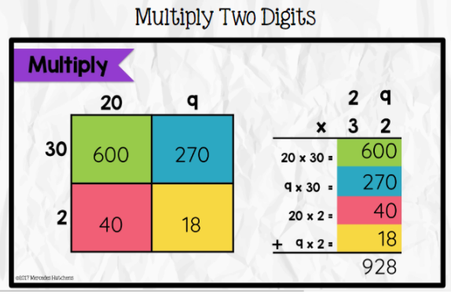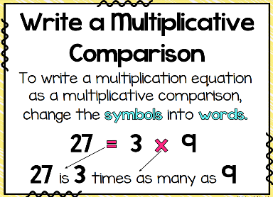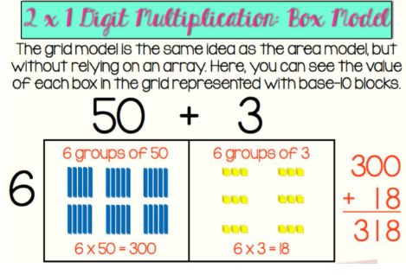

What we are learning…

Tests/Projects

-Comparison quiz 9/28

-Timed Test 9/30