**Electricity and Magnetism**



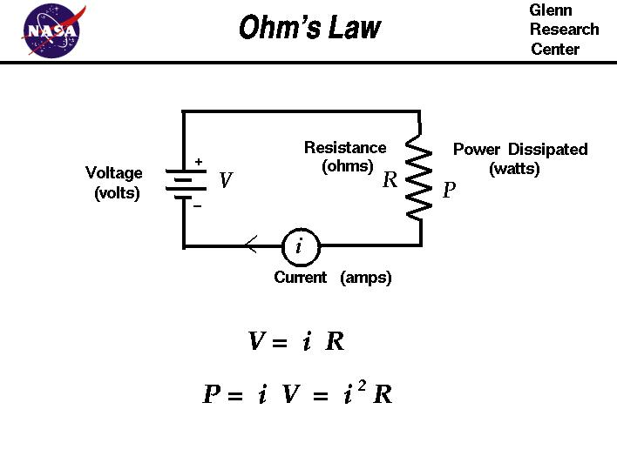

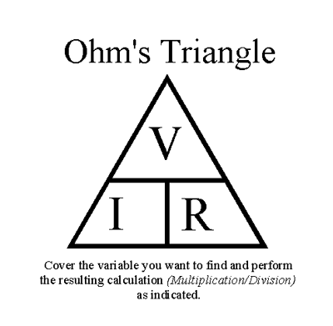

22. series and parallel circuits can be used to control the amount of electric energy produced.

23. a series circuit contains only one path for electricity to flow.

24. a parallel circuit contains more than one path

for electricity to flow.

25. parallel circuits are an advantage in that bulbs in parallel will still work if one of them burns out.

26. homes are wired with electricity using an alternating current(AC).

27. batteries use direct current (DC).

28. every object exerts gravitational force on every other object. The force depends on the mass of the objects and the distance between them.

29. an interconnection exists between electricity and magnetism.

30. magnetic substances occur naturally.

31. magnetic forces arise from the movement of electrical charge.

32. magnets can induce electric current and electric current can produce a magnetic field.

33. magnets can be used to make electricity when needed.

34. electricity can be used to make a magnet when needed.

35. electromagnets are used in electric motors to transform electrical energy to mechanical energy.

36. generators convert mechanical energy to electrical energy.

**The students will understand that…**

1. energy appears in different forms such as mechanical energy, gravitational energy, heat energy, electric energy and magnetic energy.

2. energy cannot be created or destroyed, but

only changed from one form into another.

3. transformations of energy usually release some energy, typically in the form of heat.

4. electric forces arise from the presence of an unbalance in electric charge.

5. all matter is composed of positive and negative particles. The movement of the charges created by these particles is what we call an

electric current.

6. electricity is a general term used to refer to the presence and/or flow of electrical charges. It is usually associated with the movement or

position of those charges.

7. static electricity (non-moving charges) is the attractive force between oppositely charged objects due to a buildup of negative charges.

8. a wet cell or dry cell can be used to produce electricity through a chemical reaction.

9. electricity produces heat and light.

10. the amount of electricity is measured in volts.

11. a battery is a series of electrical cells.

12. an electric circuit allows electrons to flow from a negative pole (excess electrons) to a positive pole (deficient in electrons).

13. the flow of electrons is measured in amperes.

14. insulators are poor conductors and resist charge movement.

15. the resistance to the flow of electricity is measured in ohms.

16. conductors tend to allow charges to move easily.

17. a circuit is important to electrical systems.

18. there are many ways to build an electric circuit.

19. a break in any circuit is called a short circuit.

20. fuses and circuit breakers accomplish the same tasks; however, each uses different technology in the way that it stops the flow of electricity.

21. closed circuits allow current flow while open circuits do not have an unbroken path for current movement.