IXL Learning
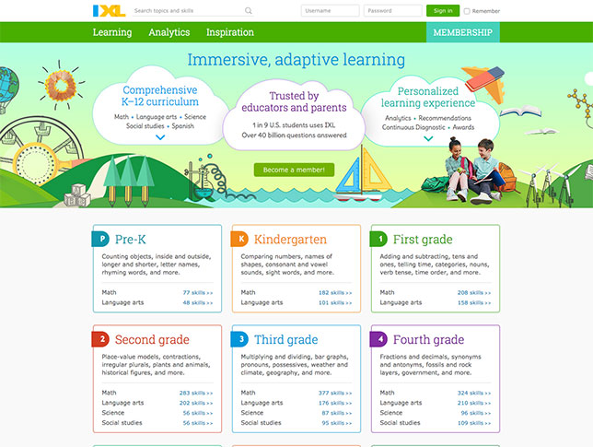

IXL has thousands of skills that match what we are learning. IXL is a great resource to help your child excel.

To use IXL, go to www.ixl.com and be sure you are not logged in to the website through any other user. Click the kindergarten skills tab. From there, you may choose any subject area, as well as any skill. This resource is available for free for 10 skills in each subject area per day.

