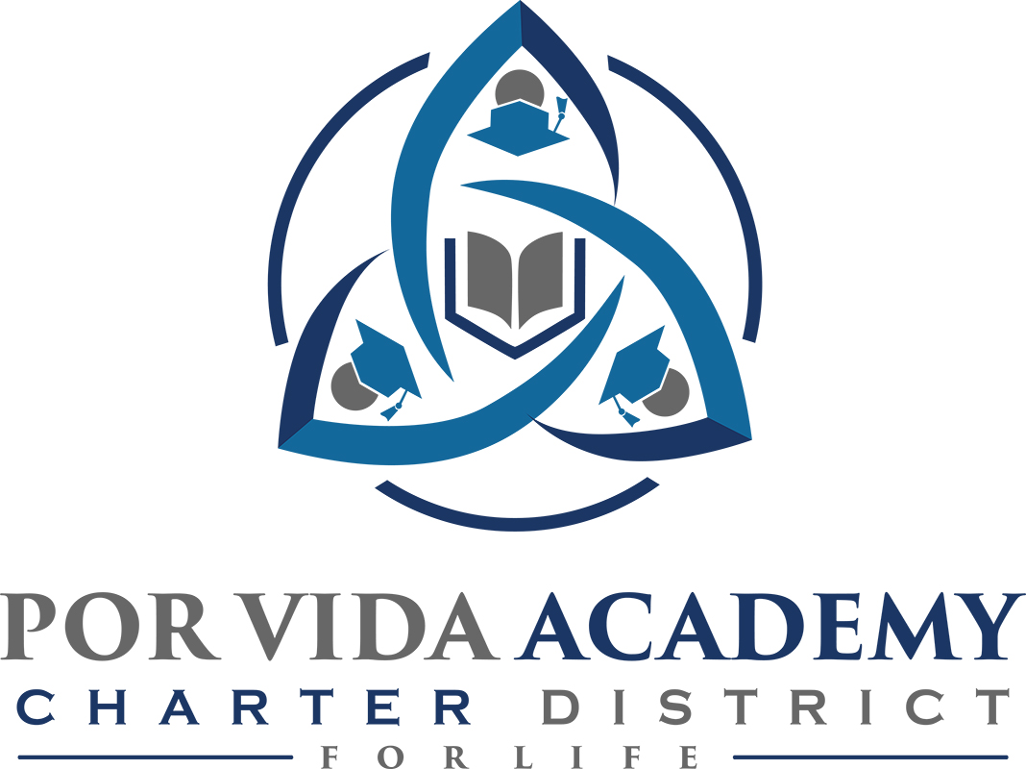

Notice of Regularly Called Meeting of the Board of Trustees

Notice is hereby given that a Regular Called Meeting of the Board of Trustees of the Por Vida Charter School District will be held on Thursday, January 10, 2019. The Board will convene in Open Session at 12:00 pm in the high school building, 1135 Mission Rd., San Antonio, Texas.
Mission Statement
A community-based organization aimed at developing life-giving skills and values for families and individuals through programs that educate, support, and empower.

- Call to Order and Establishment of Quorum
  - Roll Call & Recording of Board Members Present - Declaration of Quorum Present
  - Recording of the Executive Director/Superintendent and Staff Members Present.

- Close Session: None

- Pledge of Allegiance

- Salute to the Texas Flag- “Honor the Texas Flag; I pledge allegiance to thee, Texas, one state under God, one and indivisible.”

- Public Testimony:

- Approval of Minutes: October 19, 2018 & August 24, 2018

- Superintendent Items:
- Claudette Yarbrough discussion on sustainability
- Financial Management Report
- Charter FIRST
- School Reports

- Financials
  - current

- Board Items: None
Certificate as To Posting or Giving Of Notice

On this 7th day of January, 2019, this notice was posted at a place readily accessible and convenient to the public at the Por Vida Central Administration Offices and Por Vida Academy, 1135 Mission Road, San Antonio, Texas; Corpus Christi College Preparatory High School, & Cesar E. Chavez Academy, 4613 South Padre Island Drive, Corpus Christi, Texas 78411.

