Mrs. Daniel’s Newsletter
April 19-23, 2021
Unit 5 Reading Test Friday, April 23rd
Geometry Test: Friday, April 23rd
Text-Based  Comprehension Review:  - fact and opinion  - cause and effect  - main idea and details  - plot and theme  - character and setting | Review Vocabulary Skills:  We will be reviewing Unit 5 words and skills this week  (suffixes and compound words).  Grammar Review:  pronouns, singular and plural pronouns, using I and me,  different kinds of pronouns, contractions  a  Phonics Review:  - suffixes -ly, -ful, -er, -or, -ish  - prefixes un-, re-, pre-, dis-  - consonant patterns kn, wr, gn, mb  - consonant patterns ph, gh, ck, ng  - vowel patterns aw, au, augh, al
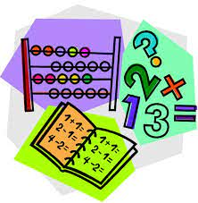  Topic 12: Geometry  This week, we will finish  studying about shapes, angles, a  and vertices.  Test on Friday! |  | 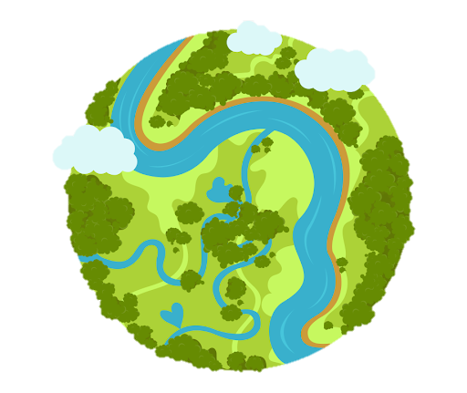  Social Studies/Science  We are continuing our study  about the different habitats on  Earth that plants and animals call  home. We can associate living  things with their environment by looking at their structures.
Spelling Words:
We will be reviewing past spelling words this week. No spelling test will be given!

