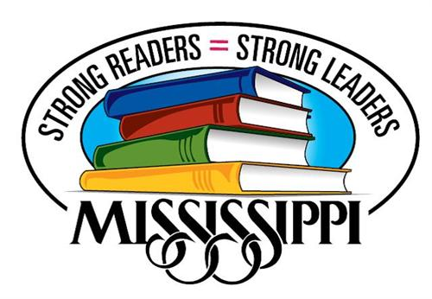
Southaven Elementary Reading Fair

We are excited to announce the annual Southaven Elementary School Reading Fair! This year’s fair will be held on Thursday, December 8. Students in grades Kindergarten through 5 are invited to read a good book and create a story board for it. All participants will receive a free book and our winners will receive ribbons! All first place winners will also advance to compete at the District Reading Fair in January.
Students can complete their boards independently, in groups of 3 or less, or as a family. All boards must follow the Mississippi Reading Fair Guidelines. Participation in this year’s fair will be optional for all students so no project boards will be given out by the school. You can find boards at Walmart, Office Depot, Micheals, Hobby Lobby, and many other retail stores. Be sure to refer to the guidelines for story board size before purchasing.
Please fill out the bottom slip of this letter if your child is interested in competing in our Reading Fair and you’d like a copy of the guidelines. All slips should be returned by Friday, November 4. Projects will be due Wednesday, December 7.
------------------------------------------------------------------------------------------------------------
Child’s Name ____________________________ Teacher __________________________

Parent Signature__________________________________________________________
My child is interested in entering a project in: (Check one)
____ Individual Fiction (Grades K-5) ____Individual Nonfiction Narrative (Grades K-5)
____ Individual Informational Nonfiction (Grades 3-5)
This is biographies, journals, reports, speeches, book/movie reviews, essays, editorials, etc.)
____Family/Group Fiction (Grades K-5)

