Monday March 30th Assignment:

Earth and Space Science
Did you know the Hubble Space Craft captures images of our world every single day? I encourage you to hop on their website and look up the image it captured on your birthday. For example, when I typed in my son’s birthday, March 20, this image and info pops up:
Colliding Galaxies NGC 6745
This image captures the collision of two galaxies. The larger spiral galaxy, NGC 6745, boasts an intact nucleus as it interacts with the smaller, passing galaxy that is nearly out of the frame to the lower right.
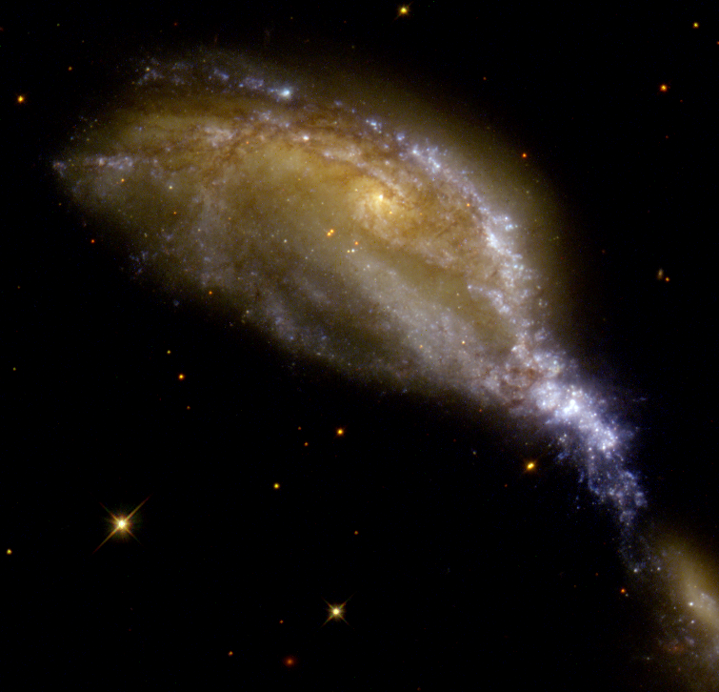

Follow the below link to see what was captured on your birthday:
https://www.nasa.gov/content/goddard/what-did-hubble-see-on-your-birthday
*these assignments are only meant to be fun and easy, not overwhelming*, NGC 6745, boasts an intact nucleus as it interacts smaller, passing galaxy that is nearly out of the frame to the lower

