How to log into your Google Chromebook and Google Classroom

ChromeBook Log in
We have been logging into our ChromeBooks and Google Classroom each week. Your student should be familiar with the process. Here are directions for when he or she is working on it at home.

Open computer/Turn On
Log in screen appears
-Type User Name: firstname.lastname Ex: sam.smith
-NO capitals
Click Next
-Type Password: SouthernStudent
-Capital S in both words
-NO space between
Click Next
The screen will open to the ProgressBook page. We will not be using this often, if at all. However, you can check grades here. Your student log in is:
User Name: FirstnameLastname Ex: SamSmith
-Capital letter in first name and last name
-No spaces
Password: Your student’s 3 initials and 5 digit lunch number
Ex:abc12345
(Please contact me if you don’t know. It starts with a 4_ _ _ _ )

Google Classroom Log in
Open a new tab at the top of your screen and type in: classroom/google.com
Your student should be in enrolled in your teacher’s classes

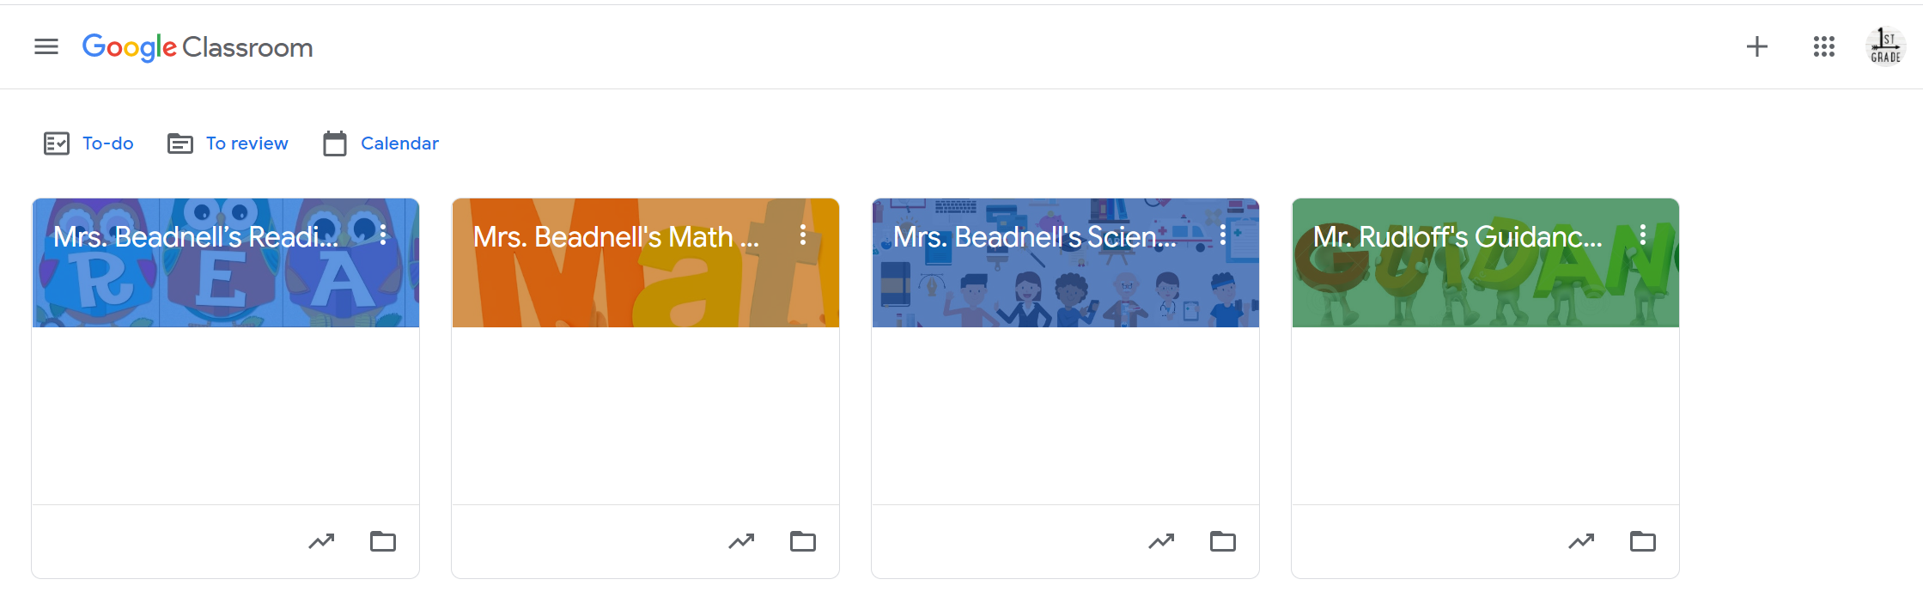
Click on a class.
This is the main screen, showing your Stream - announcements and new work assigned. There are tabs at the top. Click on Classwork to get to the assignment. Follow the instructions.
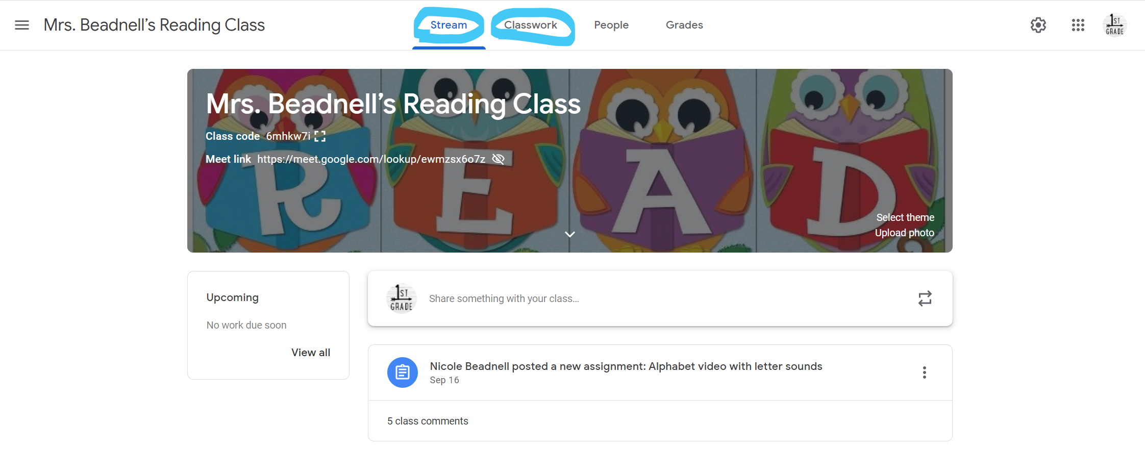
Some assignments are videos to watch and leave a comment Some assignments have quizzes your student will answer and submit online. Some assignments send you to a webpage or a link to a document. Follow the instructions. Clicking submit when completed, will let me know you have turned in an assignment. Grades will show up as a percentage, but I will turn that into a number (4,3,2,1) on the report card. K-2nd grade uses standards based grading and a number scale to show how your student is progressing.

You will also find the Meet link on this page. We would use this for a live video session, if we were to go to remote learning (everyone is at home). Your teacher can answer questions about logging in and the classroom assignments. If it is a technical question about the computer itself, please contact the school tech department by email at:
techhelp@slindians.org

