Library Media
Handbook

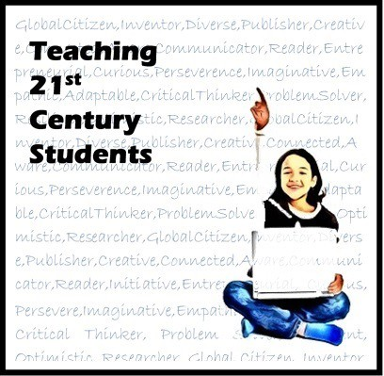

Mobile County Public School System Division of Curriculum and Instruction Library Media Services
2014

LIBRARY MEDIA HANDBOOK

Debbie Turner Supervisor
Library Media Services

Dr. Karen Mohr Chief Academic Officer

2010
Rev. June 2014

PREFACE

As we approach the second decade of the twenty-first century, school library media programs continue to undergo momentous changes that have heightened the importance of technology and evidence-based learning. The focus has moved from the library as a confined place to one with fluid boundaries that is layered by diverse needs and influenced by an interactive global community. Guiding principles for school library media programs must focus on building a flexible learning environment with the goal of producing successful learners skilled in multiple literacies.

The school Library Media Specialist uses Standards for the 21st Century Learner to create and maintain a program that will support lifelong learning.

(Empowering Learners – AASL)

LIBRARY MEDIA HANDBOOK COMMITTEE

The following Library Media Specialists assisted in preparing the 2010 Library Media Handbook.

Marsha Hollinger W. P. Davidson High School
Rhonda Massengale Citronelle High School Sylvia OrsoCentral Office Library Media Services
Deb Saleeby E. R. Dickson Elementary School
Earon Serra Katherine Hankins Middle School
Debbie Turner Olive J. Dodge Elementary School
Amy Wallace Cranford Burns Middle School

In June of 2014 the following Library Media Specialists assisted in revising the Library Media Handbook.

Melanie Adkison Phillips Preparatory School Monica Aplin MCPSS Magnet School Janet Aube Semmes Middle School
Stacy Brooks Dawes Intermediate School Nichole Dossett Semmes Elementary School
Rhonda Massengale Davidson High School Kerra Middleton Tanner Williams Elementary School Toni Morris Semmes Middle School
Anna Mouton Clark-Shaw Magnet School
Lisa Overstreet Hollingers Island Elementary
Ashley Pearce Mary G. Montgomery High School Deb Saleeby Elsie Collier Elementary School Gloria Urban Bryant High School
Sheri Westbrook Breitling Elementary School

COMMITTEE STATEMENT

This handbook is designed to serve as a guide and provide pertinent information for library media personnel in the Mobile County Public Schools. Its purpose is to facilitate uniformity of operation since individual schools vary greatly in size, composition of student body, and library media staff.

Revisions and updating will be ongoing as changes in state and system requirements, national standards, and new needs arise.

Table of Contents

1. MCPSS Mission Statement ………………………………………………...1

2. MCPSS Vision Statement …………………………………………………. 1

3. MCPSS Core Beliefs ………………………………………………………. 2

4. Library Media Program Mission ………………………………………… 3

5. Literacy Standards ………………………………………………………… 4

6. Library Media Program Objectives ……………………………………... 5

7. Library Bill of Rights ……………………………………………………… 6

- American Library Association Freedom to Read Statement …………… 7

9. Challenged Materials ……………………………………………………... 8

  - Reconsideration Procedures ………………………….. 8
  - Request for Reconsideration Form ………………….. 9
  - Procedures for Appeal ………………………………… 10
  - Appealed Decisions ……………………………………. 11
  - Review of Selection and Appeal Procedure …………. 11

10. Copyright / Fair Use Policy ………………………………………………. 12

- Copyright Procedures ………………………………….12
- Copyright Owner’s Rights ……………………………. 12 c. Fair Use Defined ………………………………………. 13

11. Rules for Copying Materials ……………………………………………... 14

a. Printed Media ………………………………………….14 b. Electronic Media ……………………………………….14
- Software / Multimedia ………………………………… 14
- Electronic Databases ………………………………….. 15
- Internet / World Wide Web …………………………... 15
- Designing Web Pages / Law ……………………………15
- Distance Education ……………………………………. 16 h. Email …………………………………………………… 16 i. Videos ……………………………………………………16
- Off-Air Taping of Videos ……………………………… 16
- Authorized Reproduction and Use of Copyrighted Music …….17-18

Table of Contents, Continued

12. Fair Use Chart of Teachers ………………………………………………. 19

Characteristics of a 21st Century Program ……………………………. 20

14. Technology ………………………………………………………………… 21

Role of Library Media Specialist 21

Creating Technology-Rich Environment …………… 22

Suggested Technology-Related Activities 23

15. Selection and Acquisitions ………………………………………………... 24

Criteria for Selection of Resources 24

Procedures for Selection 24

Collection Development 25
16. Barcodes …………………………………………………………………... 25
a. Range Assignments……………………………………. 26-28
17. Local School Purchase Order ………………………………………….. 29

a. LSPO Form ……………………………………………. 30
- Neaten Requisitions ………………………………… 31
- Information for Books / Periodicals …………………. 31

18. Receiving New Materials …………………………………………………. 32

- Maintaining the Collection ……………………………………………….. 33

  - Percentage of Book Collection per Dewey Category ... 33
  - Core Reference Collection ……………………………. 34

20. Cataloging……………..…………………………………………………… 35-43

21. Processing New Materials and Equipment ……………………………... 44-51

22. Classification Procedures ……………………………………………...….52-54

a. Books …………………………………………………... 52 b. Non-Book Materials ………………………………….. 53 c. Equipment …………………………………………….. 54

23. Weeding…………………….……………………………………………...…. 55-56
Table of Contents, Continued

24. Circulation ………………………………………………………………… 57

25. Lost / Damaged Library Books ………………………………………….. 57

26. Monies Collected …………………………………………………………. 57

27. Internet Acceptable Use ………………………………………………….. 58-64

28. Open Access to Library ………………………………………………… 65

- Understanding Library Media Specialist’s Role in Core Curriculum ... 65

  - Position Statement / Role of Library ………………...66 Media Specialist in Reading Development

- Guidelines for Library Media Center Scheduling ………………………67

  - Definition of Flexible Scheduling ……………………. 67
  - Definition of Open Access ……………………………. 68
  - Variations of Flexible Scheduling …………………. 68
- Suggestions for the Collaborative Process ………………………………. 69
32. Budgeting Procedures ……………………………………………………. 70
- Local School Library Media Advisory Committee ……………………. 71
- Staffing / Job Descriptions/Responsibilities …………………………….. 72

  - District Library Media Supervisor …………………... 72
  - Library Media Specialist ……………………………... 73-74
C. School-Level Building Administrator ……………….. 75
- Paraprofessionals ……………………………………... 76
- Library Media Clerk (Aide) ………………………….. 76
g. Student Assistants and Volunteers ………………….. 77

35. Library Media Education …………………………………………………78

36. Storage / Maintenance of Equipment …………………………………… 79-80

37. Recordkeeping / Reports ……………………………………. 81-82

38. Donations and Gifts ………………………………………………………..83

39. Public Relations / Contributions to School Community ………………. 84
Table of Contents, Continued

a. School Board ………………………………………….. 84 b. Superintendent ……………………………………….. 84 c. Principal ………………………………………………. 84 d. Teachers ……………………………………………… 84 e. Parents ……………………………………………. 85

f. Students ……………………………………………….. 85 g. Community ………………………………………. 85

40. Public Relations …………………………………………………………… 86

a. Media Attention ………………………………………. 86

41. National Reading Programs …………………………………………… 87

42. Encouraging Advocacy …………………………………………………... 88
a. Advocacy Tools …………………………………………………….. 88
- Services / Activities and Library Promotional Events …………………. 89
44. Disaster Preparedness ……………………………………………………... 90
a. Web Resources ………………………………………... 90 b. Emergency Kit ………………………………………... 91
45. Professional Development ………………………………………………...92-93

  - Professional Development Opportunities …………… 92
  - Professional Journals ………………………………… 93
  - Professional Associations …………………………….. 93

46. Evaluations / Assessments ………………………………………………...94

- State Department Review / Evaluation ………………94
- Compliance Monitoring……………………………….95-96 c. EDUCATE Alabama………………………………………97

- Other Policies / Renaissance Place Roles and Responsibilities ………... 98

a. Registrar ………………………………………………. 98
b. Teachers ……………………………………………….. 98-99
- Library Media Specialists …………………………….. 99-100
- Local MCPSS Renaissance Learning Trainers …….. 100
E. Local School Administrators ………………………….101
- District Instructional Technology Coordinator …….. 101
- District Curriculum and Instruction ………………… 102
- Local School Procedures Handbook ……………………………………... 103

MOBILE COUNTY PUBLIC SCHOOLS

Mission Statement
"The mission of the Mobile County Public School System is to graduate citizens who are literate, responsible and committed to learning over a lifetime.”

Vision Statement
We envision a Mobile County Public School System where a variety of pathways to academic and career success are available for all students; where adults consistently work in a collaborative school culture to improve student learning; where all educators willingly accept responsibility for the academic success of each student; and where all students become independent life-long learners confident in their ability to succeed in a global society following high school graduation.

Back, Table of Contents

MOBILE COUNTY PUBLIC SCHOOL SYSTEM

Core Beliefs
We believe a strong and equitable public school system is central to our success in a global economy. We believe the skilled performance of employees at all levels in the school system drives the achievement of high academic standards and determines organizational success. We believe that we must have a high performing school system that encourages employee participation in collaborative, problem-solving activities. Based on these core beliefs, we are committed to:

- Providing an ethical school system that requires fair treatment, honesty, openness, integrity and respect for all stakeholders
- Providing all students with the opportunity to perform to their fullest potential and ensuring that there is no discernable difference between the achievement levels of students by race, gender or economic level
- Placing a principal with strong instructional leadership and management skills as the key leader in every school
- Building and promoting an organizational climate where all teachers take responsibility for the academic achievement of their students
- Enhancing our personnel through meaningful professional staff development
- Operating effectively and efficiently with fiscal accountability
- Educating all students in safe and orderly environments conducive to learning
- Providing all students access to a well-rounded, rigorous curriculum
- Partnering with all stakeholders to maximize student learning
- Embracing our community's diversity and using it to enhance the educational environment
- Providing multiple pathways to graduation which prepare students to make informed career choices
- Preparing all students to be successful in institutions of higher learning or the workforce without a need for remediation
- Using internal and external stakeholder feedback to continually improve the services we offer
- Developing professional learning communities where shared decision making is expected

Back, Table of Contents

LIBRARY MEDIA PROGRAM

Mission Statement
The library media program will enable individuals to become information literate and effective lifelong readers. The program will provide educational and technological opportunities to students and staff in keeping with their needs and abilities. The program will enable individuals to access, analyze, assimilate, and use information effectively.

Alabama’s School Library Media Handbook for the 21st Century Learner expresses the mission of Alabama’s library media programs as supporting the school’s instructional program to improve student learning and student achievement. This mission is accomplished by:

- ensuring learners will be able to independently inquire, think critically, and to gain, create, and share knowledge;
- providing real and virtual access to appropriate, high-quality resources and services during and outside the school day;
- participating in curriculum development and design of learning activities; and
- facilitating professional development for the learning community.

Vision Statement

In collaboration with the school’s learning community, Alabama’s 21st Century library media programs will be the center of teaching and learning by providing access to quality collections and technologies and by extending services beyond the Library Media Center’s four walls and the school day.

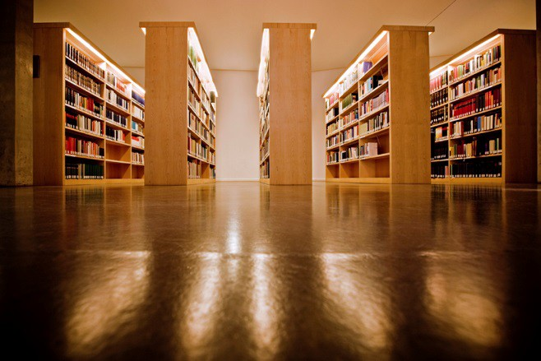

Back/Table of Contents

LITERACY STANDARDS

AASL Standards for the21st Century Learner

The American Association of School Librarians (AASL) Standards for the 21st Century Learner offers a vision for teaching and learning to guide our profession. The learning standards begin by defining nine foundational common beliefs listed below. Mobile County Public School’s library media programs promote these nine foundational beliefs.

- Reading is a window to the world.
- Inquiry provides a framework for learning.
- Ethical behavior in the use of information must be taught.
- Technology skills are crucial for future employment needs.
- Equitable access is a key component for education.
- The definition of information literacy has become more complex as resources and technologies have changed.
- The continuing expansion of information demands that all individuals acquire the thinking skills that will enable them to learn on their own.
- Learning has a social context.
- School libraries are essential to the development of learning skills.

The standards describe how learners use skills, resources, and tools to:

  - Inquire, think critically, and gain knowledge.
  - Draw conclusions, make informed decisions, apply knowledge to new situations, and create new knowledge.
  - Share knowledge and participate ethically and
  - Pursue personal and aesthetic growth productively as members of our democratic society.

The AASL Standards for the 21st Century Learner can be found on the AASL website.

Back/Table of Contents

LIBRARY MEDIA PROGRAM
Objectives

Information Access
Providing open, flexible, and equitable access to 21st Century materials and information is a primary function of the library media program.

The Learning Environment
The 21st Century library media program learning environment is designed to meet the needs of learners in both individual and collaborative settings, enhance learner success, and promote the use of the library media resources and services.

Facilities
The 21st Century Library Media Center provides an atmosphere that is conducive to student learning and allows for safe, flexible, open access for all learners.

Personnel
Competent, skilled library media personnel support and enhance the curriculum and contribute to student achievement.

Assessment and Evaluation
Annual and systematic evaluation and assessment provide data for the management and decision making policies regarding the complete library media program.

Resources
The 21st Century Library Media Center provides a variety of resources to support the diverse needs of all learners.

Technology
The Library Media Specialist is an education leader who promotes the success of all students by facilitating the use and integration of technology, telecommunications, and information systems to enrich the curriculum and enhance learning.

Budgets and Funding
The school Library Media Specialist collaborates with the local school district/system and administrators to ensure that funds are budgeted to maintain the library media program.

Policies and Procedures
Policies and procedures are needed to provide excellent resources, programs, and services for the educational community.

Back/Table of Contents

Library Bill of Rights

The American Library Association affirms that all libraries are forums for information and ideas, and that the following basic policies should guide their services.

- Books and other library resources should be provided for the interest, information, and enlightenment of all people of the community the library serves. Materials should not be excluded because of the origin, background, or views of those contributing to their creation.

- Libraries should provide materials and information presenting all points of view on current and historical issues. Materials should not be proscribed or removed because of partisan or doctrinal disapproval.

- Libraries should challenge censorship in the fulfillment of their responsibility to provide information and enlightenment.

- Libraries should cooperate with all persons and groups concerned with resisting abridgment of free expression and free access to ideas.

- A person’s right to use a library should not be denied or abridged because of origin, age, background, or views.

- Libraries which make exhibit spaces and meeting rooms available to the public they serve should make such facilities available on an equitable basis, regardless of the beliefs or affiliations of individuals or groups requesting their use.

Adopted June 19, 1939. Amended October 14, 1944; June 18, 1948; February 2, 1961; June 27, 1967;
and January 23, 1980; inclusion of “age” reaffirmed January 23, 1996, by the ALA Council.

Back/Table of Contents

American Library Association
Freedom to Read Statement

The freedom to read is essential to our democracy. It is continuously under attack. Private groups and public authorities in various parts of the country are working to remove or limit access to reading materials, to censor content in schools, to label "controversial" views, to distribute lists of "objectionable" books or authors, and to purge libraries. These actions apparently rise from a view that our national tradition
of free expression is no longer valid; that censorship and suppression are needed to counter threats to safety or national security, as well as to avoid the subversion of
politics and the corruption of morals. We, as individuals devoted to reading and as librarians and publishers responsible for disseminating ideas, wish to assert the public interest in the preservation of the freedom to read.

The freedom to read is guaranteed by the Constitution. Those with faith in free people will stand firm on these constitutional guarantees of essential rights and will exercise the responsibilities that accompany these rights.

We therefore affirm these propositions:

  - It is in the public interest for publishers and librarians to make available the widest diversity of views and expressions, including those that are unorthodox, unpopular, or considered dangerous by the majority.
  - Publishers, librarians, and booksellers do not need to endorse every idea or presentation they make available. It would conflict with the public interest for them to establish their own political, moral, or aesthetic views as a standard for determining what should be published or circulated.
  - It is contrary to the public interest for publishers or librarians to bar access to writings on the basis of the personal history or political affiliations of the author.
  - There is no place in our society for efforts to coerce the taste of others, to confine adults to the reading matter deemed suitable for adolescents, or to inhibit the efforts of writers to achieve artistic expression.
  - It is not in the public interest to force a reader to accept the prejudgment of a label characterizing any expression or its author as subversive or dangerous.
  - It is the responsibility of publishers and librarians, as guardians of the people's freedom to read, to contest encroachments upon that freedom by individuals or groups seeking to impose their own standards or tastes upon the community at
large; and by the government whenever it seeks to reduce or deny public access to public information.
  - It is the responsibility of publishers and librarians to give full meaning to the freedom to read by providing books that enrich the quality and diversity of thought and expression. By the exercise of this affirmative responsibility, they can demonstrate that the answer to a "bad" book is a good one, the answer to a "bad" idea is a good one.

Adopted June 25, 1953, by the ALA Council and the AAP Freedom to Read Committee; amended January 28, 1972; January 16, 1991; July 12, 2000; June 30, 2004.

Back/Table of Contents

CHALLENGED MATERIALS

Reconsideration Procedures

Any member of the school community (administrators, faculty, staff, parents, or students) may raise objection to instructional materials provided by the school Library Media Center or central office Media Center despite the fact that the individuals selecting such material were duly qualified to make the selection, followed proper procedure, and observed the criteria for selecting such material.

Persons requesting reconsideration of any instructional material shall complete the
Mobile County Board of Education Request for Reconsideration of Library/Instructional Materials (see next page) in its entirety. Each school and the central office will keep on hand and make available this reconsideration form. All formal objections to materials must be made on this form.

Back/Table of Contents

MOBILE COUNTY BOARD OF EDUCATION
REQUEST FOR RECONSIDERATION OF LIBRARY/INSTRUCTIONAL MATERIALS

School Title Media Format Author or Producer Date of Publication or Production
Request Initiated By:
Name Address Telephone
Does the person making this request represent a group or organization? YES � NO � If so, please identify the name of the organization.
How was this material selected? Student Choice � Required �

PLEASE ANSWER THE FOLLOWING QUESTIONS. (ATTACH ADDITIONAL SHEETS IF MORE SPACE IS NEEDED.)
- Have you read, viewed, or listened to the material in its entirety? YES � NO �
- What do you find objectionable about the material? Please cite the specific passages and their relationship to the work as a whole.

- What do you identify as the theme of this material?

- What good features do you identify?

- For what age group would you recommend this material?

- In the place of this material, please recommend other material which you consider to be of equal or superior quality for the educational purpose intended.

- Do you wish to make an oral presentation to the Library Media Committee? YES � NO �


DATE SIGNATURE
Back/Table of Contents

Procedures for Appeal
- The school official or staff member receiving a complaint regarding instructional materials shall explain the selection process utilized and the appeal procedures for challenged materials. The person receiving the complaint shall be courteous, make no commitment, and refrain from voicing personal opinion.
  - Written documentation of this contact should be filed with the school principal.
  - The material in question shall remain a part of the collection and in use until the reconsideration process is completed.
- In the event the person making an objection to material is not satisfied with the initial explanation, the person should be referred to the principal who shall explain the selection and reconsideration process but refraining from expressing personal opinion.
- If, after consultation, the complainant desires to file a formal complaint, a copy of the reconsideration form should be given to the complainant by the principal.
- The reconsideration form shall be completed and signed by the complainant and filed with the principal and a copy forwarded to the district Media Supervisor.
- Any action taken related to challenged materials must be heard by the school's Library Advisory Committee.
- Each committee member shall read, view or listen to the material in question in its entirety, and reach a professional evaluation pertaining to the material. The Library Media
Specialist will compile necessary professional evaluations of the material in question.
- The deliberation and balloting of the Library Advisory Committee shall be private.
- The Library Advisory Committee shall meet to:
  - Hear the concerns expressed by the complainant
  - Discuss the materials relative to values and faults, appropriateness to grade level, and curriculum.
  - Form opinions based on the materials as a whole and not on passages pulled out of context
  - Render a majority decision, in a meeting with a quorum present, choosing one of the following:
- take no removal action
- remove the challenged material
- limit the educational use of the challenged material
- place the material at another grade level
- Within five days of the Library Advisory Committee's decision, the chairperson shall notify the complainant in writing of the decision reached and advise of the right to appeal.

Back/Table of Contents

Appealed Decisions
- Appeals to the school's Library Advisory Committee's decision must be made within ten working days after formal notification of the decision. A written request must be addressed to the district level Library Advisory Committee. The district level Library Advisory Committee will be composed of the following:
  - Supervisor of library media services;
  - Representative Library Media Specialist/s – including Library Media Specialist from school involved;
  - Representative/s of the superintendent's Student and Teacher Advisory Committees; and
  - Curriculum & Instruction Supervisor/s.
- The school Media Specialist and/or principal will provide information to each School Board member which will include:
  - Decision of the school Library Advisory Committee
  - Right to Read
  - Library Bill of Rights
- The appeal will be scheduled on the Board meeting calendar. All parties will be given the opportunity to speak.
- The Mobile County Board of School Commissioners is the final authority.
- Requests to reconsider materials which have previously been before the Board must receive approval of a majority of the Board members before the materials will be reconsidered.

Review of Selection and Appeal Procedure
- Principals shall review the selection and reconsideration procedures with all staff annually.
- The staff shall be reminded that the right to object to material is one granted by
policies enacted by the Board of Education and firmly entrenched in the law. They shall also be reminded of ethical and practical considerations in attempting to handle
complaints with courtesy and integrity.

Back/Table of Contents

COPYRIGHT/FAIR USE
MOBILE COUNTY PUBLIC SCHOOL SYSTEM
Copyright Policy
Mobile County Public School System recognizes that federal law states that it is illegal to duplicate copyrighted materials without authorization of the holder of the copyright, except for certain exempt purposes. Severe penalties may be imposed for unauthorized copying of audiovisual or printed materials, and computer software, unless the copying or using conforms to the “fair use” doctrine.

While the system encourages its staff to enrich the learning programs by making proper use of supplementary materials, it is the responsibility of the system staff to abide by the system’s copying procedures and obey the requirements of the law. In no circumstances shall it be necessary for system staff to violate copyright requirements in order to perform their duties properly. Any staff member who is uncertain as to whether reproducing or using copyrighted material complies with the system’s procedures or is permissible under the law should contact the system’s library media services department. The library media services department will also assist staff in obtaining proper authorization to copy or use protected material when such authorization is required.

In accordance with copyright compliance, copyright regulations will be prominently posted at all areas where materials may be reproduced without supervision.

Copyright Procedures
What is Copyright? (Title 17, United States Code)
Copyright is a property right granted to authors and creators of works. Copyright is necessary to advance the public welfare by promoting artistic and scientific progress. (Title 17, United States Code)

Length of Time Protected: Life of author/creator + 70 years (Sonny Bono Extension Act) Works Eligible for Protection: Any tangible medium of expression, now known or later developed, which can be perceived, reproduced, or otherwise communicated, either with the aid of machine or device.

What are Copyright Owners’ Rights?
- The right to reproduce or copy the work
- The right to prepare derivative works
- The right to distribute to the public
- The right to public performance of the work
- The right to public display of the work
- The right to digitally transmit recordings (digital author’s right)

Back/Table of Contents

What is “Fair Use”?

“Fair Use” refers to permissible uses of copyrighted materials when certain conditions have been met. These four criteria of “Fair Use” must all be met:

  - The use of the work must be for nonprofit educational purposes;
  - The nature of the copyrighted work must be considered;
  - The portion of the copyrighted work used must meet the tests of brevity, spontaneity, and cumulative effect;
  - The effect of the use will not be a detriment to the potential market value of the copyrighted work.

In order to apply copyright laws, there are several rules of “Fair Use” that should be applied when asking if one is staying within copyright guidelines and law. These tests are for Brevity, Spontaneity, and Cumulative Effect.

Brevity – The test for brevity has to do with the amount of material you copy from a work. As a general rule, it should not exceed 10% of the whole work. Other rules for this test include:

    - A complete poem if less than 250 words; or an excerpt from a longer poem, but not to exceed 250 words;
    - An essay or any such work of 2,500 words or less;
    - Special works that combine prose, poetry and/or illustrations may be used but not more than 10% of the whole;
    - An excerpt from a larger printed work not to exceed 10% of the whole or 1,000 words, whichever is less, per class term;
    - One chart, graph, diagram, cartoon, or picture per work.

Spontaneity - The test for spontaneity has to do with time: seizing the moment.
Copying should be at the instance and inspiration of the teacher. This occurs when the inspiration and decision to use the work and the moment of its use for maximum teaching effectiveness are so close in time that it would be unreasonable to expect a timely reply to a request for permission.

Cumulative Effect – This test has to do with the amount of work that is copied over time:

- The copying of the material is for only one course in the school in which the copies are made;
- Not more than one short poem, article, story, essay, or two excerpts may be copied from the same author during the same term;
- Not more than three authors from the same collective work may be copied during the same term;
- There shall not be more than nine instances of such multiple copying for one course during one class term.

Back/Table of Contents

Rules for Copying Materials from Print Media

A single copy may be made of any of the following by or for a teacher at his or her individual request for his or her scholarly research or use in teaching or preparation to teach a class:

- A chapter from a book;
- An article from a periodical or newspaper;
- A short story, short essay, or short poem;
- A chart, graph, diagram, drawing, cartoon; or a picture from a book, periodical, or newspaper;
- A slide or overhead transparency, as long as the creation does not exceed 10% of photographs in one source (book, magazine, filmstrip, etc.) unless the source forbids photographic reproduction. Multiple copies, not to exceed in any event more than one copy
per pupil in a course, may be made by or for the teacher giving the course for classroom use or discussion, provided that:
- Each copy includes a notice of copyright;
- The copying meets the tests of brevity, spontaneity, and cumulative effect;
- The same teacher does not use the material repeatedly from term to term;
- Not more than nine classroom sets are used in one term;
- Sets are destroyed after the permitted use;
- It complies with the “Fair Use” guidelines.

Electronic Media

The Digital Millennium Copyright Act of 1998 grants permission for libraries to digitize other media in formats that are not useable because the equipment to use the format is obsolete. The digitized copy can only be used for archival/research use, not for classroom use.

Software and Multimedia
Software:

- A single copy of a software program may only be loaded on a single machine unless otherwise noted in the documentation that comes with the software.
- Site licensed software may only be used as described in the license.
- Network versions of software may only be accessed by the number of machines for which the license was purchased.
- Some software products allow teachers and/or students to take home a “home” version. If teachers or students do this, they must abide by the instructions that accompany the software package and license.
- It is in the best interest of all schools to keep good records of software licenses. Keeping a notebook with all licenses and purchase orders is suggested.
- Copying a portion of copyrighted material to be included in a student and/or teacher produced presentation must meet the “fair use” copyright guidelines.
- An image copied may not be altered or modified into something different from the intent of the copyright holder.

Back/Table of Contents

Electronic Databases:
- Regulations are usually defined in the contract and/or license agreements.
- Review contracts or license agreements and be aware of all conditions.
- Do not retain extra copies or archival copies of a downloaded search.
- Do not use downloaded materials to create a derivative work.
- Appropriate notices regarding downloading from databases will be posted near computers.

Internet & World Wide Web
- Assume all materials on the Internet are copyrighted.
- Small portions of web documents may be used for teaching due to lack of time to secure permissions, otherwise obtain permission(s).
- If you know the Internet information is in the public domain, then it is acceptable to download.
- Students may copy HTML code (not the content) and print it out for scholarship and research.
- Links may be made to other web locations on a personal web site.
- Copyrighted software may not be uploaded from the Internet.
- Materials may not be collected from the Internet to compile into a new work.
- Do not post a picture by the student with student name next to the picture.
- Student photos may not be posted without parental permission.
- Student names should not be posted with pictures.
- Only educational personnel may be the contact for a web site or page.

Designing Web Pages and the Law:
- The copyright laws apply when you are designing web pages.
- It is a copyright violation to grab Internet sites for use on another server.
- The “Fair Use” rules apply.
- Teachers and students may use a small amount for classroom use. However, many graphics and pictures on the web are most likely copyrighted.
- If there is a statement that the site is public domain or can be copied by teachers, etc., then you have permission to copy. Internet or Online Service Providers (ISPs or OSPs:)
- These may be libraries or educational institutions
- Limit liability by designating an agent to receive copyright notices and send to subscribers.
- Post a policy to comply with takedown and put back provisions in case of disputed materials.
- Do not place material online nor modify. Material-copies must be in transient storage no longer than reasonably necessary.
- ISPs or OSPs are not required to actively monitor system use or seek out offenders, except under normal system maintenance.

Back/Table of Contents

Distance Education:
- You may transmit a performance of a nondramatic literary or musical work.
- A performance works, but only in reasonable and limited portions are acceptable of any other work, including dramatic works and audiovisual.
- Displays of any work in an amount comparable to that which is typically displayed in the course of a live classroom session are also acceptable.
- You may use public domain materials in a distance course.
- You may not copy a copyrighted video for a distance course without permission.
- Limit access to course materials.
- Get permission for works you will use repeatedly.
- Remember course use and “Fair Use” may not be the same thing.

Email:
- Paraphrasing someone else’s email message is acceptable.
- Get permission to copy an entire email message, send a message to someone else, or post to electronic discussion group.

Videos
“Fair Use” rules for videos must be observed unless you have a license for public performance of a video.

- Teachers or students must present the video.
- The video must be a part of face-to-face teaching activities. It must directly relate to the curriculum and the current lesson. “Home Use Only” videos may not be used for entertainment or reward.
- The presentation must occur at school in a classroom or similar educational setting.
- The video must be legally obtained.

Off-Air Taping of Videos:
- Programs must be for direct instruction, not entertainment or reward.
- Taping must be from open-air broadcasts for which no payment is made to receive programs. (No cable, satellite programs unless they are a retransmission.)
- A video taped off-air may be kept for 45 calendar days. Then it must be erased.
- The video may only be used with students during the first 10 school days after it is taped.
- The library media specialist may only record requested programs. He/She may not record programs in anticipation of teacher requests.
- No program may be recorded multiple times for the same teacher, even if it is a rebroadcast.
- The program must be recorded in its entirety. It may not be edited or altered.

Back, Table of Contents

Authorized Reproduction and Use of Copyrighted Music
- For academic purposes, other than performance, teachers may make a single copy of an entire performable unit (section), movement, aria, etc. from a printed musical work that is (1) confirmed by the copyright proprietor to be out of print or (2) unavailable except in a larger work, for purposes of preparing for instruction.
- A teacher may make multiple copies not exceeding one copy per pupil for classroom use of an excerpt of not more than 10% of a printed musical work if it is to be used for academic purposes other than performance, provided that the excerpt does not comprise a part of the whole
musical work which would constitute a performable unit such as a selection, movement, or aria. In an emergency, a teacher may make and use replacement copies of printed music for an imminent musical performance when the purchased copies have been lost, destroyed or are otherwise not available, provided that purchased copies shall be substituted in due course.
- A teacher may make and retain a single recording of student performances of copyrighted material when it is made for purposes of evaluation or rehearsal.
- A teacher may make and retain a single copy of excerpts from recordings of copyrighted musical works owned by the school or the individual teacher for use as aural exercises or examination questions.
- A teacher may edit or simplify purchased copies of music provided that the fundamental character of the music is not distorted. Lyrics shall not be altered or added if none exist.
- Copying cannot be used to create, replace or substitute for anthologies, compilations or collective works; copying of consumable works is prohibited. Copying for the purpose of performance is prohibited, except in the case of an emergency as set forth above, and copying for the purpose of substituting for the purchase of music is prohibited, except as set forth in the first and second paragraphs above. All copies must include the copyright notice appearing on the printed copy.
- Performance by teachers or students of copyrighted musical works is permitted without the authorization of the copyright owner as part of a teaching activity in a classroom or instructional setting. The purpose shall be instructional rather
than for entertainment.

If the requirements of the foregoing paragraph are not satisfied, performances of nondramatic musical works which are copyrighted are permitted without the authorization of the copyright owner, provided that:

- The performance is not for a commercial purpose;
- None of the performers, promoters or organizers are compensated; and
- (1) There is no direct or indirect admission charge; or (2) Admission fees are
used for educational or charitable purposes only provided that the copyright owner has not objected to the performance. All other musical performances require permission from the copyright owner.

Back, Table of Contents

We would like to gratefully acknowledge the following sources for their permission to use portions of their copyright policies:

Baldwin County Board of Education Baldwin County, AL
Bannon, Susan H., Associate Professor and Director, Learning Resources Center, Auburn University Auburn, AL
Bellingham School District Bellingham, WA
Okaloosa School District Ft. Walton Beach, FL

Back, Table of Contents

Fair Use Chart for Teachers

Work or Materials to be used for Educational Purposes | Fair Use Restrictions for Face- to-Face Teaching | Illegal Use without Explicit Permission from Creator/Author
Chapter in a book | Single copy for teacher for research, teaching, or class preparation.  Multiple copies (one per student per class) okay if material is (a) adequately brief, (b) spontaneously copied, (c) in compliance with cumulative effect test. | Multiple copies used again and again without permission.  Multiple copies to create anthology.  Multiple copies to avoid purchase of textbook or consumable materials.
Newspaper/magazine article | Same as above.  Multiple copies of complete work of less than 2,500 words and excerpts up to 1,000 words or 10% of work, whichever is less.  For works of 2,500-4,999 words, 500 words may be copied. | Same as above
Prose, short story, short essay, Web article |  | Same as above
Poem | Same as for first item.  Multiple copies allowed of complete poem up to 250 words -- no more than two printed pages.  Multiple copies of up to 250 words from longer poems. | Same as above
Artwork or graphic image -  chart, diagram, graph, drawing, cartoon, picture from periodical, newspaper, or book, Web page image | Same as for first item.  No more than 5 images of an artist/photographer in one program or printing and not more than 10% or 15% of images from published collective work, whichever is less. | Same as first item  Incorporation or alteration into another form or as embellishment, decoration for artistic purposes for other than temporary purposes.
Motion media -  film and videotape productions | Single copy of up to 3 minutes or 10% of the whole, whichever is less.  Spontaneity required. | Multiple copies prohibited. Incorporation or alteration into another form as embellishment for artistic purposes for other than temporary purposes prohibited.
Music  -sheet music, songs, lyrics, operas, musical scores, compact disk, disk, or cassette taped recordings | Single copy of up to 10% of a musical composition in print, sound, or multimedia form. | Same as immediately above
Broadcast programs | Single copy of off-air simultaneous broadcast may be used for a period not to exceed the first 45 consecutive calendar days after recording date.  Use by only individual teachers. | Same as immediately above.  May not be done at direction of superior. May not be altered.

Back, Table of Contents

CHARACTERISTICS OF A 21ST CENTURY LIBRARY MEDIA PROGRAM
- The Library Media Center is a place where individuals and groups of students use information to extend classroom studies and to further personal interests.
- Students have open, flexible access to library media resources and services.
- Library media resources are available to support the curriculum, encourage research, engage students in pleasure reading, and address individual needs and interests.
- Resources are organized by a recognized method and are available in an automated format.
- 21st Century skills are integrated with all subjects and developed in a curriculum context to provide a foundation for life-long learning.
- Library media services are implemented according to a written plan based on data analysis, needs assessment, and annual evaluation, consistent with the goals of the school and school system.
- A comprehensive program is provided that includes skills instruction, information access, program management, and media center management.
- Learners are taught to seek diverse perspectives, gather and use information ethically, and make use of social tools, i.e. personal space, responsibly and safely.

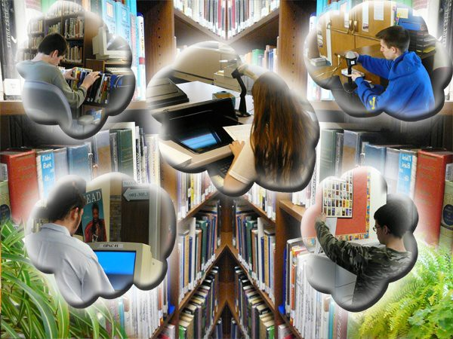

Back, Table of Contents

TECHNOLOGY
A local school's technology plan should follow the technology guidelines established by the Mobile County Public Schools. The system's District Technology Plan follows state and national guidelines. It identifies goals and objectives as well as resources needed to produce technologically literate citizens. It provides valuable information that is useful to the Library Media Specialist and teachers integrating technology within the school setting.

The Role of the Library Media Specialist in the Local Technology Program
The Library Media Specialist must be an active participant in technology curriculum integration. The Library Media Specialist is an educational leader who promotes the success of all students by facilitating the use and integration of technology, telecommunications, and information systems to enrich the curriculum and enhance learning. The Library Media Specialist:

- 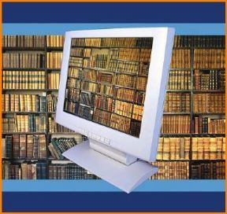participates in writing the school and system technology plans.
- participates in the assessment and acquisition of technology.
- provides and participates in professional development instruction for teachers and administrators on the use of technology and integration of technology into the curriculum.
- models and instructs on conduct, ethics, and integrity in the use of the Internet and other electronic resources.
- uses existing and emerging technology to access,
evaluate, and distribute information for integration in the instructional programs.
- models the information problem-solving processes in providing instruction using technology reference and research techniques.
- participates in state and national technology initiatives.
- attains technology competencies which are evaluated by an approved evaluation Instrument.
- collaborates with the learning community to empower students to acquire technology information literacy skills that enable them to be life-long learners and critical thinkers.
- embraces, promotes, and shares technologies to effectively demonstrate the applications of technology in the learning environment.
- models and instructs on integration and use of the Alabama Virtual Library.

Back, Table of Contents

Creating a Technology-Rich Environment
The 21st Century Library Media Specialist designs the program with a new and improved concept of the Library Media Center space and resources. The Library Media Specialist has a unique opportunity to offer customized, 24/7, point of need, relevant, and authentic service and instruction.
A Library Media Specialist knows he/she is a 21st Century librarian if:
- learners and teachers can access developmentally appropriate and relevant databases, portals, and web sites.
- he/she organizes the web for learners by pulling together electronic resources to meet the information needs of the learners.
- in addition to print materials, the collection now includes e-books, audio books, blogs, open source software, streaming media, wiki-books, and more.
- interactive library media services are provided on-line (book reviews, reference services, library calendar).
- partnering with classroom teachers is used to consider new interactive, collaborative, and engaging communication tools for student projects (digital storytelling, wikis, podcasts, streaming video, and student-produced learning objects).
- as the knowledge management center of the school, he/she collects the learning tools that the learning community is most likely to need and shares them in effective media formats.
- experts, scholars, authors, and other classrooms visit the library via telecommunication tools (Skype, Internet2.0).
- issues of digital equity are met with open source software alternatives, hardware and web-based applications are available for all learners.
- reading is promoted through digital book talks, e-books, and virtual literature circles.
- the Library Media Center becomes less book space and more creative-production and experience-sharing space. Opportunities are provided through group planning/collaborating space, performance and presentation space, event central for telecommunications and remote author/expert visits, while continuing to function as a study/reading/gathering space.
- respect for intellectual property is modeled by using appropriate documentation for media in all formats and explaining new licensing concepts to all learners.
- social networking tools are available for educational activities.
- detach journals and edtech blogs provide professional news and new strategies daily.
- students are empowered to create learning materials and provide instruction utilizing the latest technology tools.
(Adapted from Joyce Valenza’s, You Know You’re a21st Century Teacher-Librarian If… )

www.voya.com

Back, Table of Contents

Suggested Technology Related Activities

Webquests
Student Web Pages Teen Tech Week Social Networking
Virtual Tours/Field Trips Podcasts
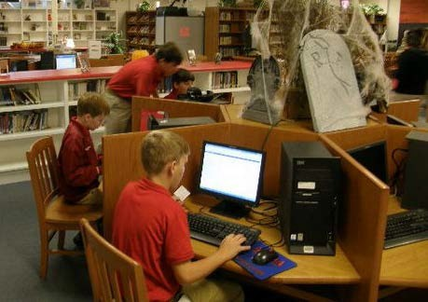Wikis/Blogs RSS Feeds Movie Making Streaming Media Virtual Worlds Video Editing Clay Animation Digital Imaging
Digital Photography
Global Positioning Systems Mixing Media
In-Hand Devices
Interactive Classroom Components Mashups
Skype

Back, Table of Contents

SELECTION AND ACQUISITIONS
A collection development policy provides the basis for developing and maintaining the collection through the planned purchase of materials in diverse formats to meet instructional needs. The policy includes guidelines for selection, deselection (weeding), and challenged materials. A collection development policy is revised periodically to reflect the changing needs of the school community. (Alabama’s School Library Media Handbook for the 21st Century Learner)

Criteria for Selection of Resources
The standard for selection of library media instructional, informational, and recreational resources is determined by the policy of the Board of School Commissioners. Content considerations include how it relates to the curriculum, the existing collection, and the needs, values, and interests of the community. Items for purchase are evaluated on the basis of:

  - Developmental, cultural, and learning needs of the school population
  - Organization and presentation
  - Importance of the subject matter
  - Quality of production and durability
  - Appeal and appropriateness to the students’ reading ability
  - Accuracy and validity
  - Reliability of producers or publishers
  - Reputation and significance of the author, artist, composer, etc.
  - Award winning materials recognized for literary and/or artistic value
  - Format and price
  - Currency

Procedures for Selection
In selecting items for purchase, the Library Media Specialist:

  - evaluates the existing collection
  - consults professionally recognized selection resources
  - consults with principal about school-wide needs
  - consults with teachers about grade level curriculum needs
  - analyzes course content and textbook coverage for each subject
  - uses knowledge of student needs, interests, goals, abilities, and concerns

Multiple items are purchased according to demand. More than five copies of any title cannot be used to satisfy SACS requirements.

Worn, missing, or outdated items are replaced as needed.
Back, Table of Contents

Collection Development
Depending on the source of funding, materials will be order either through a local school purchase order or through a Central Office requisition using NextGen. When compiling a large book order, attach a list of all books being ordered following vendor specifications. Include a “Do Not Exceed” amount and type “No Backorders Accepted” on the purchase order.

Quality, service, discounts, availability of MARC records, and processing options are considerations when selecting a vendor/jobber. It is recommended that MARC records and processing be purchased when available. Some materials must be ordered directly from the publisher. Publisher's Library Binding and Publisher's Library Edition are recommended for all School Library Media Centers. The material format must be strong, practical, suitable for its purpose, and easy to use.

Some materials are available through the MCPSS bid process. See MCPSS Active Contracts and
Alabama Active Contracts for more information.

Barcodes
Each school is assigned a specific range of barcode numbers as shown in the chart on the following pages.

Back, Table of Contents

BARCODE RANGE ASSIGMENTS

SCHOOLS
BEGINNING | ENDING | ADDITIONAL
NUMBER | NUMBER | BARCODE NUMBERS

Alba Middle | 950000 | 980000
Allentown Elementary | 6500000 | 7000000
Austin Elementary | 995000 | 1025000
Baker High | 1070000 | 1100000
Belsaw Elementary | 1130000 | 1160000
Blount High | 1170000 | 1200000
Booth Elementary | 910000 | 940000
Brazier Elementary | 1330100 | 1360100
Breitling Elementary | 9525302 | 9555302
Bryant High | 7700000 | 7970000
Burns Middle | 8550000 | 8800000
Burroughs Elementary | 1360200 | 1390200
Calcedeaver Elementary | 000001 | 006000
Calloway Smith Middle | 8850000 | 9100000
Castlen Elementary | 550000 | 580000
Causey Middle | 1000 | 9120 | 10127320 | 10157320
Central Office  Library Media Services | 7601000 | 7690000 | 600000  10307326 | 630000  10337326
Chastang Middle | 1390300 | 1450400
Citronelle High | 1480700 | 1540800
Clark-Shaw Magnet | 400000 | 430000
CLC | 1540890 | 1570890
Collier Elementary | 760000 | 790000 | 10247324 | 10277324
Collins-Rhodes Elementary | 2170200 | 2200000 | 9245300  9917313 | 9495300  9947313
Council Traditional | 1570899 | 1610900
Craighead Elementary | 1611000 | 1641000
Crichton Elementary (CLOSED) | 1642000 | 1672000
Dauphin Island Elementary | 1672100 | 1702100
Davidson High | 1800000 | 2100000
Davis Elementary | 3151300 | 3190000
Dawes Elementary | 9977315 | 10007315
Denton Middle | 1030000 | 1060000
Dickson Elementary | 2110000 | 2140000 | 10067318 | 10097318
Dixon Elementary | 2140100 | 2170100
Dodge Elementary | 580000 | 609999 | 10007316 | 10037316
Dunbar Magnet | 520000 | 549000
Eanes Middle | 2600000 | 2950000

Back, Table of Contents

BARCODE RANGE ASSIGMENTS

SCHOOLS
BEGINNING | ENDING | ADDITIONAL
NUMBER | NUMBER | BARCODE NUMBERS

Evans Elementary | 985000 | 990000
Fonde Elementary | 430000 | 459000 | 9857311 | 9887311
Fonvielle Elementary (CLOSED) | 2201000 | 2231000
Forest Hill Elementary | 610000 | 639999
George Hall Elementary | 730001 | 760000
Gillard Elementary | 3530200 | 3900000 | 860000  9615305 | 900000  9645305
Glendale Elementary (CLOSED) | 2232000 | 2262000
Grand Bay Middle | 670001 | 700000
Grant Elementary | 8250000 | 8500000
Griggs Elementary | 2263000 | 2293000
Hamilton Elementary (CLOSED) | 2293100 | 2323200
Hankins Middle | 3710000 | 3750000
Haskew Elementary | 9646305 | 9676305 | 9707306 | 9737306
Hillsdale Middle (CLOSED) | 2324000 | 2354000
Hollingers Is. Elementary | 2384000 | 2420000
Holloway Elementary | 2421000 | 2500000
Howard Elementary | 7980000 | 8200000 | 3264000 | 3300000
Hutchens Elementary | 9110000 | 9170000
Indian Springs Elementary | 2500100 | 2540100 |  | 2507100
Just 4 | 4100000 | 4160000
LeFlore Magnet | 2550000 | 2590000
Leinkauf Elementary | 1300000 | 1330000 | 10097319 | 10127319
Lee Elementary (K-2) (CLOSED) | 3300100 | 3330200 | 9585304 | 9615304
Lee Intermediate (3-5) (CLOSED) | 9555303 | 9585303
Lott Middle | 9171000 | 9185000
Maryvale Elementary | 1 | 905844 | 905871
McDavid-Jones Elementary-(K-2) | 9185100 | 9215100 | 3330300 | 3370300
McDavid-Jones Elementary-(3-5) | 9245200 | 9245200
Meadowlake Elementary | 1000 | 22000 | 9827310 | 9857310
Mertz Elementary | 3066000 | 3069000
Montgomery High | 3031000 | 3062000
Mobile County Math and Science | 580000 | 600000
Mobile Co. Trng. Middle | 3069100 | 3101100
Morningside Elementary | 490000 | 519000 | 10157321 | 10187321
Murphy High | 600000 | 6022145
North Mobile County Middle | 9947314 | 9977314
Old Shell Road Magnet | 3200000 | 3230000

Back, Table of Contents

BARCODE RANGE ASSIGNMENTS

SCHOOLS
BEGINNING | ENDING | ADDITIONAL
NUMBER | NUMBER | BARCODE NUMBER

Orchard Elementary | 3231000 | 3263000
O’Rourke Elementary | 640000 | 670000 | 9555400  9645306 | 9585400  9677304
Phillips Preparatory | 000500 | 012500 | 9767308 | 9797308
Pillans Middle | 000001 | 019999
Rain High | 100000 | 130000 | 10187322 | 10217322
Regional School | 9495301 | 9525301
Robbins Elementary | 3370400 | 3400000
Satsuma High (CLOSED) | 3430200 | 3460200
Scarborough Middle | 3460300 | 3500000 | 10217323 | 10247323
Semmes Elementary | 700001 | 730000 | 9887312 | 9917312
Semmes Middle | 000001 | 012000
Shaw High (CLOSED) | 3500100 | 3530100 | 9737307 | 9767307
Shepard Elementary | 460000 | 489999 | 9797309 | 9827309
Spencer-Westlawn Elementary | 1642000 | 1672000
St. Elmo Elementary | 3560400 | 3590400
Tanner Williams Elementary | 3600000 | 3660000
Taylor-White Elementary | 10277325 | 10307325
Theodore High | 3661000 | 3700000
Thomas Elementary (CLOSED) | 3000000 | 3030000 | 9677305 | 9707305
Turner Elementary | 9000000 | 9030000
Vigor High | 3800000 | 3850000
Washington Middle | 1210000 | 1250000
Westlawn Elementary (CLOSED) | 3860000 | 3900000
Whistler Elementary (CLOSED) | 3910000 | 3950000
Whitley Elementary | 3951000 | 3990000
Will Elementary | 160000 | 189999
Williamson High | 4000000 | 4050000 | 10037317 | 10067317
Wilmer Elementary | 4051000 | 4060000
Woodcock Elementary (CLOSED) | 4061000 | 4092000

Back, Table of Contents

Local Purchase Order
Contact the local school's bookkeeper for specific guidelines for purchases made with local school funds. Some materials are available through the Mobile County Public School System bid process. See MCPSS Bid List for more information. Include the bid number from the Active Contracts list on local purchase orders if you choose to purchase items listed in the bid catalog.

See the next page for a sample purchase order. When ordering a large quantity of books from a single vendor, show the quantity as “1” and description as “See attached title list”. Submit the local purchase order to the bookkeeper or principal and retain a copy for your files.

A copy of all requisitions and local purchase orders should be kept on file for a minimum of three (3) years.

Back, Table of Contents

B-LS  Revised 6/2010 | LOCAL SCHOOL PURCHASE ORDER ENTER SCHOOL NAME HERE | Page of
ENTER SCHOOL ADDRESS HERE
Requisition – Purchase Order – Material Receipt
Ship To
Vendor Name
Vendor Name & Address
School Name & Address

ATTN: Your Name

Notice To Vendor: This is not a valid purchase order until it has been approved by the principal with a Purchase Order Number. Address all correspondence to the school.

Quantity | Item and Description |  |  | Extention
1 | Library Books: See attached title list | Total Amount of Order |  | Total Amount of Order
 | Processing Charges
 | Shipping & Handling Charges
 | DO NOT EXCEED TOTAL PO AMOUNT
 | NO BACKORDERS ACCEPTED
 | NOTE: For questions concerning this order please call YOUR NAME & PHONE NUMBER/EMAIL
 |  | Total |  | P.O. TOTAL

Requisitioned By YOUR NAME DATE
Date Requisitioned

Approved By

Date Approved

For FUND SOURCE
Purchase Order Number
Back, Table of Contents

Library Media Center Requisitions on The McAleer (NextGen) Accounting System

Purchases made with allocations other than local monies must be entered electronically using the McAleer Accounting System (NextGen). All Library Media Specialists must be trained on the McAleer Accounting System. Training is available through the Purchasing Department (221-4473).

Detail Information for Book and Periodical Orders:
When ordering a large quantity of books from a single vendor, show the quantity as “1” and description as “See attached title list”. Include a beginning barcode number or a range of barcode numbers for the order, processing fees, MARC record fees, Accelerated Reader labeling information, shipping charges, and Do Not Exceed Amount (amount of total purchase order).

When ordering periodicals follow the same procedures and include the following statements in the description:

  - Please Prepay
  - This is a Subscription
  - Beginning Date

Back, Table of Contents

Receiving New Materials

The following steps should be taken when the order is received.

- Check packing slip against the materials received and the purchase order.
- 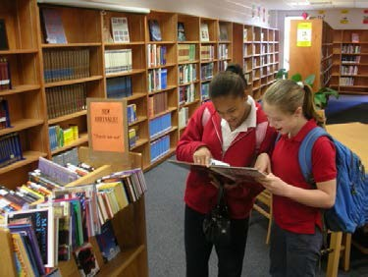Note any deficiencies or defects so claims or returns may be made.
- Contact the vendor concerning claims or returns.
- If order is complete, sign and date the pink copy of the purchase order, and send the copy to Accounts Payable along with the packing slip.
- If order is incomplete when received, reconcile packing slip with purchase order. Indicate on your file copy and on the pink copy the corrected total. Sign pink copy, and send to Accounts Payable. Submit new requisition to spend balance of funds.
- Record on your file copy the date the pink copy was signed and returned to Accounts Payable.

- 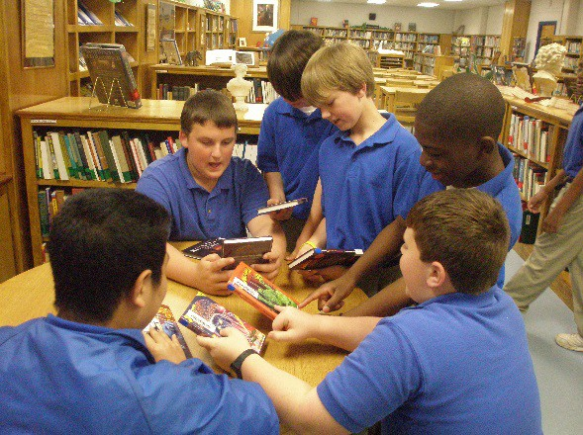A copy of all requisitions and local purchase orders should be kept on file for a minimum of three (3) years.
- Central Office will issue a purchasing deadline. This may be different each year. Check with your principal for this date. All monies, except local funds, must be spent and materials received by this deadline.

Back, Table of Contents

MAINTAINING THE COLLECTION
Maintaining the collection ensures that all subjects will be represented in proportions appropriate for the school. The following percentage chart may be used as a guide to help determine the number of books needed in the different areas of the collection. The collection analysis provided by your vendor of choice (i.e. Follett, Permabound, etc.) will also provide alternative guidelines for collection development.

Percentage of Book Collection per Dewey Category

Dewey Number | Subject | Percentage K-5 | Percentage 6-8 | Percentage 9-12
000-099 | Generalities | 1 | 2 | 2
100-199 | Philosophy | 1 | 2 | 2
200-299 | Religion | 1 | 2 | 2
300-399 | Social Sciences | 12 | 10 | 10
400-499 | Languages | 1 | 2 | 2
500-599 | Science | 12 | 15 | 15
600-699 | Technology | 5 | 9 | 9
700-799 | Arts | 5 | 4 | 4
800-899 | Literature | 4 | 3 | 3
900-900 | History, Geography | 7 | 12 | 12
FIC | Fiction | 18 | 29 | 29
E | Easy books, Picture Books | 28 | 0 | 0
92 & 920 | Biography | 5 | 10 | 10

The distribution of Dewey categories comes from the recommendations of the American Library Association, Wilson Children’s Catalog, Best Books for Children and a history of opening day collections.

Back, Table of Contents

Core Reference Collection

Based on the needs of each school’s student population, a core reference collection should contain some or all of the following information sources to be used for student research.

- General Encyclopedias
- Dictionaries (Abridged, Unabridged, Abbreviations, Science, Geographic)
- Almanacs
- Periodical Indexes
- Literature Handbooks (i.e. Book of Quotations, Poetry Index)
- Atlases (i.e. Historical, Physical)
- Directories & Biographical Sources (i.e., Congressional Directory)
- Current Event Resources (i.e., News Digest, SIRS)
- Guides (i.e., Parliamentary Handbook, Style Manual)
- Statistical Resources (i.e., U.S. Statistical Abstract, Statesman’s Yearbook)

These resources may be in digital, print, or other format but regardless of format, titles with publication or production dates that exceed ten years old may not be counted.

Back, Table of Contents

CATALOGING

School library media collections are composed of different material formats. In order to assure that all resources are readily accessible and available, standard processing and accurate cataloging of materials is necessary. The equipment necessary to utilize these materials is also processed and maintained.
Yearly inventories assure that the record of the collection reflects what is actually available for circulation. Mobile County Public School System uses Destiny, an automated management system, to organize all materials. A flexible circulation policy and system encourages patrons to borrow materials and ensures maximum use throughout the school, at home, and in the Library Media Center.

MARC Records – What is a MARC Record and why is it important?

What is a MARC record? A MARC record is a MA chine-Readable Cataloging record.

And what is a machine-readable cataloging record?

Machine-readable: "Machine-readable" means that one particular type of machine, a computer, can read and interpret the data in the cataloging record.

Cataloging record: "Cataloging record" means a bibliographic record, or the information traditionally shown on a catalog card. The record includes (not necessarily in this order): 1) a description of the item,
2) main entry and added entries, 3) subject headings, and 4) the classification or call number. (MARC records often contain much additional information.)

- Description: Librarians follow the rules in Anglo-American Cataloguing Rules, 2nd ed., 2002 revision to compose the bibliographic description of a library item. This "description" is shown in the paragraph sections of a card. It includes the title, statement of responsibility, edition, material specific details, publication information, physical description, series, notes, and standard numbers.

- Main entry and added entries: AACR2 also contains rules for determining "access points" to the record (usually referred to as the "main entry" and "other added entries"), and the form these access points should take. Access points are the retrieval points in the library catalog where patrons should be able to look up the item.

- Subject headings (subject added entries): The Media Specialist uses the Sears List of Subject Headings (Sears), the Library of Congress Subject Headings (LCSH), or some other list of standard subject headings to select the subjects under which the item will be listed. Use of an approved list is important for consistency, to ensure that all items on a particular subject are found under the same heading and therefore in the same place in the catalog.

Back, Table of Contents

For instance, the subject heading list indicates that all books about cats should be assigned the subject CATS. Using this authorized heading eliminates the possibility of listing some books under CATS and others under FELINES. Even if a book is called All About Felines, the subject heading will be typed CATS. That way, all books on that subject will be listed in one place in the catalog for the patron to find. The patron does not have to imagine all the possible synonyms for the word he is looking for.

- Call number: The librarian uses a Dewey Decimal classification schedule to select the call number for an item. The purpose of the call number is to place items on the same subject together on the same shelf in the library. Most items are sub-arranged alphabetically by author. The second part of the call number usually represents the author's name, facilitating this sub arrangement.

Why Is a MARC Record Necessary?

Why can't a computer just read a catalog card? The information from a catalog card cannot simply be typed into a computer to produce an automated catalog. The computer needs a means of interpreting the information found on a cataloging record. The MARC record contains a guide to its data, or little "signposts," before each piece of bibliographic information. These “signposts” are also referred to as “access points”.

The place provided for each of these pieces of bibliographic information (author, title, call number, etc.) is called a "field." The records in simpler computer files sometimes have a fixed number of fields, and each field contains a fixed number of characters.

However, to allow proper cataloging of books and other library items, the best file structure allows for records with an unlimited number of fields and unlimited field lengths. This flexibility is necessary because not all titles are the same length. Some books are part of a series, requiring a field for that information, while others have no series statement. And audiovisual items have much longer physical descriptions (5 CDs: sd., col.; + teaching manual) than do most books (403 p.: ill.; 22 cm.).

The computer cannot expect a certain type of information to begin and end at the same position in every bibliographic record. The statement of responsibility will not always begin with the 145th character of the record and end at the 207th position, for example. Therefore each MARC record contains a little "table of contents" to the record, according to a predefined standard.

Data "signposts” or “access points": The computer must have assistance if it is to read and interpret the bibliographic record. If a bibliographic record has been marked correctly and saved in a computer data file, Destiny can then punctuate and format the information correctly for displaying the information on a computer screen. Patrons can search for and retrieve certain types of information within specific
fields, and also to display lists of items meeting the search criteria.

Back, Table of Contents

Ideas to remember about Access Points:
  - Users locate information in a catalog through access points.
  - The more access points provided, the easier it is for the user to locate what they’re searching for
  - Keyword searching is not a substitute for access points –“What you know and what you want to know searching” relies on the data entered in a MARC records.
  - Once access points and main entry are determined, filling in a MARC record becomes less complicated
  - Access points include author, title, series, notes, and subject headings.

Why one standard? Using the MARC standard prevents duplication of work and allows libraries to better share bibliographic resources. Choosing to use MARC enables libraries to acquire cataloging data that is predictable and reliable. If a library were to develop a "home-grown" system that did not use MARC records, it would not be taking advantage of an industry-wide standard whose primary purpose is to foster communication of information.

MARC 21: MARC 21 is the standard used by Destiny. The MARC 21 bibliographic format, as well as all official MARC 21 documentation, is maintained by the Library of Congress. It is published as MARC 21 Format for Bibliographic Data.

A comparison of the same record with textual information and with MARC tags illustrates the compactness of the MARC 21 format. It's a matter of storage space. Look at the box charts below. The MARC 21 format uses "260" "$a" "$b" and "$c" to mark the field that holds imprint data instead of storing the words "publication area," "place of publication," "name of publisher," and "date of publication" in each record. This convention makes more efficient use of computer storage space.

Back, Table of Contents

Record with textual "Signposts" or “Access Points”

"SIGNPOSTS" or “ACCESS POINTS” | DATA
Main entry, personal name with a single surname: The name: | Arnosky, Jim.
Title and Statement of responsibility area, pick up title for a title added entry, file under "Ra..."  Title proper:  Statement of responsibility: | Raccoons and ripe corn / Jim Arnosky.
Edition area:  Edition statement: | 1st ed.
Publication, distribution, etc., area: Place of publication: Name of publisher:  Date of publication: | New York:  Lothrop, Lee & Shepard Books, c1987.
Physical description area:  Pagination: Illustrative matter: Size: | 25 p.:  col. ill. ; 26 cm.
Note area:  Summary: | Hungry raccoons feast at night in a field of ripe corn.
Subject added entries, from Library of Congress subject heading list for children:  Topical subject: | Raccoons.
Local call number: | 599.74 ARN
Local barcode number: | 8009
Local price: | $15.00

Same record with MARC tags

"SIGNPOSTS"  or “ACCESS POINTS” |  |  | DATA
100 | 1# | $a | Arnosky, Jim.
245 | 10 | $a
 |  | $c | Raccoons and ripe corn /
250  260 | ##  ## | $a  $a  $b  $c | Jim Arnosky.  1st ed. New York:  Lothrop, Lee & Shepard Books, c1987.
300 | ## | $a | 25 p.:
520 | ## | $b  $c  $a | col. ill. ;  26 cm.  Hungry raccoons feast at night in a field of ripe corn.
650 | #1 | $a | Raccoons.  599.74 ARN
900 | ## | $a | 8009
901 | ## | $a | $15.00
903 | ## | $a

Back, Table of Contents

MARC records that are incomplete or BRIEF will not allow Destiny to make successful hits. The main purpose of the MARC record is to allow patrons to successfully find information. The Media Specialist should refrain from adding items to the collection with brief MARC records to simply create the ability to circulate items. “A child can’t read what a child can’t find!”

See the following examples of full and brief MARC records:
A FULL MARC record has multiple access points and complete field information. This record will give the patron a hit on title, author, subjects (African Americans, Dogs, Poverty, Family life), and Accelerated Reader.

FULL MARC record
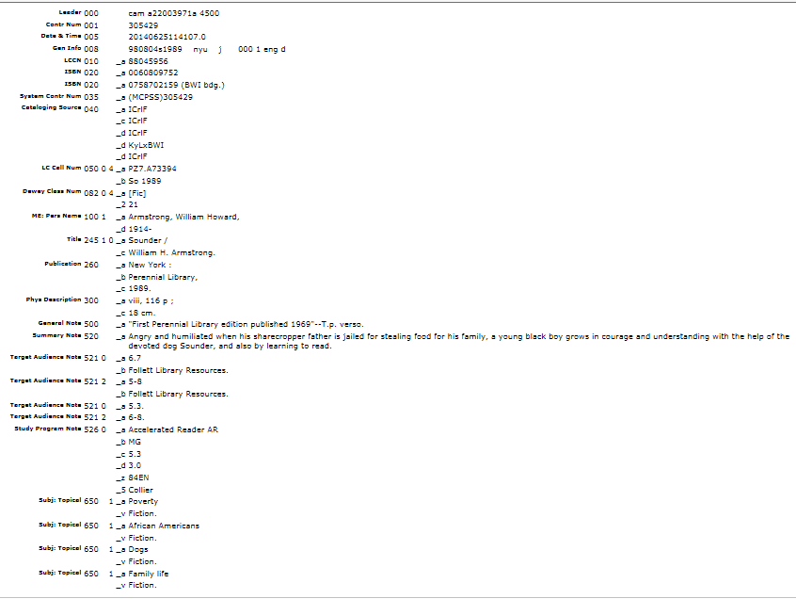

Back, Table of Contents

BRIEF MARC record

This is an example of an incomplete (BRIEF) MARC record. The physical description, publication information, summary, subject headings and Accelerated Reader data is all missing. In order for a patron to receive a hit for this book, the patron must type in Armstrong, William H. or Sounder. Since there are no subject headings or Accelerated Reader fields listed, this book will not show a hit if a patron uses any other search terms. The importance of a complete, full MARC record is apparent in this record, as a patron would not even receive this title using the search term “DOGS”.
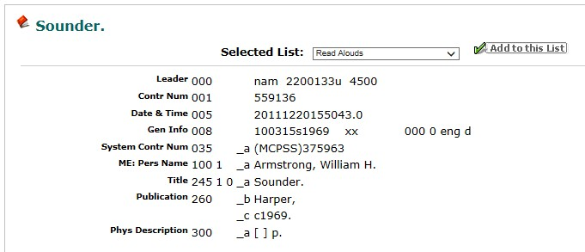

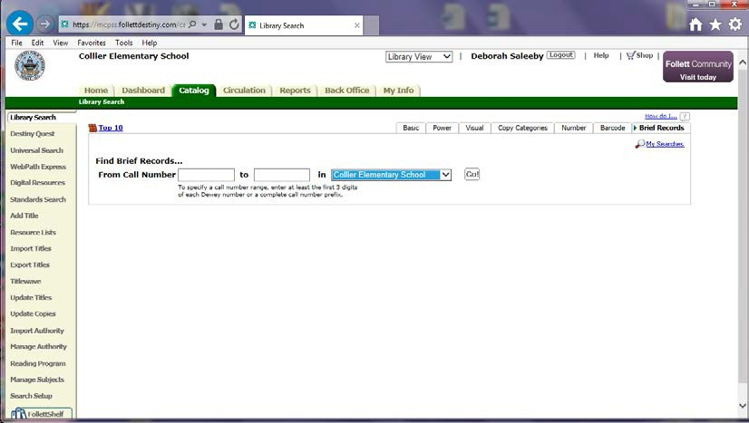
To determine whether you currently have BRIEF records in your collection, use the BRIEF record tab within the Destiny CATALOGING tab. Select the call number range and your school to perform your search.

Back, Table of Contents

ANATOMY OF A MARC RECORD
  - Each record has the same components: leader, record directory, control fields—fixed fields, and variable fields
  - Two character positions follow each tag (except for Fields 001 through 009). One or both of these character positions may be used for indicators.
  - In some fields, only the first or second positon is used, in some fields, both are used, and in some fields, like the 020 and 300 fields, neither is used.
  - When an indicator position is not used that indicator is referred to as “undefined” and the position in left blank. It is the convention to represent a blank, or undefined indicator position by the character “#”.

Indicators
    - Each indicator value is a number from 0 to 9
    - Although the MARC 21 rules say it can be a letter, letters are uncommon.
    - Even though two indicators together may look like a 2-digit number, they really are two single-digit numbers.

Subfields and delimiters
    - Subfield codes are one lowercase letter (occasionally a number) preceded by a delimiter.
    - A delimiter is a character used to separate subfields.
    - Each subfield code indicates what type of data follows it.

Tags – A 3-digit numeric code that identifies each field
Tags are divided by hundreds. The basic divisions of the MARC 21 bibliographic record are: OXX Control information, numbers, codes
1XX Main entry
2XX Titles, edition, imprint (in general, the title, statement of responsibility, edition, and publication information)
3XX Physical description, etc.
4XX Series statements (as in the book) 5XX Notes
6XX Subject added entries
7XX Added entries other than subject or series
8XX Series added entries (other authoritative forms) 9XX locally-defined data and uses*
*The Library of Congress uses this for local information. However, this is NOT a tag that should be utilized in a MCPSS MARC record.

Back, Table of Contents

ISBNs

  - ISBN evolved from the Standard Book Number (SBN). An SBN is converted to a 10-digit ISBN by adding a preceding “0”.
  - ISBN-10 consists of 9 digits plus one check digit
  - The barcodes that appear on the back of books are known as Bookland EAN barcodes
  - ISBNs now have 13-digits instead of 10 digits.

SUBJECT HEADINGS (650) – Don’t dream them up!
  - Verify a heading as being the latest terminology in the official list used by the library (SEARS)
  - Ensure that all necessary Subject Headings are included in the record so that patrons will get search results.
  - Subject heading consistency = good subject authority
  - All works on a subject will be found together—that depends upon the subject headings assigned through subject analysis
  - That all terms a user thinks of will match a heading or reference

Why do SUBJECT HEADINGS change?
- Headings are seen as outdated
- Headings are seen as politically incorrect
- Terms are no longer used in the connotation the heading portrays

ACCELERATED READER INFORMATION
Accelerated Reader information should be added in the Study Program Note field (526) as follows:
526a Accelerated Reader AR

526b | MG | (LG, MG, UG)
526c | 5.3 | (Quiz Number)
526d | 3.0 | (Level of Book)
526z | 8425 | (Quiz Number)

MCPSS Cataloging Specifications

  - The classification system used by MCPSS is the Dewey Decimal System.
  - Descriptive cataloging of print or non-print materials should use the Sears List of Subject Headings (current edition). The Library of Congress Subject Headings (current edition) may be used as a reference.
  - For classification of library materials (print or nonprint) see the Recommended Classifications for Library Materials list.

Back, Table of Contents

PROCESSING NEW MATERIALS AND EQUIPMENT

A well-organized collection is the first step toward providing an effective library media program. To ensure this, the Library Media Center should practice a uniform method of processing materials. All circulating materials and equipment should be barcoded and managed through Destiny, the online catalog system.

BOOKS

- Check new books against the purchase order and the company's invoice or packing slip.
- Indicate books received and note discrepancies on all PO copies. Sign and date appropriate (pink) copy and return to Accounts Payable (Central Office) If pink copy is not available, make a copy of the original, and mark "duplicate pink copy." Sign, date, and return the Accounts Payable. Keep yellow copy for your records.
- If there are discrepancies or a book is defective, contact the vendor.
- Stamp/label the book with your school's Library Media Center name and mailing address. Stamp/label the inside back and front covers and the title page.
Example:

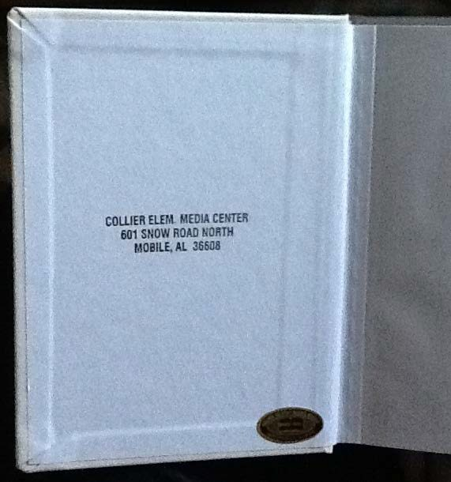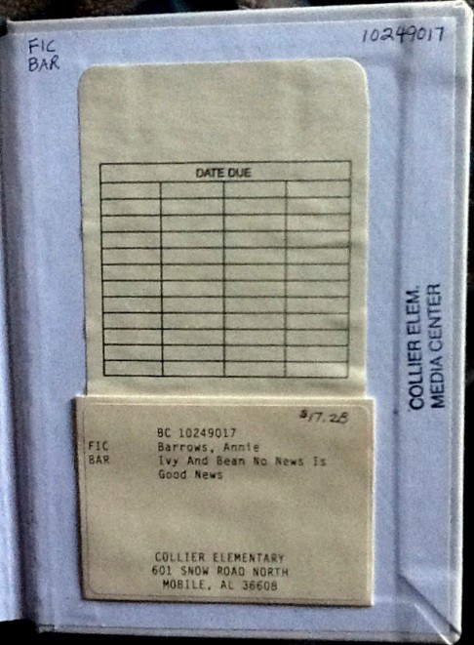
School stamp inside front cover
Barcode
Call Number
School Stamp inside back cover
Price

Inside Front Cover Inside Back Cover

Back, Table of Contents

- Record a barcode number on each book by writing it on the title page. Include this information in the gutter on the title page or page verso: date, vendor, funding source, cost, call number, and barcode number. Stamp the school name on the title page. As an alternative, an extra barcode may be placed on the title page.

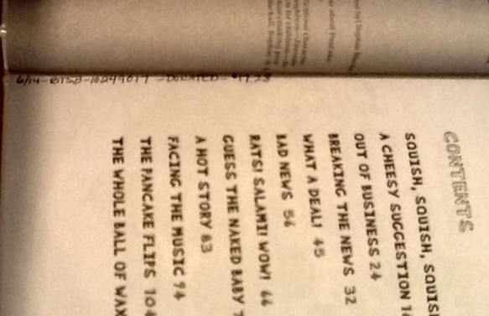Example: 6/14 – BTSB- Title 1 - $18.00 – E MAY – 2140556

Call Number Barcode Call Number Barcode
Additional Barcode
School Stamp

- Add the MARC records to Destiny. Vendor MARC Records:
Import the MARC records from the vendor into the MARC Wizard. Process the records through the MARC Wizard FIREWALL to do a cleanup before adding them to Destiny.

Items without MARC records (print or nonprint):

  - Select new titles in Destiny - CATALOG tab and ADD TITLE. (see following steps)
    - OR
  - Select new titles in MARC Wizard – Access MARC
    - OR
  - Select new titles from the Library of Congress online catalog. (Remember, information in the 900’s fields must be deleted before importing the records into Destiny.)

Back, Table of Contents

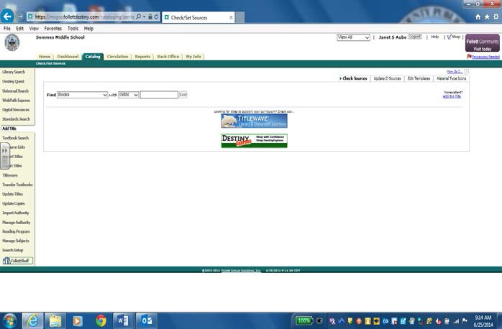
ADDING A TITLE IN DESTINY
The first step in adding a book to your collection starts with working inside the CATALOG TAB of
Destiny. Click on the
ADD TITLE TAB on
the left side of the screen. There are three drop down boxes. Fill in the drop down boxes according to what item you are cataloging.

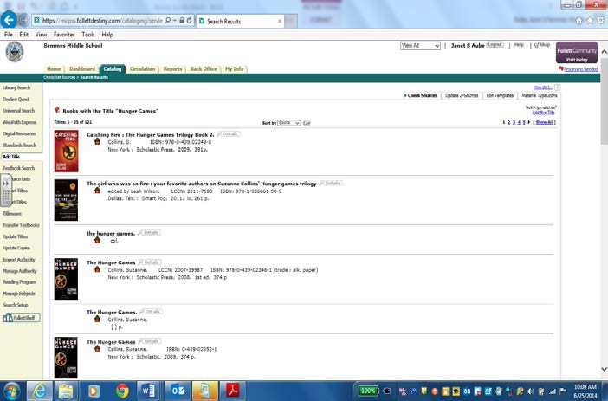
Select the record that matches the item you are cataloging. Look for a record with the RED SCHOOL
ICON . Open the record to see if the MARC record is a full record.

Back, Table of Contents

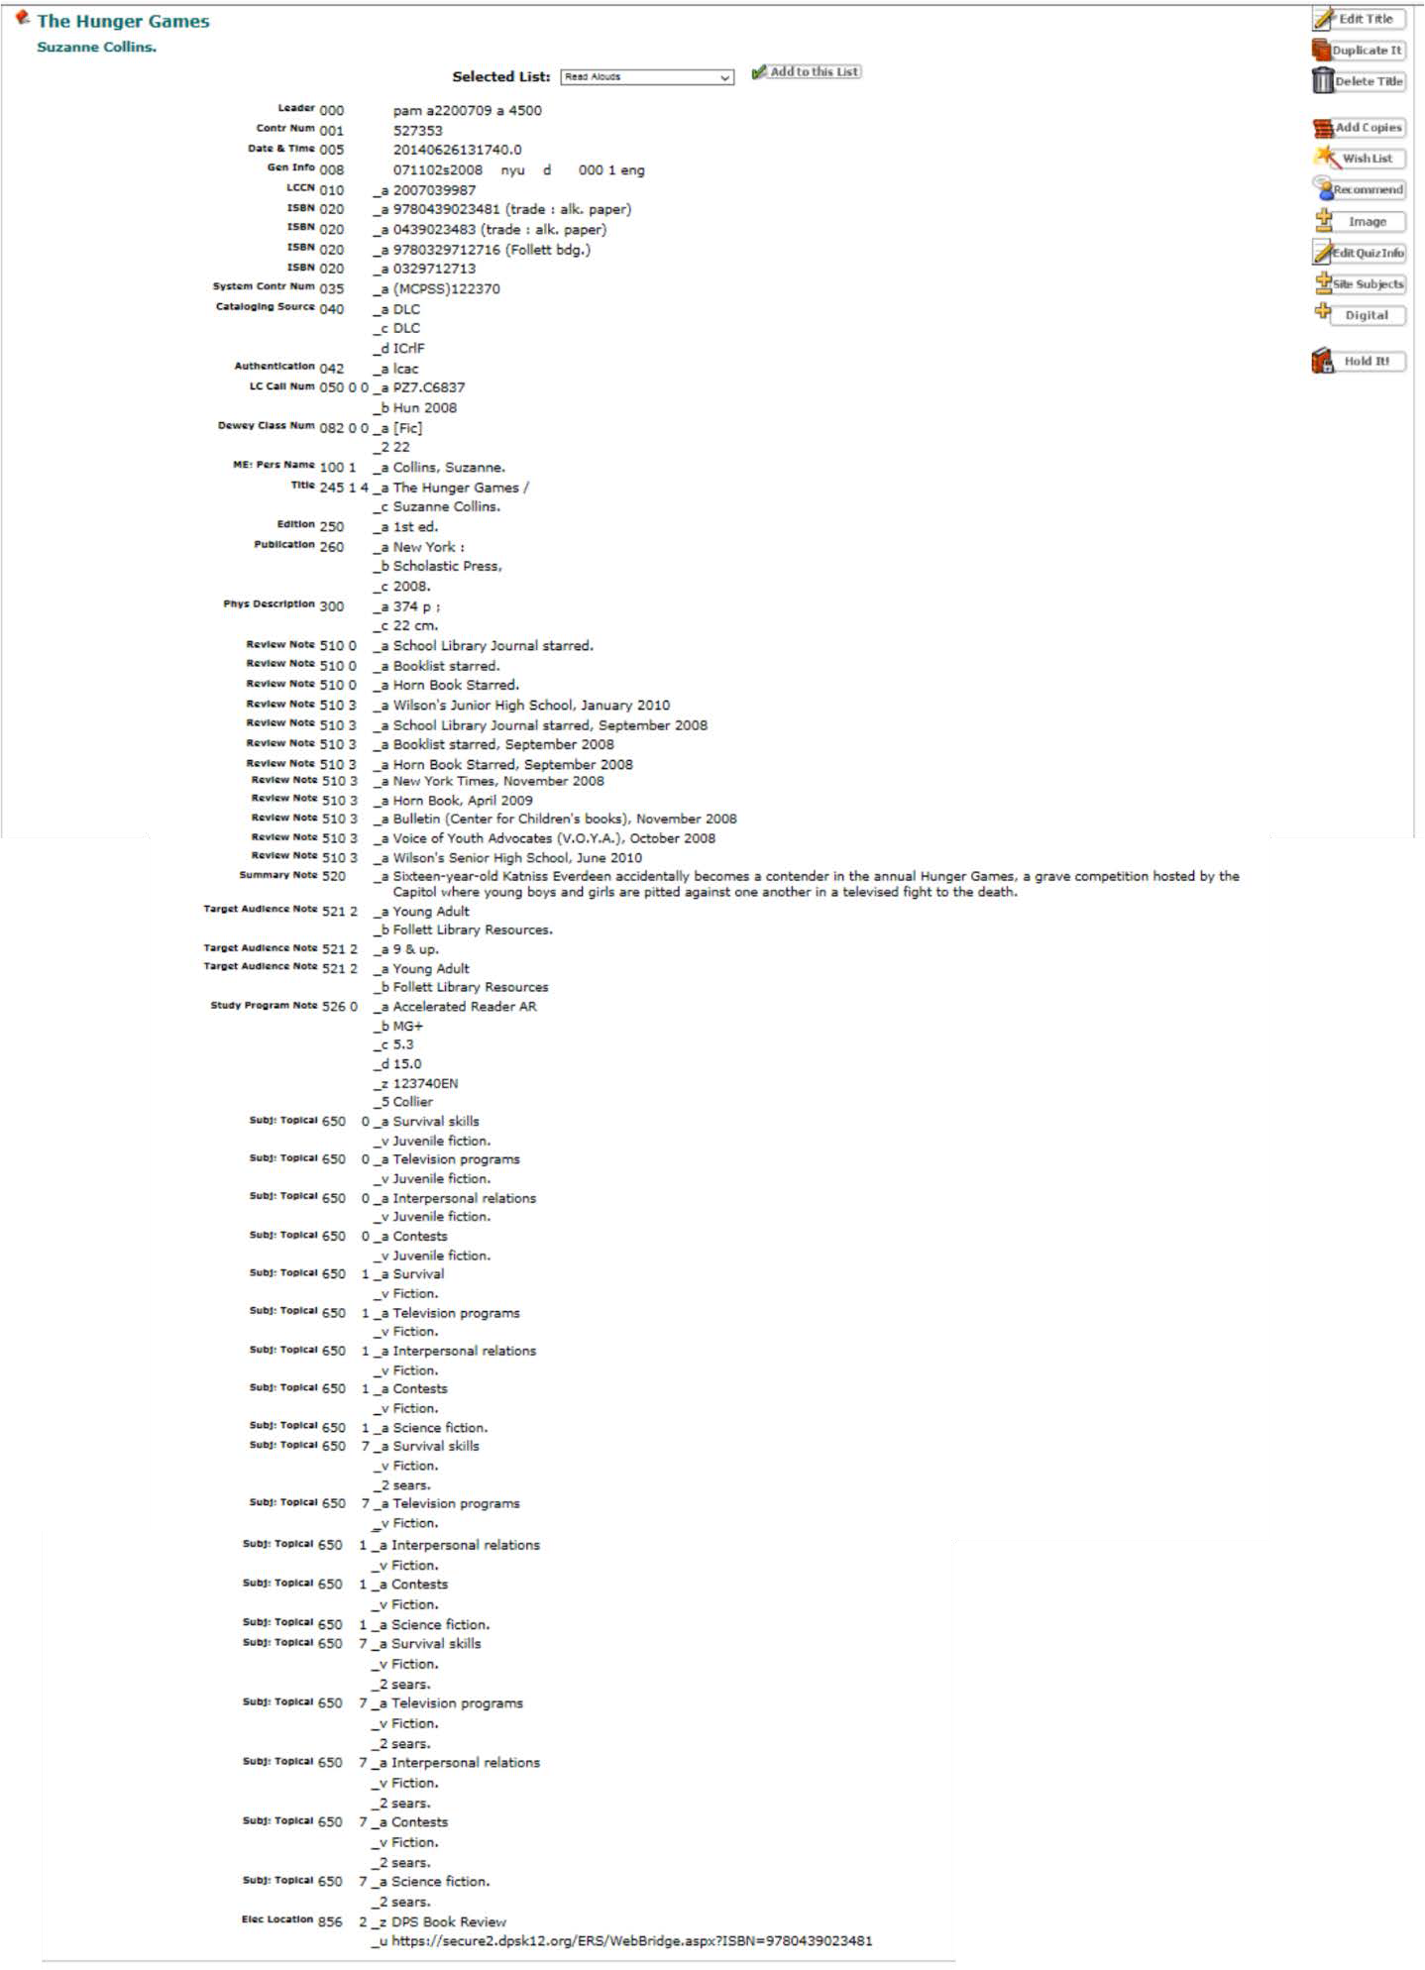

This is an example of full MARC record for this book.

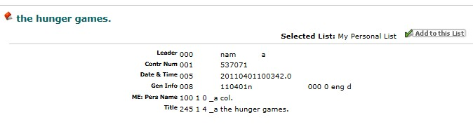
This is an example of a BRIEF
(incomplete) MARC
record.

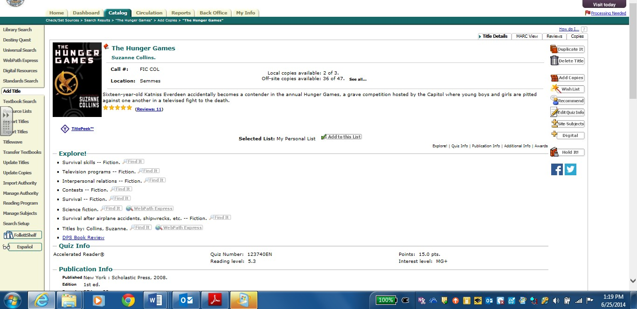
When you find the record that you want, select the ADD COPIES BUTTON.

Back, Table of Contents

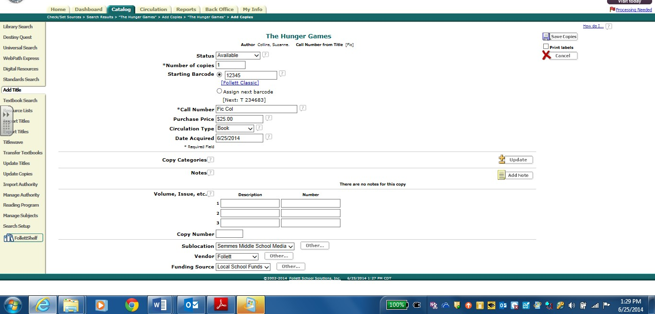
Fill in the text boxes that pertain to your item.
After you fill in the text boxes, save your record with SAVE COPIES.

PRINTING A BARCODE

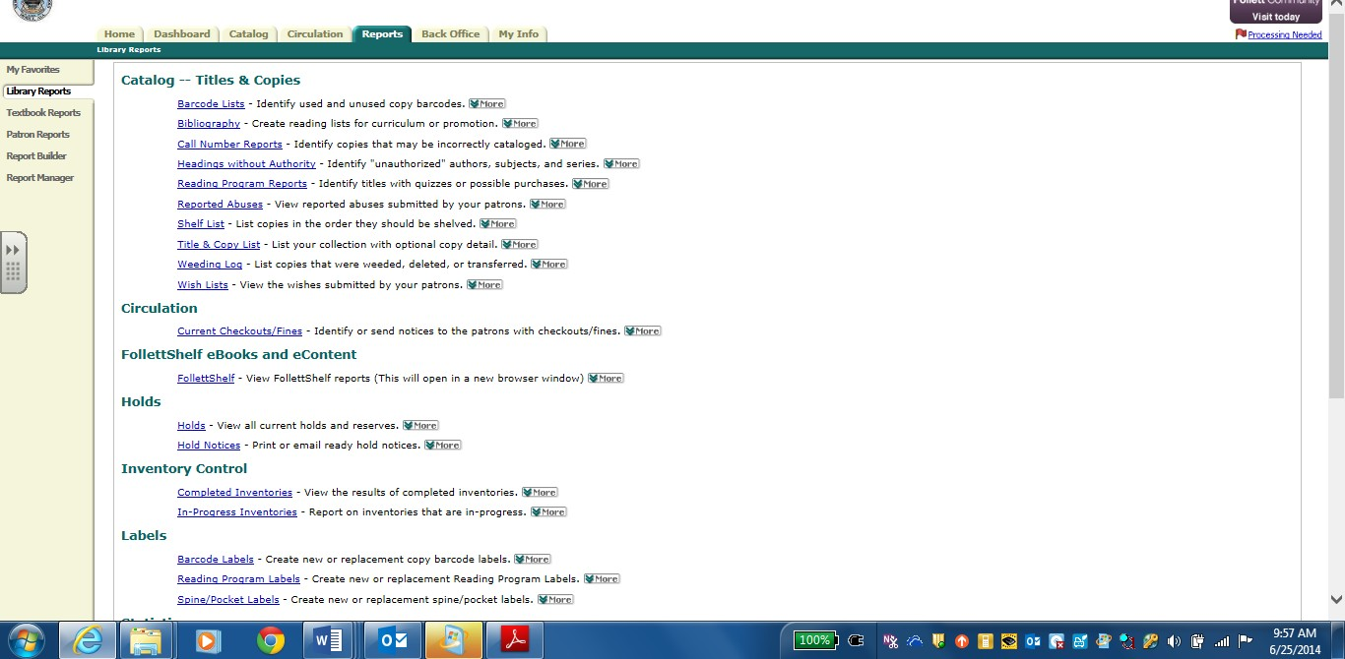
After the item has been entered into Destiny, a barcode will need to be produced. Click the REPORTS TAB at the top of the screen, then scroll down to LABELS and select BARCODE LABELS.

Back, Table of Contents

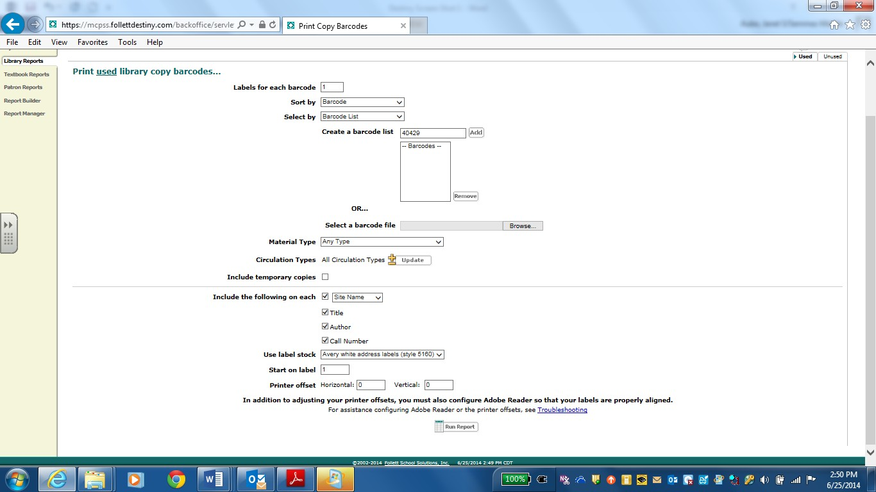.
2. Select barcode list and type the barcode number(s) assigned to the item(s), then ADD. The barcode number(s) will be added to the list.
3. Select the information to be printed on the barcodes.
4. Select the labels, position and printer offset.
5. Select RUN REPORT to produce the barcode report.
1. Select the USED barcode tab
as this barcode is now on a cataloged item in the collection.

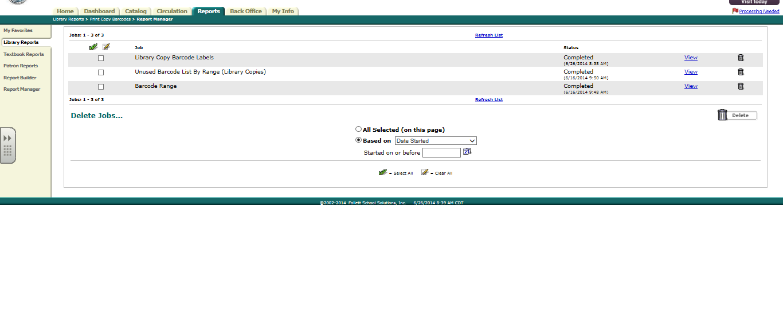
Click REFRESH LIST
and then VIEW for the barcode list just produced.
Back, Table of Contents

Hint….
Depending on your printer, you may have to adjust the horizontal or vertical settings. If this is your first time printing labels, use a plain piece of paper rather than labels. Change the horizontal and vertical settings if the labels are drifting down the page or are too far left or right. It may take several attempts to find the correct settings for the printer being used. When the labels are correctly centered, record the settings and print on the actual sheet of labels.

- Insert date due pocket or date due slips. (optional)

- Apply appropriate labels and stickers for reading programs such as AR.

Back, Table of Contents

CLASSIFICATION PROCEDURES FOR BOOKS

All books in the Library Media Center's collection should be classified according to the latest edition of the Dewey Decimal Classification and Relative Index. Use the latest edition of Sears List of Subject Headings for subject headings assigned to items in the media center. The following designations should be used in classifying books.

CATEGORY | 852 tag subfields | CALL NUMBER DESIGNATIONS
EASY | h i | E  3 letters (upper case) of author's last name
FICTION | h i | FIC  3 letters (upper case) of author's last name
STORY COLLECTION | h i | SC  3 letters (upper case) of author's last name
COLLECTIVE BIOGRAPHY | h i | 920  3 letters (upper case) of author's last name
INDIVIDUAL BIOGRAPHY | h i | 92  3 letters (upper case) of bio’s last name
NONFICTION (000-999) | h i | DEWEY #  3 letters (upper case) of author's last name
REFERENCE | k h i m | REF DEWEY #  3 letters (upper case) of author's last name Volume # or Year
PROFESSIONAL | k h i | PRO DEWEY #  3 letters (upper case) of author’s last name
PAPERBACKS PBK | k h i | DEWEY #  3 letters (upper case) of author’s last name
BIG BOOK BB | k h i | DEWEY #  3 letters (upper case) of author's last name

CLASSIFICATION PROCEDURES FOR NONBOOK MATERIALS
A unified approach of treating print and nonbook materials is recommended. Nonbook materials should be classified according to the Dewey Decimal Classification System. The following abbreviations should be used as call number prefixes in classifying nonbook materials.

AUDIOVISUAL

ASR | Audio Sound Recording (spoken word)
CAS | Cassettes
DVD | Digital Versatile Disc
EBK | e-Books
GAM | Games
KIT | Kit
MOD | Model
MCD | Music CDs
PIC | Picture
REA | Realia
PLA | Play-A-Ways
SLI | Slides and Microscope Slides
SWC | Software/Computer File
TOY | Toys, Puppets, etc.
TRA | Transparency
VCT | Video Tape Recording

Sample call number for a video tape recording: | VCT | Prefix
 | 510 | Main
 | SEV | Cutter 3 letters of author’s last name

SERIALS

PER | Periodicals, Magazines & Microfilms

Sample call number for a periodical: | PER | Prefix
Highlights for Children | HIG | Main 3 letters of title

CLASSIFICATION PROCEDURES FOR EQUIPMENT
If creating a MARC record for any equipment, use Destiny cataloging or an equipment template in MARC Magician. Library Media Center equipment should be housed in a central location and easy accessibility for checkout to all teachers and students.

EQUIPMENT
The following abbreviations should be used in the local holdings 852 tag as a Prefix.
AVC | Audiovisual Cart
CAL | Calculator
CAM | Camera
CAP | Cassette Player
CAR | Cassette Recorder
CDP | CD Player
CPU | Computer/Laptops
DCAM | Digital Camera
DOC | Document Camera
DVDP | Digital Versatile Disc Player
IWB | Interactive Whiteboard (i.e. Mimio)
LCDP | LCD Projector
LDP | Laser Disc Player
LSS | Listening Station
OHP | Overhead Projector
PDA | Personal Digital Assistant
PRI | Printer
PRS | Projection Screen
PWR | Portable Writers
SCAN | Scanner
SMB | Smart Board
SRS | Student Response System
TAB | Tablet (all handheld devices)
TEL | Television
TRI | Tripod
TVCR | TV/VCR Combo
VCAM | Video Camera (Camcorder)
VCR | Video Cassette Recorder
VTM | Video Title Maker
WSL | Wireless Slate
Sample call number for equipment: CPU
IBM

Circulation Type: Equipment (EQ)

Back, Table of Contents

WEEDING THE COLLECTION

To ensure balance, reliability and comprehensiveness, the development of a vibrant collection of resources must be carefully planned. An underlying principle of planned collection development is evaluation. In the same way both the materials and the existing collection are evaluated before selection takes place, evaluation of the materials and the existing collection must occur before materials are removed.

Good collection management requires the weeding and discarding of obsolete or worn materials. This process should be carried out in a continuous, systematic manner, so as to ensure that the collection remains current, relevant, inviting, and meets AdvancED standards.

By providing materials that are appropriate to the total school program, the Media Center will be a more integral part of the educational process. Systematic weeding is not an irresponsible disposal of school property; rather it is a needed service that will enhance the credibility and use of the school library.

- Weeding is an activity that is premised upon informed professional judgment and a carefully articulated plan.
- Weeding ensures that the school library collection contains only those resource materials that are accurate, current and relevant to the curricular and recreational programs of the school.
- Weeding facilitates access to quality resources.
- Weeding removes the outward illusion of a well-stocked resource collection.
- Weeding results in more effective utilization of available space and assures an aesthetically appealing collection of materials.

In general, consider for discard, for any or all of the following reasons, books that are:

- Unattractive in appearance because of yellowed paper, fine print, etc.
- In poor physical condition as to ragged binding, torn or dirty pages, etc.
- Seldom circulated
- With old copyright dates that make the books outmoded in content, use, or accuracy
- Mediocre or poor in quality
- Duplicated with several copies of titles no longer in heavy demand
- Of a subject matter or treatment not suitable for the clientele served by the library
- Sets of books (especially in the literature and history sections) that have gathered dust for years
- Replaced by new or revised editions
- Of passing interest at the time of publication, such as travel and biographies of persons who were known in their generation, but not likely to be of interest again

Back, Table of Contents

The MUSTIE system will serve as a guide in the weeding of library books.
Misleading: Factually inaccurate or out of date Ugly: Worn out beyond mending or rebinding Superseded: A new edition or better source available Trivial: No discernible literary or scientific merit
Irrelevant: No longer pertinent to the needs and interests of your school or students
Elsewhere: Easily borrowed or researched from another source

Books To Be Discarded – the process of withdrawing books:

  - Stamp or write "Withdrawn" or "Discard" over all spots where school name is stamped.
  - Remove anything that identifies school's ownership, including barcode labels.
  - Delete withdrawn COPY from the collection as shown below.

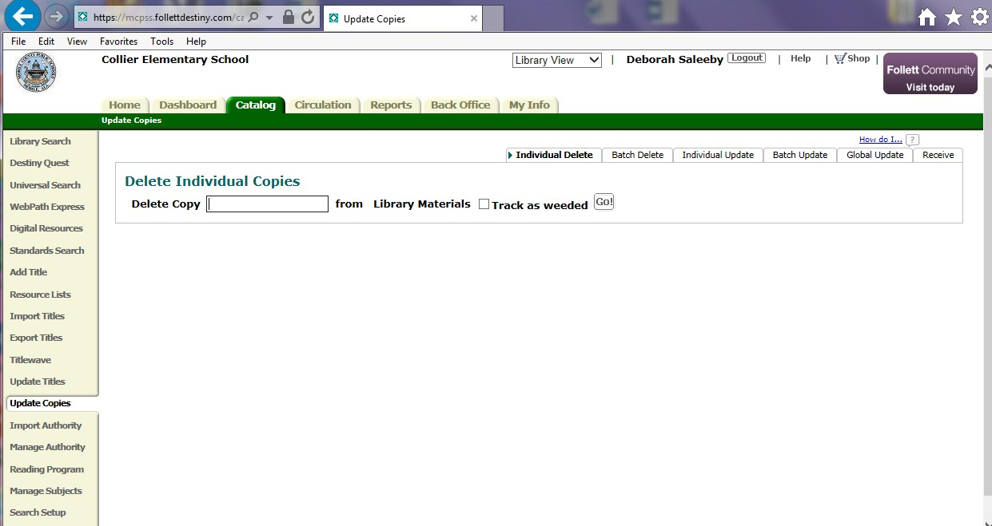
To delete the copy from the collection, go to the CATALOG tab, UPDATE COPIES, INDIVIDUAL
DELETE. Check the box TRACK as WEEDED and scan the barcode of the item(s) you are deleting.
The copy will be deleted and a printable list of the weeded items will be generated.

NOTE: DELETE COPY ONLY – NOT MARC RECORD!
Back, Table of Contents

CIRCULATION

Each Library Media Center in the Mobile County Public School System maintains its own circulation procedures dependent upon the grade level and specific needs of the school. Each Library Media Specialist will establish check-out procedures suitable for individual school situations. Self check-out is not recommended at any grade level to ensure accuracy of circulation statistics, privacy of student information, and prevent loss of materials. If self check-out is allowed, this must be done with careful monitoring by the media specialist, media aide, or another adult.

All Library Media Centers provide online access to the catalog of materials
in the Library Media Center through the Destiny library management program. For instructions and/or assistance in utilizing the Destiny library management program please refer to the Destiny web help located within the Destiny program.

Lost/Damaged Library Books

Students and teachers must pay for all damaged (beyond reasonable wear) or lost materials. Fines for lost books will be $20 per book or the replacement fee. Fines for replacement of labels will be $3 per book. Damage fines will vary depending upon whether or not the book can be repaired and what the repair involves. Students may be required to pay a replacement cost if the book is damaged beyond repair. Fines charged for overdue books will be determined by the local school Media Specialist and principal. Check-out privileges will be suspended when a patron has overdue materials or lost/damaged fines at any school in the Mobile County Public School System. At the principal’s discretion, end-of- year report cards may be held in the school office for parent pick up pending payment of fines.

Monies Collected

All monies collected for damaged or lost materials should be placed in a separate library fund or account by the school’s bookkeeper and designated for library purposes.

Monies collected at one school for lost/damaged book fines that originated at another school, will be sent to the originating school for deposit and receipting. The Library Media Specialist at the originating school will notify the Destiny administrator so that the student’s record can be cleared.

Books returned to one school but belonging to another school, can be returned to the originating school through the school mailbag.

Back, Table of Contents

3.50

COMPUTER, INTERNET AND ELECTRONIC COMMUNICATION ACCEPTABLE USE

MCPSS relies on its computer network to conduct its business. To ensure that MCPSS Computer Resources are used properly by its employees, students, independent contractors, agents, vendors and other computer Users (the “Users”), the Board of School Commissioners for MCPSS has created and passed has created this Computer Use Policy (the ”Policy”). The rules and obligations described in this Policy apply to all Users (the “Users”) of MCPSS’ computer network or Computer Resources, wherever they may be located.

MCPSS’ policies against discrimination and harassment (sexual or otherwise) apply fully to MCPSS’ Computer Resources and Resources, and any violation of those policies is grounds for discipline up to and including termination. Students who violate these policies are subject to disciplinary action consistent with Board policy and the Student Handbook. Vendors, consultants and other third parties must adhere to these policies and are subject to losing their right to access MCPSS Computer Resources for violations of these policies.

The term Computer Resources as used herein refers to MCPSS’ entire computer, electronic and communications network. Specifically, the term Computer Resources includes, but is not limited to: computers, host computers, file servers, application servers, communication servers, mail servers, fax servers, Web servers, workstations, stand-alone computers, laptops, tablets such as IPAD’s, telephones, facsimile machines, scanners, software, data files, peripherals such as printers, and all internal and external computer and communications networks (for example, Internet, commercial online services, value-added networks, e-mail systems) that may be accessed directly or indirectly (including access by Students, vendors, consultants and other third parties using personally owned computer hardware as authorized by MCPSS) from our computer network or that are owned or have been purchased by MCPSS.

The Computer Resources are the property of MCPSS and may be used for only legitimate business and educational purposes. Users are permitted access to the Computer Resources to assist them in performance of their jobs. Computer and internet access is provided for MCPSS business use, but occasional minimal personal use is allowed. Use of the Computer Resources is a privilege that may be revoked at any time. Users who violate this Policy may have their Computer/Internet use privileges revoked at any time and without prior notice AND are subject to discipline up to and including the possibility of termination.

Back, Table of Contents

In using or accessing the Computer Resources, users must comply with and be aware of the following provisions:

- No Expectation of Privacy
The computers and computer accounts given to users are to assist them in the performance of their jobs or in the case of students, in their educational studies and activities. Users should not have an expectation of privacy in anything they create, store, send or receive on the computer resources. Computer resources belong to MCPSS and may be used only for the purposes set forth herein. MCPSS has the right, but not the duty, for any reason and without the permission of any user, to monitor any and all of the aspects of its computer resources, including, without limitation, reviewing documents created and stored on its computer resources, deleting any matter stored in its system, monitoring sites visited by users on the Internet, monitoring chat and news groups, reviewing material downloaded or uploaded by users from the Internet, and reviewing E-Mail sent and received by users. Employees and users should not have an expectation of privacy in anything they create, store, send or receive using the Computer Resources.

Waiver of privacy rights
MCPSS reserves the right to inspect the contents of all electronic data stored on MCPSS computer equipment or Computer Resources. Users, in using MCPSS Computer Resources, expressly waive any right of privacy in anything they create, store, send or receive on MCPSS Computer Resources or through the Internet or any other computer network. Users consent to allowing personnel of MCPSS to access and review all materials Users create, store, send or receive on the computer or through the Internet or any other computer network. Users understand that MCPSS may use human or automated means to monitor use of its Computer Resources, including data stored on the local drive, data stored on any network drive, and electronic mail.

Passwords
Users are responsible for safeguarding their passwords for access to the Computer Resources or Computer Resources. Individual passwords should not be printed, stored online or given to others. Users are responsible for all transactions made and actions taken using their passwords. No User may access the Computer Resources with another User’s password or account. Use of passwords to gain access to the Computer Resources or to encode particular files or messages does not imply that Users have an expectation of privacy in the material they create or receive on the Computer Resources.

Viruses and Virus Protection
Users may not disable or remove virus protection software. Viruses can cause substantial damage to Computer Resources. Each User is responsible for taking reasonable precautions to ensure he or she does not introduce viruses into MCPSS’ Computer Resources or computer network. Virus software updates are automatically distributed regularly to Computer Resources. Users may not interrupt the update process and must report any errors in the update

process immediately to MCPSS’ support help desk. PCs not attached to the LAN must be updated by the User. The Information Technology Department will provide virus updates.

Compliance with applicable laws and licenses
In their use of Computer Resources, users must comply with all software licenses, copyrights and all other state, federal and international laws governing intellectual property and online activities. It is MCPSS’ policy to comply fully with all software copyright licenses. Employees who willfully circumvent this policy will be subject to disciplinary action up to and including termination of employment. In compliance with the Children’s Internet Protection Act, each year, all District students will receive internet safety training which will educate students about appropriate online behavior, including interacting with other individuals on social networking sites and in chat rooms, and cyberbullying awareness and response.

Prohibited Activities

The following activities, items or materials are prohibited:

Inappropriate or unlawful material
- Material that is fraudulent, harassing, embarrassing, sexually explicit, profane, obscene, intimidating, defamatory or otherwise unlawful or inappropriate may not be sent by e-mail or other form of electronic communication (such as bulletin board systems, newsgroups, chat groups), downloaded from the Internet or displayed on or stored in MCPSS computers. This includes e-mails known as "Spam" and e-mails containing non business related matter. Users encountering or receiving this kind of material should immediately report the incident to their supervisors.
- Without prior written permission from the Executive Manager of Information Technology. Computer Resources may not be used for dissemination or storage of commercial or personal advertisements, solicitations, promotions, destructive programs (that is, viruses or self-replicating code), political material or any other unauthorized use, including material or significant personal uses.
- Using or copying software in violation of a license agreement or copyright. Violating any state, federal or international law.

Waste of Computer Resources
Users may not deliberately perform acts that waste Computer Resources or unfairly monopolize resources to the exclusion of others. These acts include, but are not limited to, sending mass mailings or chain letters, spending excessive amounts of time on the Internet playing games, engaging in online chat groups, printing multiple copies of documents or otherwise creating unnecessary network traffic.

Accessing other User’s files
Users may not alter or copy a file belonging to another User without first obtaining permission from the owner of the file. The ability to read, alter or copy a file belonging to another User does not imply permission to read, alter or copy that file. Users may not use the Computer Resources to “snoop” or pry into the affairs of other Users by unnecessarily reviewing their files and e-mail. Excepted from this provision are those persons conducting investigations or

administrative duties at the request and with the authorization of the Executive Manager of Information Technology or Executive Manager of Human Resources.

Misuse of software
Without prior written authorization from the Executive Manager of the Information Technology Department, Users may not do any of the following:

- Copy software for use on their home computers;
- provide copies of software to any independent contractors or third party;
- install software on any MCPSS workstations or servers;
- download any software from the Internet or any other online service to any MCPSS workstations or servers;
- modify, revise, transform, recast or adapt any software or reverse-engineer, disassemble or decompile any software. Users who become aware of any misuse of software or violation of copyright law should immediately report the incident to their supervisors; and
- Users who have currently copied software for home computers, distributed software or installed software on corporate computers are required to obtain approval according to the current guidelines or remove the software immediately.

If you become aware of someone using Computer Resources for any of these activities, you are obligated to report the incident immediately to your supervisor. Violations of any aspect of this policy will be taken seriously and may result in disciplinary action, including possible termination, and civil and criminal liability.

E-Mail Policy

To maximize the benefits of its Computer Resources and minimize potential liability, MCPSS has created this E-mail usage policy. All computer Users are obligated to use these resources responsibly, professionally, ethically and lawfully.

Employees and other Users are given access to our computer network to assist them in performing their duties. Employees and Users, including students, should not have an expectation of privacy in anything you create, store, send or receive on the Computer Resources. The Computer Resources belongs to MCPSS and may only be used for business purposes. Without prior notice, MCPSS may review any material created, stored, sent or received on its network or through the Internet or any other computer network.

Sending unsolicited e-mail (spamming)
Without the express permission of their supervisors, employees may not send unsolicited e- mail to persons with whom they do not have a prior relationship.

Altering attribution information
Employees must not alter the “From:” line or other attribution-of-origin information in e-mail, messages or postings. Anonymous or pseudonymous electronic communications are forbidden.

Employees must identify themselves honestly and accurately when participating in chat groups, making postings to newsgroups, sending e-mail or otherwise communicating online.

Attorney-client communications
E-mail sent to in-house counsel, if any, or an attorney representing MCPSS should include this warning header on each page: “ATTORNEY-CLIENT PRIVILEGED; DO NOT FORWARD WITHOUT PERMISSION.” Communications from attorneys may not be forwarded without the sender’s express permission.

Confidential Transmissions
Any confidential e-mail, and/or files transmitted with it, is intended solely for the use of the individual or entity to whom it is addressed. The communication may contain material that is privileged, confidential and exempt from disclosure under applicable law. If you are not the intended recipient or the person responsible for delivering the e-mail to the intended recipient, be advised that any dissemination, distribution or copying of this communication is strictly prohibited. If you have received an e-mail or communication in error, please notify the sender immediately.

Internet Use Policy

The Internet can be a valuable source of information and research. In addition, e-mail can provide excellent means of communicating with other employees, our customers and clients, outside vendors and other businesses. Use of the Internet, however, must be tempered with common sense and good judgment. Users who abuse their use of Computer Resources to access the Internet will may have access to the Internet restricted or removed. In addition, Users who violate this policy may be subject to disciplinary action, including the possibility of termination, student discipline (as applicable) and civil and criminal liability.

Your use of the Internet is governed by this policy:

Disclaimer of liability for use on Internet
MCPSS is not responsible for material viewed or downloaded by Users from the Internet. The Internet is a worldwide network of computers that contains millions of pages of information. Users are cautioned that many of these pages include offensive, sexually explicit and inappropriate material. In general, it is difficult to avoid at least some contact with this material while using the Internet. Even innocuous search requests may lead to sites with highly offensive content. In addition, having an e-mail address on the Internet may lead to receipt of unsolicited e-mail containing offensive content. Users accessing the Internet do so at their own risk.

Employees’ duty of care
Employees should endeavor to make each electronic communication truthful and accurate. You should use the same care in drafting e-mail / electronic documents as you would for any other written communication. Please keep in mind that anything created or stored on the Computer Resources may, and likely will, be reviewed by others.

Back, Table of Contents

Duty not to waste Computer Resources
Because audio, video and picture files require significant storage space, files of this sort may not be downloaded unless they are business-related.

No privacy in communications
Users of MCPSS Computer Resources should never consider electronic communications to be either private or secure. E-mail may be stored indefinitely on any number of computers, including that of the recipient. Copies of your messages may be forwarded to others either electronically or on paper. In addition, e-mail sent to nonexistent or incorrect usernames may be delivered to persons whom you never intended.

Monitoring of computer usage
MCPSS has the right, but not the duty, to monitor any and all aspects of its Computer Resources, including, but not limited to, monitoring sites visited by Users on the Internet, monitoring chat groups and newsgroups, reviewing material downloaded or uploaded by Users to the Internet and reviewing e-mail sent and received by Users.

Blocking of inappropriate content
MCPSS may use software to identify inappropriate or sexually explicit Internet sites. Such sites may be blocked from access by MCPSS networks. In the event you, nonetheless, encounter inappropriate or sexually explicit material while browsing on the Internet, immediately disconnect from the site, regardless of whether the site was subject to MCPSS blocking software.

Games and entertainment software
Users may not use MCPSS’ Internet connection to play games, download games or other entertainment software including screen savers. Educational games approved by the teacher and or administration of the MCPSS are exempt from this provision.

Illegal copying
Users may not illegally copy material protected under copyright law or make that material available to others for copying. You are responsible for complying with copyright law and applicable licenses that may apply to software, files, graphics, documents, messages and other material you wish to download or copy.

Accessing the Internet
To ensure security and avoid the spread of viruses, employees accessing the Internet through a computer attached to MCPSS’ network must do so through an approved Internet firewall. Accessing the Internet directly, by modem, is strictly prohibited.

Prohibited Activities
The prohibited activities referenced above are also prohibited in connection with Users of MCPSS’ Computer Resources use of the internet. Users must avoid internet websites and locations that are harassing, embarrassing, sexually explicit, profane, obscene, intimidating, defamatory or otherwise unlawful or inappropriate while using MCPSS Computer Resources.

Students

The board supports access by students to rich information resources and the development by staff of appropriate skills to analyze and evaluate such resources.

All such materials shall be consistent with board-system guidelines and staff will provide guidance and instruction to students in the appropriate use of such resources.

Annually, students and parents will be given MCPSS’ guidelines and rules governing procedures for acceptable use of the Internet describing the information available and prohibited uses of system computers. Students and parents must sign a written statement acknowledging the guidelines in order for the student to access the Internet at school.

In compliance with the Children’s Internet Protection Act, each year, all District students will receive internet safety training which will educate students about appropriate online behavior, including interacting with other individuals on social networking sites and in chat rooms, and cyberbullying awareness and response. In compliance with federal law, the online activities of minors will be monitored.

Employees

Employees will be provided a copy of the MCPSS acceptable use guidelines and sign a statement that they agree to the terms.

See also Board Policy 6.12
References – Procedures: Computer, Internet and Electronic Communication Acceptable Use Date Adopted: December 11, 2007
Public Hearings: March 19, 2013, March 25, 2013Amended: March 23, 2011, March 25, 2013

Back, Table of Contents

OPEN ACCESS TO THE LIBRARY
►FLEXIBLE SCHEDULING◄

"In a student-centered school library media program, learning needs take precedence over class schedules ...student categorizations, and other logistical concerns. Flexible, equitable, and far-reaching access to the library media program is essential to the development of a vibrant, active learning community…." (Information Power: Building Partnerships for Learning, Edition, 1998)

Understanding the Library Media Specialist’s Role in Core Curriculum
The Library Media Specialist is not a core subject teacher, i.e. Reading, Math, Science, and should not be used as one. For example, reading goes beyond decoding and comprehension to interpretation and development of new understandings. While the Library Media Specialists are not trained to deliver reading instruction, they play an integral role in a school reading program.

The Library Media Specialist’s role in the reading program is that of managing and organizing the resources of the Library Media Center, while the teacher’s role is that of reading skills instruction. The Library Media Specialist’s extensive knowledge of the Library Media Center collection and expertise at matching books to readers provides a crucial supportive role in the total reading program.

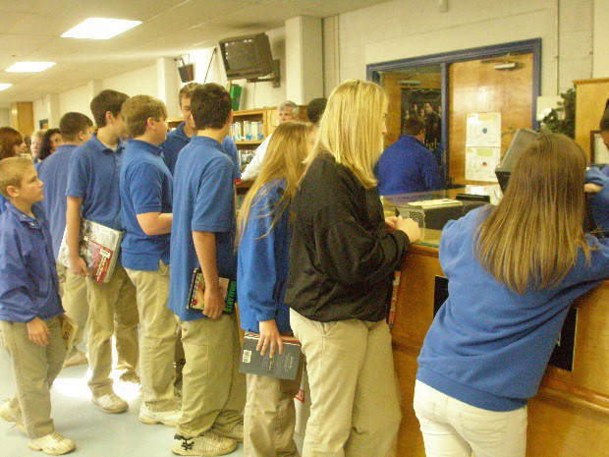This example could be applied to any core curricular subject. The American Association of School Librarians published a Position Statement on the role of the school Library Media Specialist in reading development.

Back, Table of Contents

Position Statement on Resource-Based Instruction: Role of the School Library Media Specialist
In Reading Development
Reading development is a process for attaining literacy by integrating oral and written language experiences into the literature and content areas. Spoken language, reading and writing are learned simultaneously. As students read "real books" and write to communicate, learning becomes relevant, interesting, and motivational and prepares students for life-long learning. Acquisition, organization, and dissemination of resources to support the reading program through the library media center is cost effective for the entire school district.

The following elements are integral to an effective reading program:

    - The Library Media Center is flexibly scheduled so that students and teachers have unlimited physical and intellectual access to a wide range of materials. Students are not limited to using only commercially prescribed or teacher-selected materials.

Students choose from a varied, non-graded collection of materials which reflect their personal interests.

    - Students learn to identify, analyze, and synthesize information by using a variety of materials in a variety of formats.
    - Multi-disciplinary approaches to teaching and learning are encouraged.
    - Teachers and Library Media Specialists cooperatively select materials and collaboratively plan activities that offer students an integrated approach to learning.
    - Teachers and Library Media Specialists share responsibility for reading and information literacy instruction. They plan and teach collaboratively based
on the needs of the student.
    - Continual staff development is critical to reading instruction. The responsibility for successful implementation of reading development is
shared by the entire school community—teachers, Library Media Specialists, and administrators working together. (adopted June 1993; revised July 1999)

The integrated library media program philosophy requires that an open schedule must be maintained. Classes cannot be scheduled in the Library Media Center to provide teacher release or preparation time. Students and teachers must be able to come to the center throughout the day to use information sources, to read for pleasure, and to meet and work with other students and teachers. The Library Media Center should be considered a learning resource that extends classroom learning, not a substitute classroom where students are placed for a designated period of time without the classroom teacher present as a collaborator. (State Handbook p. 30) (AASL)

Back, Table of Contents

Promoting Flexible, Open Access Guidelines for Library Media Center Scheduling
In order for the Library Media Center to be the core of the educational setting, the Library Media Specialist, with the assistance of the administrator, must be allowed to schedule the Library Media Center for its most effective use. Weekly schedules that list whole-class and small group instruction, administrative periods, special programs, planning times, and other planned library activities are collected for documentation of library use through the year.

Points to Remember:

- The Library Media Specialist, with the assistance of the administration, sets the schedule. The schedule is posted and available at all times.
- The Library Media Center should not be closed for non-library purposes. The Library Media Center is open for student use at all times.

Time should be allocated daily for the Library Media Specialist to spend in the Library Media Center administering the Library Media Program. During this time, no classes are scheduled for instruction by the Library Media Specialist, although students and teachers may still use the Library Media Center.
- The Library Media Specialist is provided a scheduled lunch time.
- Teachers and administrators should understand the difference in flexible scheduling, open access, and fixed scheduling.

Definition of Flexible Scheduling
The Library Media Center does not have a set daily or weekly schedule for classes to use the library. Classes are scheduled as the result of collaborative planning for use and instruction to integrate with the classroom curriculum. In this case the Library Media Center is an extension of the classroom; used to provide access to resources, information fluency, and independent and group learning.

Points to Remember:

  - All students and teachers have access at their point of need
- Teachers and Library Media Specialists can collaborate to develop enhanced curriculum units
- Student achievement is higher with this type of scheduling
- Flexible scheduling provides equity of access
- The Library Media Specialist can work with all grade levels and subject area teachers to build research units around school wide themes

Back, Table of Contents

Definition of Open Access
In order to maximize the benefit of the Library Media Center, learners must have access to resources and services at their point of need. The Library Media Center may also be scheduled for individuals, groups, or classes to use resources, check out and return materials, to read for pleasure or information, or research topics for reports, using a variety of resources.

Variations of Flexible Scheduling

These are SAMPLES only and not meant to serve as requirements Of each type of scheduling.

Completely flexible
- The Library Media Specialist provides a scheduling calendar with time for teachers to schedule their classes. A collaboration log should be used to ensure that every teacher is scheduling regular library media time. (Time should be allocated daily for the Library Media Specialist to spend in the Library Media Center administering the Library Media Program. During this time, no classes are scheduled for instruction by the Library Media Specialist, although students and teachers may still use the Library Media Center.)

Partially flexible
- This scenario is seen in lower elementary schools where Grades K-1 are scheduled at regular times to have contact with the Library Media Specialist for exposure to read aloud stories. If this type of scheduling is used, classes are normally concentrated into one or two days a week and are held at the beginning or end of the day, thus, allowing large blocks of time for other classes to schedule as units are developed. Priority should not be given to one grade level over another. Equal access to collaborative instruction by the Library Media Specialist should be available for all grade levels.

For additional information on flexible scheduling: Position statement adopted by the American Association of School Librarians (AASL), a division of the American Library Association.

Back, Table of Contents

Suggestions for the Collaboration Process
Collaboration with the learning community is an essential element that enhances student
achievement and the school curriculum. The following information is given to assist the Library Media Specialist in collaborating with grade level and subject area teachers to create a quality learning environment.

Facts to Remember:

- Planning is the first step in collaboration between the teacher(s) and the Library Media Specialist. Together they agree on the objectives to be addressed, the process for teaching the unit, what products, if any, that will be created, what assessment will be used for evaluation, the timeline for the unit of study, and how the teaching responsibilities will be divided.
- Collaboration is based on shared goals and visions, and an atmosphere of trust and respect. Educators have different strengths and viewpoints that contribute to the teaching process.
- The Library Media Specialist has knowledge of information and technology skills and the methods needed to integrate them into the unit of study. The Library Media Specialist also has the knowledge for teaching these skills and an understanding of the research process.
- The teacher has an understanding of the strengths, weaknesses, attitudes, and interests of the students, and of the curriculum content to be taught.
- Each educator has his/her area of expertise.
- Each educator has equal input and contributions to the planning process which involves a shared responsibility for implementation and evaluation.
- Communication between the Library Media Specialist and the teacher is essential to success.
- Curriculum mapping is important so that the Library Media Specialist has knowledge of the curriculum content being taught in the classrooms.
- A planning template is essential to the success of the unit of study.
- The time to plan for collaboration is sometimes difficult to find. Educators have to be creative. Collaborative lessons may occur within the library and continue in the classroom setting.
- At the end of the collaborative unit of study, there is reflection for revision by collaborative partners.

Back, Table of Contents

BUDGETING PROCEDURES

- Obtain the total amount allotted for Library Enhancement from the Principal.
- Survey the faculty to determine items of need.
- Set a date to meet with the Library Advisory Committee. Recommended purchases will be discussed at this meeting. Keep minutes of all committee meetings.
- Compile the Library Media Center budget and present it to the local school Budget Committee for final approval.
- Finalized budgets are recorded in the ECIP (Electronic Continuous Improvement Plan).
- Budget should be kept on file for three years.

Budgeting and Funding

- The school Library Media Specialist collaborates with the local school district/system and administrators to ensure that funds are budgeted to maintain the library media program.
- The library media program must have adequate, consistent, and sustained funding for professional staff, new materials, technologies, professional development, and facilities to meet the 21st Century learning needs of the students in the school community.
- The budget process of the Library Media Center includes operating funds for new resources such as: books, reference materials, equipment, and emerging technologies.
- The budget supports the philosophy of the Library Media Center and the community it serves.
- The Library Media Specialist must maintain accurate budget records in order to monitor and document use of available funds. These records should be retained for three years.
- Data collected from the assessment of the Media Center’s collection, school curriculum/instructional changes as well as the increased cost of materials should be used in planning the budget for the year.
- The Library Media Specialist must be proactive in obtaining adequate funds to meet the curriculum, the physical facilities, and the information needs of the school community.
- The Library Media Specialist should prepare annual reports documenting how each source of funding for the Library Media Center was spent. These documents should be retained for a minimum of three years.
- The Library Media Specialist must administer the Library Media Center’s budget and monitor acquisitions in order to meet all the instructional and informational needs of the school’s learning community.
- State, national and regional learning and accreditation standards should be considered in the acquisition and budgeting process of the library media program. The Alabama Code must be followed in the expenditure of state funds.
- Budgeting procedures for library enhancement funds, as stated by the Alabama Department of Education, must be followed. These procedures can be found on the ALMO Web page.

Back, Table of Contents

LOCAL SCHOOL
LIBRARY MEDIA ADVISORY COMMITTEE
A Library Media Advisory Committee is an essential component of the Library Media Center Program. This committee should be formed and used as an advisory committee in all aspects of the Library Media Program. The committee is headed by the Library Media Specialist and is comprised of the following members:

  - Administrative Representative
  - Library Media Specialist
  - Department/Grade Representative
  - Student
  - Parent
  - Community Member

Back to Page 10

Back, Table of Contents

STAFFING/JOB DESCRIPTIONS/RESPONSIBILITIES
The Alabama Department of Education provides funding for school Library Media Specialists based on earned units. Local school districts are required to place library media units where they are earned. Therefore, these units funded through state library allocation must be assigned to the school’s Library Media Center and may not be used elsewhere in the school.

Each local school district designates a person responsible for library media programs to serve as a liaison for the Alabama Department of Education and the local district.

DISTRICT LIBRARY MEDIA SUPERVISOR

Position Statement – SCHOOL LIBRARY MEDIA SUPERVISOR
Today's schools demand the presence of quality library media programs in order to meet the needs of students in gaining the competencies needed to manage the vast amount of knowledge in our rapidly changing, technologically oriented world. Superior instruction requires the use of multiple instructional resources in the educational process. To satisfy these needs, the quality school library media program is led by a Library Media Supervisor and staffed by qualified library media professionals and competent library media support personnel. The responsibilities of a supervisor encompass many areas but can be classified as those of administrator, communicator, teacher, facilitator and leader.

ADMINISTRATOR: The Library Media Supervisor directs and administers the library media program based on a plan of action that is based on the district's mission statement, goals, and objectives. The supervisor is responsible for evaluating and making recommendations for the improvement of the library media program, developing and administering the budget, and administering district policies and procedures. Additional responsibilities include administering policies regarding materials selection, the handling of challenged materials and copyright issues. Personnel responsibilities include selection, supervision and evaluation of the district media office staff, and, along with principals, selection and evaluation of building library media staff. Closely related activities are the development of job descriptions and the recruitment of school library media personnel. In a consulting capacity, the supervisor is actively involved in specifications for remodeling or new construction of Library Media Centers.

COMMUNICATOR: The supervisor must know and be able to explain the district's goals and objectives, administrative and educational policies, and philosophy. The supervisor conveys information to Library Media Specialists, teachers, administrators, parents, and students through the development of newsletters, manuals, handbooks, presentations, and bulletins. Reports and studies pertaining to library media are provided as needed to the district, the state, or other agencies. The interpretation and promotion of library media programs are important functions of the supervisor.
Serving as a spokesperson for school library media programs, the supervisor represents the district in government, private agencies, and professional organizations. The supervisor provides information on educational studies, research, standards, legislation, and growth opportunities to library media staff, administrators, and other teachers.

Back, Table of Contents

TEACHER: The supervisor serves as a teacher in developing and coordinating an integrated program of library/information skills instruction, and as a resource person to administrators, teachers, Library Media Specialists, and students. The supervisor provides staff development in the use of instructional resources and technology innovations for school district personnel.

FACILITATOR: The supervisor coordinates the operation of a district-wide library media program that encompasses all aspects of instructional resources. The major goal is to provide access to information through a variety of sources at each building and throughout the district. The supervisor serves as a member of curriculum development teams, and as a planner and implementer of the K-12 instructional program.

LEADER: The supervisor is alert to new ideas, keeps abreast of innovative teaching methods, and applies research principles to the development and advancement of library media programs. The supervisor assesses needs and develops long-range plans for the district and building level library media programs. The supervisor gives direction to the district in implementing the objectives of the school library media program.

LIBRARY MEDIA SPECIALIST
A Library Media Specialist has a unique role in the school setting. Responsibilities of the Library Media Specialist include:

- Collaborating with teachers to plan and implement instructional units integrating the resources of the Library Media Center with the classroom curriculum
- Participating in school curriculum planning meetings
- Providing instruction and resources to reach diverse student needs
- Providing access to available appropriate resources such as digital, visual, print, and technological materials
- Implementing the use of technology, both in library media program management and instruction
- Ensuring students have access to the Library Media Center at the point of need for class related research, individual investigation, independent reading, and personal inquiry
- Collaborating with teachers to integrate inquiry, 21st Century learning standards, and technology skills into school curriculum and to support their instruction
- Providing a welcoming and respectful climate in the Library Media Center
- Developing and implementing reading initiatives to motivate and engage each student in independent reading
- Providing professional development for teachers and administrators to demonstrate how technology and information skills can be used to support the curriculum and instruction
- Developing a scheduling policy which provides open and flexible access for all students and teachers
- Establishing, maintaining, and updating an automated catalog and organizing the collection using a system such as the Dewey Decimal System

Back, Table of Contents

- Maintaining fair and consistent circulation and use policies
- Developing a policies and procedures manual, approved by the local board of education, for the Library Media Center
- Documenting, reporting, and maintaining records of use of Library Media Center resources
- Working with technology personnel to maintain working and up-to-date computers, Internet access and other technology peripherals
- Staying current on the latest technologies and their use for teaching and learning
- Managing library staff, volunteers, and student assistants
- Establishing budget priorities based on assessment of needs, status of library collection, technology needed, library plan for improvement, input from the Library Media Advisory Committee, and industry trends
- Ensuring that library enhancement funding is allocated and spent each year according to Alabama Department of Education procedures and policies
- Maintaining budget and expenditure records
- Developing a vision, a mission, and goals for the Library Media Program with input from administrators, teachers, students, parents, and all other stakeholders
- Attending local, state, or national professional development workshops and meetings
- Communicating regularly with staff, students, and parents about library resources and programs in various forms (e.g., staff meetings, newsletters, student newspaper, displays, web page)
- Developing an ongoing advocacy program for the Library Media Center
- Arranging the Library Media Center for variety of uses by large groups, small groups, and individuals
- Promoting use of the Library Media Center to teachers, students, and parents to ensure that the library is a vital and active center of learning for the entire school

Back, Table of Contents

SCHOOL LEVEL BUILDING ADMINISTRATOR (PRINCIPAL)
Administrators have the responsibility of ensuring successful school library media programs and also maintaining a safe and equipped Library Media Center. Their active engagement and support is a vital element to the success of the Library Media Program.

Administrator responsibilities include:

- Hiring certified Library Media Specialists
- Assigning earned media units as provided by the Local Education Agency (LEA) Unit Breakdown
- Understanding the competencies needed for an effective Library Media Specialist
- Understanding the role of the school Library Media Specialist in the educational setting
- Supporting the work of a Library Advisory Committee
- Ensuring funds are expended according to the Alabama Code
- Utilizing discretionary funds to enhance the Library Media Center’s resources and programs
- Ensuring the appropriate maintenance of the Library Media Center, including the physical space, furnishings, and technology infrastructure
- Encouraging students, teachers, and parents to provide input into the development of the collection
- Supporting efforts to keep the collection current, which includes print, nonprint, and electronic resources
- Encouraging teachers to plan differentiated learning activities collaboratively with the Library Media Specialist
- Supporting the establishment and maintenance of an automated catalog system
- Ensuring that technology resources are sufficient for teacher and student use
- Providing resources for the maintenance and upgrade of technology
- Including the Library Media Specialist in the development of the school technology plan
- Ensuring that the Library Media Specialist provides instruction in the ethical and safe use of technology and the Internet
- Collaborating with the Library Media Specialist to develop schedules that facilitate open and flexible access of students to the instruction and assistance by the Media Specialist
- Ensuring that the Library Media Specialist and library staff follow job descriptions as developed by LEA in board policy and according to certification of Library Media Specialist
- Ensuring that the Library Media Specialist and teachers have time to collaborate in planning curriculum activities which integrate inquiry, 21st Century learning standards, and technology into the school curriculum.
- Communicating the scheduling policy to the staff, ensuring that the Library Media Specialist has time during their instructional week reserved for management responsibilities
- Planning periodic assessment of the Library Media Specialist and Library Media Program, using district approved evaluations (i.e., Library Media Professional Education Personnel Evaluation)
- Encouraging participation and securing financial support for the Library Media Specialist to participate in local, state, regional, and national professional development.
- Ensuring that the Library Media Specialist provides professional development opportunities for teachers.

Back, Table of Contents

PARAPROFESSIONALS
Both professional and paraprofessional personnel are needed to implement an effective library media program. Every school needs a certified Library Media Specialist, regardless of its size, as this individual provides a range of professional services. However, paraprofessionals make a distinct difference in the level of service a Library Media Specialist can offer. Research has shown that paraprofessional support allows library media services to shift to a higher level because this allows the Library Media Specialist to spend more time in professional and instructional activities. There are routine but essential operations that must be addressed every day, even in the smallest schools. These routine and mostly clerical tasks can absorb the Library Media Specialist's time and thereby eliminate time for professional and instructional services. This is why paraprofessional support is needed.

Clerical and technical personnel are employed on the basis of student enrollment according to the AdvancED.

Library Media Clerk (Aide)

A Library Media Clerk should be a high school graduate, have proficient keyboarding skills and demonstrate an aptitude for the work expected. She/he reports to the Library Media Specialist and is expected to perform routine clerical and technical tasks, as well as provide user assistance in the Library Media Center.

Performance Responsibilities:

- Implements practices and procedures established by the Library Media Specialist;
- Responds to the needs and interests of students and teachers;
- Assists with reports, bibliographies, forms, library media schedules, etc.
- Files publishers' catalogs;
- Assists with preparing notices concerning overdue materials;
- Mends damaged materials;
- Prepares current periodicals for shelving and maintains back issues in correct order;
- Assists in inventorying library media and equipment;
- Shelves materials and maintains shelved items in correct order;
- Assist with circulation of materials to students and teachers;
- Assists teachers and students in the proper use, operation, and care of equipment;
- Assist with Library Media Center displays;
- Engages in an in-service program that is designed specifically to increase competency in areas of performance; and
- Performs other tasks as assigned by the Library Media Specialist.

Back, Table of Contents

STUDENT ASSISTANTS AND VOLUNTEERS
Student assistants and volunteers can perform independent tasks in the Library Media Center under the direction of the Library Media Specialist. They should become familiar with the rules of conduct for the Library Media Center. They should always remain courteous, friendly and helpful at all times.

Independent tasks to be performed are as follows (according to grade level):
- Return books and materials to their proper places.
- Read shelves.
- Mend print and nonprint materials.
- Prepare displays and bulletin boards.
- Aid students and teachers in locating and using print and nonprint materials.
- Process new materials.
- Check periodicals and file back issues in storage.
- Typing, word processing, and filing as required.
- Deliver equipment to other areas of the school.

***Students should not transport televisions, monitors or other large pieces of equipment unless items are securely strapped to an equipment cart. Younger students should not transport equipment carts under any circumstances.
- Assist with inventory.
- Other tasks assigned by the Library Media Specialist.

Back, Table of Contents

LIBRARY MEDIA EDUCATION

The Library Media Management Program provides opportunities for students to experience training in media skills. This training is essential in order for program participants to assist with information retrieval services to teachers, fellow students, and the school. Through this training, positive attitudes and special abilities are developed and fostered. All credits in library media management courses may count toward Alabama Graduation Requirements for electives. In order for students to be enrolled in these courses, the students must have approval from the school librarian(s). There is an enrollment limit of four students per block.

For questions regarding course descriptions and/or course numbers, please contact Debbie Turner.

INDEX OF COURSES

COURSE # COURSE TITLE
802206af Library Media Management 1
802206ag Library Media Management 2
802206ah Library Media Management 3
802206ai Library Media Management 4

DESRIPTION OF COURSES

802206af Library Media Management 1 1 Credit
This course is designed for students to broaden their experiences in the library media center (LMC) and to become more adept and confident in their use of instructional media and technologies used in accessing and retrieving information.

Prerequisite: Basic computer literacy and/or typing skills

802206ag Library Media Management 2 1 Credit
This course continues the students’ use of instructional media and technologies used in accessing and retrieving information.

Prerequisite: Library Media Management 1 (802206af)

802206ah Library Media Management 3 1 Credit
This course emphasizes the creation of materials and displays to support the mission of the library media center.

Prerequisite: Library Media Management 1 and 2 (802206af and 802206ag)

802206ai Library Media Management 4 1 Credit
This course continues the development of materials and displays to support the mission of the library media center.

Prerequisite: Library Media Management 1, 2, and 3 (802206af, 802206ag, and 802206ah)

Back, Table of Contents

STORAGE/MAINTENANCE OF EQUIPMENT

Facilities

The 21st Century Library Media Center provides an atmosphere that is conducive to student learning and allows for safe, flexible, open access for all learners.

Indicators:

- Designed to encourage simultaneous use by large groups, small groups, or individuals.
- Arrangement of the Library Media Center permits visual control of the entire center.
- Age-appropriate sized and constructed shelving and seating.
- Proper lighting for designated areas and tasks.
- Infrastructure needed to sustain existing and emerging technologies.
- Functional circulation area close to the entrance and easily accessible.
- Attractive, adequately sized signage.
- Aesthetically pleasing arrangement of the Library Media Center.
- Office space and adequate work areas.
- Accessibility for persons with disabilities in accordance with Public Law 101-476, Education of the Handicapped Act Amendments 1990.
- Sufficient temperature and humidity control. Specific facility requirements
are located in the Alabama Department of Education: Alabama’s School Library Media Handbook for the 21st Century Learner.

For more detailed media center facility recommendations refer to Alabama’s School Library Media Plan
for the 21st Century Leaner pages 34-38.

Maintaining Equipment
The vendor will service equipment under warranty. The Library Media Specialist is responsible for the maintenance of equipment that is no longer under warranty. The Library Media Specialist will provide minor on-site repairs. Work orders for repairs are submitted using local school procedures. For audio- visual (AV) equipment repairs and for computer repairs see your technology support teacher. Library Media Center equipment on the school's Fixed Asset Inventory that is no longer usable may be discarded by sending a Furniture and Equipment Transfer Form B-7. This form is located at the MCPSS website under forms room under business office fixed assets to the Distribution Services. The list must include the specific type of equipment, serial number, property number, reason for discard, and location of items. This list should be signed and dated by principal or Library Media Specialist, and the representative from Central Receiving who collects the equipment. Send a copy of the signed and dated list of discarded items to the Fixed Assets Department (Controller's Department) to have the items removed from inventory. Retain a copy of all documentation for your records.

Equipment that is not on the school's Fixed Assets Inventory may be discarded following the same procedures as above. No material may be given to an individual for individual use.

When equipment is to be transferred to another school, notify the Fixed Assets Department to have the items removed from inventory using the Furniture and Equipment Transfer form B-7. Documentation of specific items, serial numbers, property numbers, and reason for transfer should be signed and dated by the principal or Library Media Specialist, and person transferring the equipment. Send documentation to Fixed Assets Department and retain a copy for your records.

Back, Table of Contents

RECORD KEEPING/REPORTS
Each Library Media Specialist will maintain accurate and timely records regarding the collection, the budget, circulation, and use of Library Media Center resources for a minimum of three years. Patron records will be kept confidential.

ALA Policy 52.4 Confidentiality of Library Records

The ethical responsibilities of librarians, as well as statues in most states and the District of Columbia, protect the privacy of library users. Confidentiality extends to "information sought or received, and materials consulted, borrowed, acquired," and includes database search records, interlibrary loan records, and other personally identifiable uses of library materials, facilities, or services.

The American Library Association recognizes that law enforcement agencies and officers may occasionally believe that library records contain information which may be helpful to the investigation of criminal activity. If there is a reasonable basis to believe such records are necessary to the progress of an investigation or prosecution, the American judicial system provides mechanism for seeking release of such confidential records: the issuance of a court order, following a showing of good cause based on specific facts, by a court of competent jurisdiction.

The American Library Association strongly recommends that the responsible officers in each library, cooperative system, and consortium in the United States: Formally adopt a policy which specifically recognizes its circulation records and other records identifying the names of library users with specific materials to be confidential.

Advise all librarians and library employees that such records shall not be made available to any agency of state, federal, or local government except pursuant to such process, order, or subpoena as may be authorized under the authority of, and pursuant to, federal, state, or local law relating to civil, criminal, or administrative discovery procedures or legislative investigatory power.

Resist the issuance or enforcement of such process, order, or subpoena until such time as a proper showing of good cause has been made in a court of competent jurisdiction.

Taken from AASL website: AASL Confidentiality Position

Each Library Media Specialist is required to conduct an end of the year inventory and complete an Annual Report and file with Central Office.

Back, Table of Contents

Other records that need to be kept include the following:
- Budget
- Requisitions and POs for Expenditures
- Lesson Plans and Grade Book (If Required)
- Circulation Statistics
- Maintain Reading Program Statistical Data (i.e. Renaissance Place, Read 180)
- Bibliographies
- Fixed Assets and Technology Reports
- Portfolio (optional)
- Inventory
- Annual Report
- Collection Analysis by Titlewave, PermaBound, or Bound-to-Stay-Bound

Back, Table of Contents

DONATIONS AND GIFTS
Gift materials are accepted or rejected according to the selection criteria. Donations not used in the Library Media Center will be passed on to classrooms or charity organizations.

Back, Table of Contents

PUBLIC RELATIONS
Contributions of the School Community
An effective library media program requires support and participation from representatives of every constituency in the school community. Members of the school community serve on the school's Library Media Advisory Committee, recommend library media policies, help prioritize services, suggest items to be added to the collection and help decide reconsideration requests. Participation promotes understanding and encourages support of the library media program because teachers, administrators, parents, students, and business partners realize the program is there to create a community of lifelong readers.

School Board
- Promotes sufficient finances for the success of the Library Media Center program.
- Establishes policies that assure flexible access

Superintendent
- Assumes responsibility for meeting standards.
- Provides good library media facilities.
- Expects quality library media programs.
- Requires adherence to selection and copyright laws.

Principal
- Appoints Library Media Specialist to school budget committee.
- Supports a flexible schedule.
- Provides planning opportunities.
- Encourages integrated skill instruction.
- Approves Library Media Advisory Committee members.
- Supports Library Media Advisory Committee recommendations.
- Confers regularly about program results. Supports intellectual freedom.
- Requires compliance with copyright laws.

Teachers
- Provide students with a reason to use the Library Media Center.
- Conduct learning activities that incorporate information literacy and curricular mastery. Collaborate with the Library Media Specialist. Assure that all students actively use the Library Media Center.
- Use trade books to enrich the curriculum.
- Stay abreast of available resources and inform the Library Media Specialist.
- Serve on the Library Media Advisory Committee.
- Help evaluate materials.

Back, Table of Contents

Parents
- Promote reading and worthwhile television viewing.
- Participate in and support special Library Media Programs.
- Request adequate funding for materials and equipment.
- Serve on the Library Media Advisory Committee.

Students
- Use a variety of information resources to acquire basic and advanced knowledge.
- Seek quality materials to use in leisure time. Respect property and people in using the Library Media Center.
- Serve on the Library Media Advisory Committee.
Participate in reviewing new materials and presenting to the community via school web page.
- Become an independent, lifelong learner and user of information.
- Contribute effectively and responsibly to the learning community.

Community
- Participates as active business partners to support the Library Media Center.
- Provides volunteers for special library media projects.
- Helps with funding and donations.

Back, Table of Contents

PUBLIC RELATIONS
Publicity is designed to attract attention, create interest and gain support. The key to effective communications outreach is developing an organized approach. Like other functions your library or school performs, good publicity depends on getting a clear sense of who your audience is, what your goals are, and what media attention can and cannot do.

Media Attention/Publicity:
- increases public awareness of your programs, personnel, and services;
- increases involvement of public and private partners;
- creates, changes, builds, or enhances the public image of your library;
- encourages contributions of money, materials, services, and time;
- wins support for city, state, federal, foundation, or individual donor funding of your library;
- helps you to reach new or never before approached audiences, such as non- English speakers;
- clarifies misunderstandings about what libraries do and how they’re financed;
- mobilizes opinion leaders in your community to become active supporters and advocates of your efforts; and
- helps knit together a vital network of libraries throughout the region, state, and nationwide and helps build public and private support for libraries.

Back, Table of Contents

NATIONAL READING PROGRAMS

The American Library Association and its divisions sponsor nationally recognized events that promote the value of the library media program. A partial listing of these events and links to information about them is below:

- National Children’s Book Week – Celebrated annually, the third week in November

- National Library Week - Celebrated annually, the third week in April American Library Association

- Teen Read Week - Celebrated annually, the third week in October
American Library Association Young Adult Library Services Association (YALSA)

- Read Across America
National Education Association

- BOOK IT! Program 1-800-426-6548

- Banned Books Week: Celebrating the Freedom to Read - Celebrated annually, the fourth week in September
American Library Association

- Be a Champion and Read Contest – An annual contest that promotes reading to students and parents utilizing the state football mascots Big Al and Aubie.
Alabama Educational Association

Back, Table of Contents

Encouraging Advocacy
Leadership and advocacy require stepping out of comfortable behind-the-scene roles and becoming a proactive leader. The professional Library Media Specialist needs to provide leadership and advocacy in information fluency, technology initiatives, policy creation, instructional design, and professional development.

Advocacy Tools

  - The American Association of School Librarians (AASL) provides an advocacy toolkit on the web site. It also refers to the School Library Campaign of ALA’s @ your library.
  - Web page/web site — A library media web page or web site can be the virtual face of the Library Media Center. The information needs to be clear and kept up to date. Items found on the page may include mission statement, links to web sites, database access, library media news, book reviews, unit projects, recommended titles, and hours of circulation. Show what you are accomplishing in your Library Media Center!
  - Promote Online catalog use – Follett Destiny
  - Newsletters — Newsletters can be an important tool for Library Media Center promotion. These can be short –one page, a double-sided page, booklet, or pamphlet. Focus on what is new in the Library Media Center, events that have happened or will happen, class visits, projects, circulation reports, books added, pictures of students/projects. The newsletter can be monthly, bi-monthly, or once a semester. Create a “catchy” name for your newsletter and choose a logo.

Back, Table of Contents

SERVICES/ACTIVITIES OFFERED and LIBRARY PROMOTIONAL EVENTS
The American Library Association and its divisions sponsor nationally recognized events that promote the value of the Library Media Program. Some suggestions are listed below.
- Orientation
- Book Talks
- Blogs
- Wikis
- Web Pages
- Podcasts
- Guest Readers
- Author Studies/Visits/Displays
- Bulletin Boards
- Book Character Parades
- Reading Bowl

- Drop Everything and Read (DEAR)
- Battle of the Books
- Book/Library Clubs
- Reader’s Theatre
- Literacy Circles
- Book Buddies (different grade levels read to each other)
- Book Covers (students design covers)
- Read Alouds (listening to good readers)
- Reading Environment (atmosphere / environment conducive to reading)
- Silent Sustained Reading (SSR)

  - Principals/Teachers Challenge (challenge students to read a certain number of pages, etc.)
  - Book Fairs
  - Treasure Hunts/Scavenger Hunts
  - Summer Reading Lists
  - Monthly Book Displays Using Themes
  - Suggestion Box
  - Newsletters
  - Family Reading Night
  - Open House
  - Display New Arrivals
  - Accelerated Reader Program
- Book Trailers

Back, Table of Contents

DISASTER PREPAREDNESS
The Library Media Center contains many valuable resources. Protecting the resources in your library is a major concern. Steps to minimize the loss of materials need to be taken to ensure the safety of materials in the event of an emergency. A copy of your school’s safety plan should be available. In the event of a hurricane, look for directives from the district.

Points to Consider:

  - Post emergency phone numbers.
  - Prepare emergency book bag (flashlight, band-aids, rosters,).
  - Be aware of special needs students.
  - Post evacuation maps.
  - Know how to use fire extinguisher.
  - Know where keys to burglar bars and doors are.
  - Have a battery powered radio and extra batteries.
  - Review evacuation maps during orientation.

Web Resources

Beyond Words Library Relief - This is an excellent place to start. It has toolkit.
(library disaster grant application from Dollar General)
Dollar General School Library Relief Fund

Syracuse University Library
(books and electronic salvage after flooding, See “Preservation: Disaster Plans”) Syracuse Disaster Plan

Back, Table of Contents

Emergency Kit
Every Library Media Center should have a “toolkit” of supplies and materials to use in salvage and recovery efforts after a disaster strikes. Ideally, every Library Media Specialist should prepare both a mobile emergency kit for quick evacuation and an on-site protected storage cabinet to keep supplies for salvage and recovery after the disaster.

Some supplies should be kept in both locations.

- Storage—set aside a storage container or cabinet for on-site recovery supplies. Remember that in the aftermath of a disaster, supplies may be hard to find.
Recommended recovery supplies include but are not limited to:
- packing tape – seal boxes, secure plastic sheeting, etc.
- notepads, pens – record critical information when you return
- flashlights, batteries – replace batteries regularly for power outages
- protective goggles, masks, gloves – use protective gear when working in debris and mold
- Boxes—a few sturdy boxes or stackable plastic containers to hold supplies, irreplaceable materials, and critical files.
- Electronic backups—back up disks that contain critical computer files and any specialized programs; these need to be updated regularly.
- Duplicates of critical files— copy of your disaster plan, key contact information, an inventory of furnishings and equipment, insurance policies, information on the initial salvage process (i.e., how to handle wet books, dry out videotapes, etc.), and any other information that you may need to prepare for reopening and normal operations.
- A digital camera— take “before” pictures to support insurance claims before a disaster strikes; use the camera afterward to document damage.
- Plastic sheeting, trash bags— cover equipment and bookcases to minimize water damage.
- A radio scanner—tune into the open airwaves to track weather, emergency information, and 911 when traditional communications fail. Update the inventory each year or after a disaster occurs.

Back, Table of Contents

PROFESSIONAL DEVELOPMENT
The role of the Library Media Specialist is crucial in ensuring that students obtain information literacy skills for the 21st Century. The success of students in the real world depends on their ability to access, evaluate, use, and produce information. Therefore, the Library Media Specialist must learn about and incorporate the changing information environment in order to integrate 21st Century skills into the curriculum. To remain proficient, Library Media Specialists must connect and share expertise and programs within the library media professional learning community.

It is the Media Specialist’s professional and ethical responsibility to keep abreast of current and emerging:

  - trends in technology that support and enhance teaching and learning
  - state guidelines and national standards for library media
  - courses of study for all grades served
  - teaching and learning strategies that meet the needs of all learning styles
  - resources and materials in a variety of formats

Professional Development Opportunities

Throughout the year the Alabama Department of Education, Technology Initiatives, and other educational and professional agencies offer many professional development programs designed specifically for the Library Media Specialist:

- Professional Development Sessions—Information about these sessions designed for Library Media Specialists can be found on Alabama Library Media Online (ALMO)
- Technology in Motion—Offers sessions to update Library Media Specialists
on the Alabama Virtual Library and integration of emerging technologies into the curriculum.
- Alabama Educational Technology Conference
(AETC)—Offers technology sessions designed specifically for Library Media Specialists
- Alabama Virtual Library (AVL)—Offers training on the use of the AVL and curriculum integration.
- Alabama Public Television (APT)—Offers training on the different resources available through their Web site, such as United Streaming, eLearning for Educators, Discovering Alabama.
- American Association for School Librarians, (AASL)—The mission of the American Association of School Librarians is to advocate excellence, facilitate change, and develop leaders in the school library media field.
- International Society for Technology in Education (ISTE)—Provides leadership and service to improve teaching and learning by advancing the effective use of technology in education.

Back, Table of Contents

- National Education Technology Standards – (NETS)—An ongoing initiative of the International Society for Technology in Education (ISTE) and a consortium of distinguished partners and co- sponsors.
- International Reading Association (IRA)—A nonprofit professional organization for those involved in teaching reading to learners of all ages. http://www.reading.org/General/Default.aspx
- South Alabama Research and Inservice Center – a regional and local in-service center.
- Discovery Education –Offers on demand PD resources for navigating the site, integrating digital media, and providing your own professional development at your local school.
- ELearning for Educators –Uses a Web-based model to provide effective professional development that leads to gains in teacher’s content knowledge, improvements in their teaching practices, and increases in the achievement of their students.

Professional Journals
To keep current on what is happening in the 21st Century Library Media Center, the Library Media Specialist reads professional journals regularly such as School Library Journal, Library Media Connection, Voice of Youth Advocates, School Library Monthly, School Library Media Research, School Libraries Worldwide, Children and Libraries and other professional journals. The Library Media Specialist may also contribute his/her own articles for inclusion in professional journals.

Professional Associations

Library Media Specialists who wish to build professional relationships with other Library Media Specialists and to develop an awareness of library issues across the United States are encouraged to obtain membership in professional organizations.

These organizations offer publications, discussion groups, and state and national conferences. Other associations that offer educational opportunities in technology, reading, and literacy can be found in abundance.

  - Alabama School Library Association
  - Alabama Library Association
  - American Association of School Librarians
  - American Library Association http://www.ala.org
  - International Association for School Librarianship http://iasl-online.org/
  - International Reading Association
  - International Society for Technology in Education
  - Alabama Library Media Specialists
  - LM_NET - ListServ

Back, Table of Contents

State Department Review/Evaluation of Library Media Programs Compliance Monitoring
The objective of the LEA Compliance Monitoring program is to adequately monitor all K-12 school systems in Alabama for compliance with state and federal regulations and State Board of Education mandates.

After departmental research and planning, the following monitoring method was devised which includes:

    - A self-assessment to be completed by your school system due by Nov. 1 of each year. (Compliance Monitoring Library Summary completed by each school yearly.)
    - An on-site monitoring visit conducted by the ALSDE, of your school system, once every four years. *Please note that the Library Media Program audit is a desk audit. All required documents must be sent to the SDE. (See Below)

Due to recent changes in monitoring, Instructional Services reconfigured the monitoring document so that the Library Media audit can be done via desk audit.

Several documents are required to support compliance in the area of library media. System directors for Library Media will receive the information prior to the audit. Required documentation will be sent to either Meg Lowry (mlowry@alsde.edu) or Dede Coe (dcoe1@alsde.edu).

Yearly Survey
The State Department will require the following information to be submitted yearly via the Compliance Monitoring Library Summary:

- School System Name
- School Name
- Librarian Name
- Librarian E-mail Address
- Library Website Address
- Library Supervisor Name
- Library Supervisor e-mail Address
- Average age (the year) of your print collection by Dewey Classification number (000-099, 100- 199, etc.)
- Average Age of fiction collection
- Total number of print books in collection
- Total number of e-Books in collection
- Total number of Audios in collection

- Total number of DVD’s in collection
- Name of Management (Automation) System
- Number of periodical subscriptions
- Number and list of electronic resources paid for by the library
- List of Software Programs paid for by the library
- Circulation statistics by Dewey Classification number (000-099, 100-199, etc.)
- Circulation statistics of fiction collection
- Circulation statistics of video collection
- Circulation statistics of audio collection
- Number of library computers with Internet access for student use
- Number of other electronic devices with Internet access for student use
- Is your school a BYOD or 1:1 school?
- Usage statistics for AVL
- List school library program successes
- Describe collaborative efforts with teachers
- Describe how you encourage the use of technology and information literacy with students and teachers
- Describe your role as the school literacy program leader

State Compliance Monitoring Requirements (Desk Audit):

(This audit is completed once every 4 years.)

Personnel:
- Are qualified library media specialists units placed where earned as indicated by the LEA Unit Breakdown? (Ala. Admin. Code r. 9010.01 (1) (a) 1. (n)) Supporting Documents:
  - Review of LEA Breakdown
  - Review of Certificates

Information Access:
- Does the LMC provide flexible, real, and virtual access to a wide range of
information resources both within the LMC and outside the school facility? (Ala. Admin. Code r. 290-3-3.49 Supp 6/30/13 3-3-228)

Supporting Documents:
  - Review of Media Center Web Page and Links
  - Review of use of State Sponsored Digital Resources

The Learning Environment:
- (a). Is the Library Media Center flexibly scheduled so that students and teachers have unlimited physical and intellectual access to resources?
- Does the LMC participate in curriculum based and collaborative learning opportunities (including information literacy and technology literacy) with teachers and students in order to improve instruction and student learning?
(Ala. Admin Code r. 290-3-3-40 Supp 6/30/13 3-3-228)

Supporting Documents:
  - Review of Collaboration in Planning Documents
  - Review of Library Schedule
  - Review of Lesson Plans

Assessment and Evaluation:
- Are the indicated reports used to evaluate and enhance the library programs?
- Local Board Approved Policy Manual
- Circulation Report
- Collection Development Report
- Budget Records
- LEA Board Approved Policy Manual
- Alabama School Library Summary
(Ala. Admin. Code r. 290-3-3-40 Supp. 6/30/13 3-3-228)
Supporting Documents:
  - Review Local Board Approved Library Media Policy Manual
  - Review of Collaboration Planning Documents
  - Review Library Schedule
  - Review Lesson Plans
  - Review of Alabama School Library Summary (Compliance Monitoring Survey)
  - Name of Management System, Copy of agreement or yearly renewal
  - Review indicated reports
  - Review documents named (a-f)

Policies and Procedures:
- Is there a local school system board-approved policies and procedures
library media handbook which reflects legal guidelines and professional ethics?
(Alabama’s School Library Media Plan p. 9)
Supporting Documents:
  - Review Local Board Approved Library Media Policy Manual

Adapted from Alabama Library Media Online/Compliance Monitoring (http://alex.state.al.us/libmedia/node/181)

Back, Table of Contents

Library Media Specialist Evaluation

EDUCATEAlabama

Adopted by the Alabama State Board of Education in May 2009, then piloted in 2009-2010, EA is a formative system designed to provide information about a teacher’s/educator’s current level of practice within the Alabama Continuum for Teacher Development/ Library Media Continuum. The Continuum is a tool used to guide teacher/educator reflection, self-assessment, and goal setting for professional learning and growth.

Library Media Specialists will complete the Educate Alabama process yearly as required by school and district personnel. More information about the Library Media Continuum can be found at the ALMO (Alabama Library Media Online) site.

Adapted from Alabama State Department of Education Educator Effectiveness (http://alex.state.al.us/leadership/educatealabama.html)

Back, Table of Contents

OTHER POLICIES/PROCEDURES
Mobile County Public Schools Renaissance Place Roles and Responsibilities

Registrar:
- 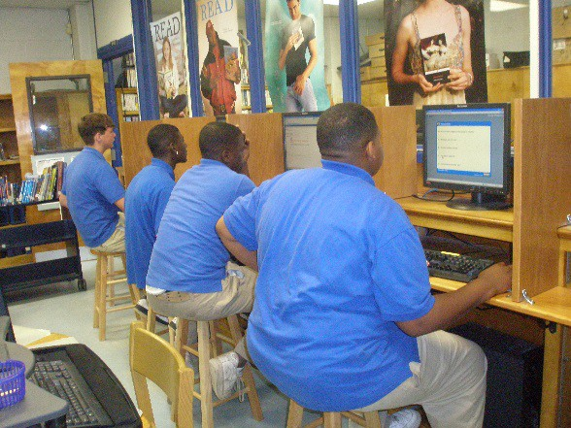Support the Renaissance Place programs both
publicly and privately
- Verify Master Schedule in student information system including basic classes
  - Elementary – students need to be in Reading classes by start of school
  - Middle School – students need to be in
Language Arts/English classes by start
of school
  - High School – students need to be in
Language Arts/English classes by start
of school
- Verify that students’ demographics are correctly entered
  - Verify student information data – date of birth, name, grade, teacher, etc.
- Verify that teachers’ demographics are correctly entered
  - Verify teacher number, date of birth, name, grade, schedule
- Print an Entry and Withdrawal Report from student information system daily for the librarian

Teachers:

Note: Some activities may be delayed for kindergarten and first grade classrooms
- Support the Renaissance Place programs both publicly and privately
- Verify student rosters in student information system and Renaissance Place.
- Administer and monitor STAR Reading and/or STAR Early Literacy (SEL) tests to students during early August, December/January and first of April.
  - Prepare students for STAR/SEL testing using pre-test instructions
  - Emphasize importance of students taking STAR/SEL testing seriously to obtain accurate and valid results
  - Retest students with questionable results that do not seem to match classroom performance and/or ability on other assessments
- Print STAR Reading and/or STAR Early Literacy Parent Reports
- Test (or verify previous testing within the district) new students with STAR assessments
- Set up student Accelerated Reader folders to include Zone of Proximal Development (ZPD) and Reading Logs

Back, Table of Contents

  - Set up reading logs and model/teach students how to record information correctly.
Provide guidance about pacing themselves, explanation of the ZPD, etc.
- Accelerated Reader individualized student goals (percent correct, book level, and point goals from Goal-Setting chart) must be entered in Accelerated Reader software within one week of STAR testing
- Goals will need to be updated during the first week of the new marking period (quarterly) in the software
- Attend library orientation with your students
- Assist students in choosing their first Accelerated Reader books within their individual ZPDs
- If Media Specialist is using library cards, teachers should record ZPD on this card
- Reading practice time is an essential component of the reading curriculum. A minimum of 30 minutes of reading practice time should be incorporated throughout the day. This reading time should be monitored by the classroom teacher and can be scheduled each day as a reading center during the reading block. Additional reading practice time can be utilized as students finish assignments.
  - This 30 minute block does not have to be in one sitting. It can be broken down into 10 to 15 minute blocks. This can be accomplished through bell-ringer activities using time provided in all classes.
- Model and teach students how to take Accelerated Reader quizzes
- Review TOPS Reports, weekly Diagnostic Report, and/or weekly Student Record Report
  - Model/teach students how to read these reports
  - Use these reports to guide student book selection
  - Send printed Student Record Report home quarterly with report card.
- Confirm AR quiz score accuracy in student reading log and initial reading log
- Have fun! Encourage and support Renaissance Place motivation systems within your classroom and/or school
- Share Accelerated Reader goals and STAR Reading results with parents quarterly
- Encourage students to take vocabulary quizzes
- Monitor STAR testing progress and goal setting
- Print the following reports to bring to quarterly data and/or department meetings for review and discussion:
  - STAR Reading Summary Report / STAR Early Literacy Summary Report
  - Accelerated Reader Reading Practice Diagnostic Report
  - Accelerated Reader Student Record Report for students with diagnostic codes

Library Media Specialists:
- Support the Renaissance Place programs both publicly and privately
- Provide orientation to teachers/students
- Assign software products to classes
- Print class rolls to verify correct class enrollment (Student Information Report)
- Consult with Registrar to make corrections in student information system as needed
- Schedule classes for STAR Reading and STAR Early Literacy testing during early August, December/January and first of April.
- Create student library circulation barcode labels after enrollment has taken place and information has correctly rolled into Destiny and Renaissance Place.
Back, Table of Contents

  - Determine a secure location to place this information (sticker), when applicable (folder, index card, etc.)
  - Student usernames and passwords should be secured information
- Print Home Connect parent letters for all classes and distribute to teachers with instructions for
home distribution
- Conduct Home Connect parent training during parent meetings, Parenting Day, and Parent University
- Label books – ongoing process
  - Label AR books
  - Print vocabulary list labels and place inside front cover of book
  - Print Literacy Skills quiz list and make available to teachers and parents
- Support teachers with information about Home Connect and AR BookFinder
- Attend quarterly data meetings and or appropriate departmental meetings
- Coordinate the school-wide recognition programs
- Serve as a liaison between school and district Technology Coordinator and Curriculum and Instruction leaders
- Attend Renaissance Place district meetings
- Run library circulation reports and bring to data meetings for review and discussion
- Assist and/or train new teachers
- Order Accelerated Reader materials for students (books or audio books)
- Assist students in selecting books within ZPD
- At the end of school year, generate Accelerated Reader School-wide Summary Report and bring to data meeting where standardized test scores are reviewed at the beginning of the next school year
- Print Literacy Skills teacher guides as resources (keep in binder in Media Center)

Local MCPSS Renaissance Learning Trainers:
- Support the Renaissance Place programs both publicly and privately
- Partner with Media Specialists for orientation to teachers/students
- Assist Media Specialists with scheduling classes for STAR Reading and STAR Early Literacy testing during early August, December/January and first of April.
- Assist Media Specialists with printing Home Connect parent letters for all classes and distributing to teachers with instructions for home distribution
- Assist Media Specialists with conducting Home Connect parent training during parent meetings, Parenting Day, and Parent University
- Support teachers with information about Home Connect and AR BookFinder
- Participate in quarterly data meetings
- Assist Media Specialists with coordinating the school-wide recognition programs
- Attend Renaissance Place district meetings as requested
- Assist and/or train new teachers
- Assist students in selecting books within ZPD

Back, Table of Contents

Local School Administrators:
- Support the Renaissance Place programs both publicly and privately
- Require all PreK-12 teachers to participate in Renaissance Place programs
- Verify creation of master schedule for all students
- Verify all students have taken STAR Reading and/or STAR Early Literacy tests during early August, December/January and first of April
- Review the following data:
  - Library circulation report – quarterly
  - Dashboard – weekly
  - STAR Reading and STAR Early Literacy Summary Reports – quarterly
  - STAR Reading and STAR Early Literacy screening reports by grade levels - quarterly

Support flexible scheduling of Library so students have access to an open library
- Check to make sure student goals are set in Accelerated Reader
- Follow up with teachers to be sure a minimum of 30 minutes of Reading practice time each day is part every classroom’s daily schedule
- Observe classrooms during reading practice time to ensure that teachers are following Renaissance Place Best Practices.

District Instructional Technology Coordinator:
- Support the Renaissance Place programs both publicly and privately
- Set STAR Reading testing windows
- STAR Early Literacy testing windows
- Set standardized Renaissance Place student passwords
- Set up new school year: rollover, promotions, calendar, etc.
- Provide general technical support and training
- Supervise all Media Specialists and trainers
- Monitor all professional development
- Monitor and coordinate hardware and software needs
- Keep curriculum administration apprised of STAR Reading, STAR Early Literacy, and Accelerated Reader results and progress
- Approve any change in the management of the Renaissance Place programs
- Identify Media Specialist at each school to serve as school Renaissance Place coordinator
- Serve as a liaison between the schools and the Assistant Superintendent of Curriculum and Instruction
- Distribute Renaissance Place information and updates as necessary to Media Specialists, Registrars, and Principals
- Coordinate training dates, sites, and materials
- Monitor implementation of motivation and recognition programs across the district
- Work with the Communications Department in creating public awareness of Renaissance Place
- Review Renaissance Place Dashboard data
- Run district reports as requested

Back, Table of Contents

District Curriculum and Instruction:
- Determine grading procedures and policies at elementary, middle and high school levels
- Set and monitor reading practice time guidelines
- Coordinate, assist, and attend Renaissance Place training events
- Partner with Instructional Technology Coordinator
- Attend data review meetings with Renaissance Place program management
- Verify students have taken STAR Reading and STAR Early Literacy tests during early August, December/January and first of April
- During Team visits:
  - Monitor library circulation and daily library schedules
  - Review Renaissance Dashboard
  - Verify 30 minutes of engaged reading time with Accelerated Reader Diagnostic Reports or Renaissance Place Consolidated Implementation Status Reports

Back, Table of Contents

Local School Procedures Handbook
In addition to the MCPSS Library Media Handbook, every school will develop and insert local policies as an attachment to the district handbook. This should include:

- Local school circulation policy
- Faculty & Students
- Patron checkout limits for each patron type and material format o Length of loan periods for each patron type and material format o Overdue fines
- Library rules & procedures
- Administrator Usernames & Passwords for all software programs
- Destiny
- FollettShelf
- Renaissance
- eBook Websites
- Any other software programs being used at your school
- Library Mission and Vision Statements

Back, Table of Contents

