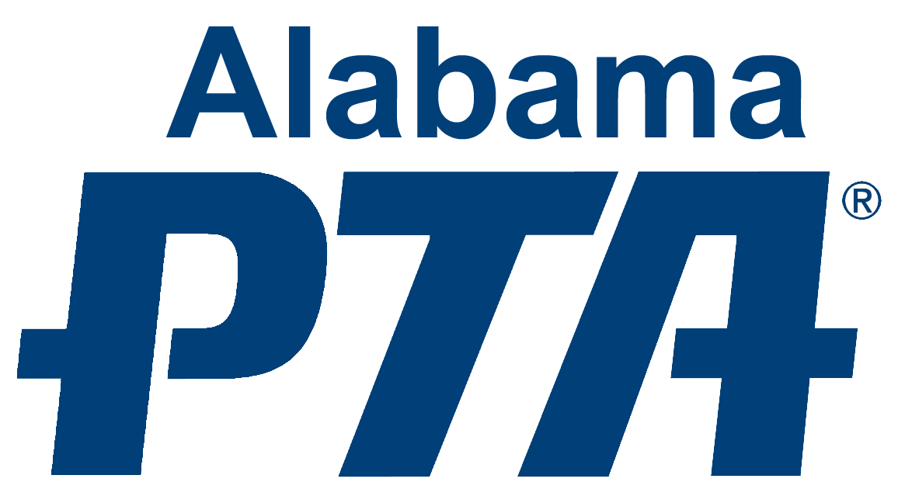

This SECTION is to be completed by PTA before distribution.
PTA LEADER NAME TITLE EMAIL PHONE
PTA ID PTA NAME STATE AL
COUNCIL PTA DISTRICT PTA REGION PTA
MEMBER DUES PAID DATE INSURANCE PAID DATE BYLAWS APPROVAL DATE
*STUDENT NAME *GRADE *AGE GENDER (optional)
*SCHOOL SCHOOL CITY
*PARENT/GUARDIAN NAME *EMAIL PHONE
*MAILING ADDRESS
CITY STATE AL ZIP
Ownership in any submission shall remain the property of the entrant, but entry into this program constitutes entrant’s irrevocable permission and consent that PTA may display, copy, reproduce, enhance, print, sublicense, publish, distribute and create derivative works for PTA purposes. PTA is not responsible for lost or damaged entries. Submission of entry into the PTA Reflections program constitutes acceptance of all rules and conditions. I agree to the above statement and the National PTA Reflections Official Rules.

*STUDENT SIGNATURE: ____________________________ *PARENT/LEGAL GUARDIAN SIGNATURE: _________________________

*GRADE DIVISION (Check One) ARTS CATEGORY (Check One)
PRIMARY (Preschool- Grade 2) HIGH SCHOOL (Grades 9-12) DANCE CHOREOGRAPHY MUSIC COMPOSITION
INTERMEDIATE (Grades 3-5) SPECIAL ARTIST (All Grades) FILM PRODUCTION PHOTOGRAPHY
MIDDLE SCHOOL (Grades 6-8) LITERATURE VISUAL ARTS

*TITLE OF ARTWORK

*ARTWORK DETAILS (Dance/Film: cite background music; Music: musician(s)/instrumentation; Literature: word count; Photo/Visual Arts: materials & dimensions)
*ARTIST STATEMENT REQUIRED (Must be 10 to 100 words describing your work and how it relates to the theme)

*REQUIRED – artwork will not be judged on the state level if these items are not complete.
This form must accompany any entry; attach to the back of visual art and photography entries.
please do not tape all around the form.

