Gifted English I—Mrs. Stevens
April 20-24

You will find class resources (notes and PowerPoints/presentations) for me each week in your class TEAM's General Section.

At the top, click Files>Class Materials>Week 5 folder for me. I'll try to post any Powerpoint documents in PDF form as well just in case the actual PPT doesn't cooperate with your device. There will also be a Week 5 specific channel set up in Teams for any questions/comments for that week’s work.

- Continue reading Animal Farm. Last week, you were supposed to read Ch. 1-3 and jot down some quick highlights for each chapter and any questions you may have after you read. This week, I want you to read Ch. 4-7. http://www.huzheng.org/geniusreligion/AnimalFarm.pdf
Again, let me know if you have any issues accessing the book or if you are in need of a physical copy.
*Unfortunately, there are multiple IN-CLASS activities that we usually do while reading Animal Farm to better connect with its message and RELEVANCE in our lives; however, we aren’t able to do some of these group activities and discussions individually, so we need to do the best we can to still see how this text is relevant in our society.
What to do with Animal Farm this week along with reading Ch. 4-7:
********All of the resources needed within these assignments will be posted in the Class Materials folder for Week 5 in Microsoft Teams (see directions at the top of this document to locate this folder).
- Read through the Intro to Animal Farm Allegory and Utopia slides (Powerpoint); you are not required to complete the utopia assignment within the slides; I mainly want you to read over this for review on the allegory term that we have already covered in class this semester. If it is an allegory, there is another level of meaning beyond its surface meaning. The last slide shows you some important Russian historical figures. Each of these men are connected to characters in the book, but I want you to discover who each character symbolizes the more you read.
- Read article on Herd Mentality. After reading the article “Herd Mentality: The Dangers of Following the Crowd,” answer the questions along the side of the article in your notebook or on a document. Most require just one letter responses, but a few ask for an explanation/a few sentences. Turn in the answers to these 10 questions by Friday.
- Read through the Satire and Political Cartoons Powerpoint, focusing on the samples of sheep-related cartoons/herd mentality. After you’ve studied these for a little bit, I want you to find a political cartoon to analyze. Keep in mind that a POLITICAL or EDITORIAL cartoon isn’t the same as any comic strip you find out there. A political cartoon is opinionated and usually satirizes/criticizes some area of society. Make sure you save the cartoon in a Word document or take a picture of it somehow, because I will need to see it along with a paragraph explanation of what you think the political cartoon means/what is it saying to the public? You can find one that is more recent, or one from history, but you usually have to know the context (what is happening in the world at the time), to fully understand the cartoon’s meanings/depth. If you need some help finding a cartoon, here are some links to a few publications’ cartoonists:
https://mississippitoday.org/author/mramsey/ (Marshall Ramsay is a MS poltical cartoonist)
https://madison.com/search/?sd=desc&l=25&s=start_time&f=html&t=article%2Cvideo%2Cyoutube%2Ccollection&app=editorial&nsa=eedition&k=%23wsj&q=political+cartoons (so MANY right now on the pandemic—just one site from Madison)
https://www.pulitzer.org/prize-winners-by-category/215 (national award-winning editorial cartoonists documented in one place that have won PULITZERS, one of the biggest annual writing honors in the nation.
- As you continue reading the chapters for this week, begin a chart/notes page in your notebook titled Propaganda in Animal Farm. Most of you have heard of propaganda and even studied some propaganda techniques in middle school. Go ahead and start jotting examples of propaganda you notice down while you can remember. We will talk more about this next week, but I want to see what you already know. (ex. bandwagon, fear tactics, name calling, etc.) See the definition of propaganda and a sample poster below.

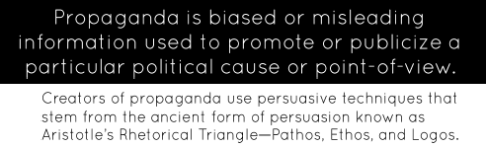
Propaganda is used within this poster to promote Stalin in 1938.
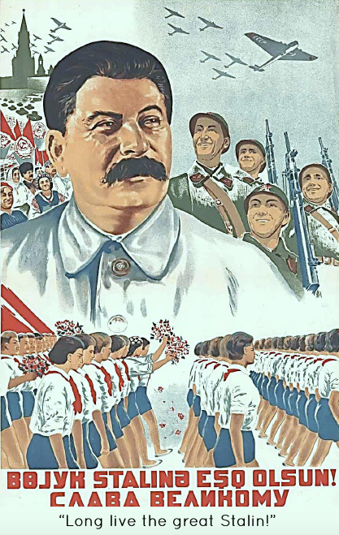
Propaganda is also connected to “fake news.” “Fake news” refers to news stories that are false; the story itself is fabricated or has no verifiable facts, sources, or quotes (unverifiable logos). Sometimes these stories may be used as propaganda that is intentionally designed to mislead the reader, or the fake news may be designed as “clickbait” written by unethical people for economic incentives. In recent years, fake news stories have thrived on social media because they are so easily and quickly shared online.
Good infographic on this website to spot fake news: https://www.ifla.org/publications/node/11174
Brief chart on some propaganda: http://english.glendale.edu/propaganda.examples.html

- You’ve recorded Set 11 Words in your notebook (last week). You have a choice of what you can do to practice with your words for Set 11’s weekly quiz. Choose ONE.
- Write a 1-2pg. story that correctly uses all Set 11 words within it (make sure you UNDERLINE each word as you use it as well as spell it correctly/use the correct form.
- Video a short skit/play that uses all of the words correctly. You can make this a one-person play starring you, you can enlist help from members of your household, or you can make puppets/use figurines, etc. Please make sure that the sound quality is clear and that the video isn’t too long; otherwise, the file will be too large to upload to Teams and submit. If you really want to get into making a short video with editing, you can do that if you wish, but it’s not required (something like iMovie).

YOU WILL NOT BE GETTING A SET 12 SET OF WORDS THIS WEEK, SO THIS ASSIGNMENT WON’T BE DUE UNTIL NEXT WEDNESDAY—APRIL 29.

Study all words you’ve had over the last 3-4 sets while we’ve been doing distance learning. We will probably participate in some kind of game for review on these in the next few weeks.

~~~~~~~~~~~~~~~~~~~~~~~~~~~~~~~~~~~~~~~~~~~~~~~~~~~~~~~~~~~~~~~~~~~~~~~~~~~~~~~~~~
OLD NEWS— (also mentioned last week):
Reading Animal Farm can count toward your encouraged daily reading time. I also encourage you to continue reading whatever independent book choice you’ve been reading as well. Your writing for any of the above assignments can count toward your writing expectations (mentioned in week 1, twice a week for around 2pgs. each). If you continue writing about ideas from the world around you, that’s great, too. I’d like to see you find ideas and topics you want to write about and explore/play around with instead of solely adhering to just what the teacher asks. Again, the idea for all of this is to keep reading and writing daily/weekly. It is HEALTHY (mentally…and even spiritually) to have these outlets of creativity.

Also, If you are DESPERATE for some new reading material and need a book at your house, please email me 3 book titles that you want to read (I’ll see what I can do.)
This will require research on your part if you don’t already have some books in mind. Look at books recommended based on books that you’ve liked before or look in specific genres that you like (Good Reads and NPR Concierge are great for this). kara.stevens@dcsms.org

Information mentioned every week…
You can record any writing/reading in your writer’s notebook. If you don’t have access to your notebook, you can keep up with this on separate paper or type it/save it as you go.
PLEASE CONTACT ME via Teams chat or Remind (or email) if you don't understand my directions. Read all directions thoroughly first.

Remind codes
1st period: @geng1s to 81010 (or just add these codes within the free app for Remind)
2nd period: @geng2s to 81010

