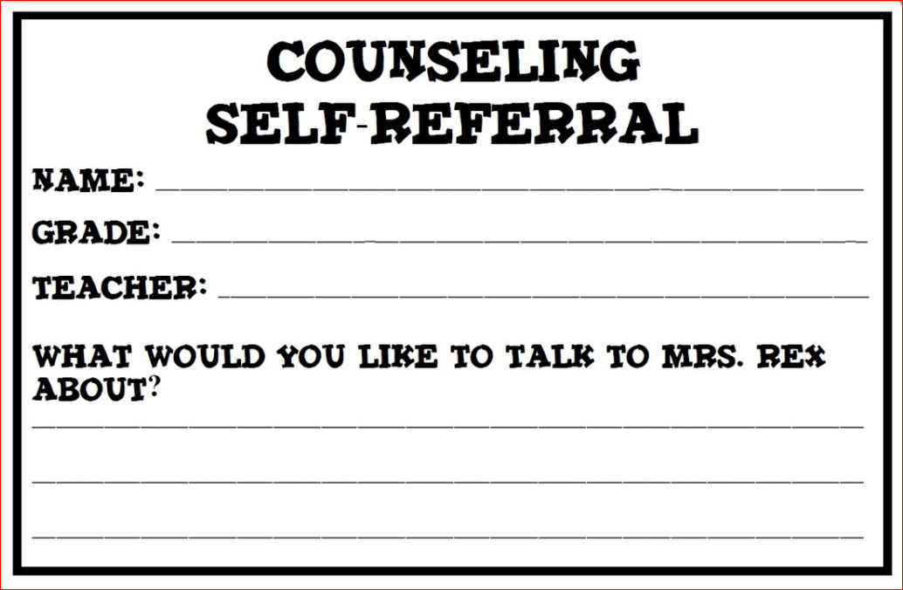

Slide this paper under my door. I will see you as soon as possible.

Mrs. Ballew



Slide this paper under my door. I will see you as soon as possible.

Mrs. Ballew