Dear Parent,
Our guidance session this month is the Eddie Eagle GunSafe Program. Its purpose is to promote gun accident prevention by teaching a simple safety message so the children know what to do should they come upon an unsecured firearm.
Stop!
Don’t Touch!
Leave the Area!
Tell an Adult!
This program teaches children that guns are not toys, and makes no value judgement about whether guns are good or bad. It only promotes safe behavior. Toy manufacturers are on board by putting orange tips on toy guns.
I taught the 4 steps in a rap style with hand/body movements. Please take the time to share with your child this important lesson. It is also a good time for you to make sure your home firearms are secure.
Since this program began in 1988 and according to the National Center for Health Statistics, the annual number of firearm accidents is more than 80% lower today than in 1988. I will continue with more safety tips throughout the remaining months of school.
Please take the time to talk to your child about gun safety. Let them show you what they have learned!!
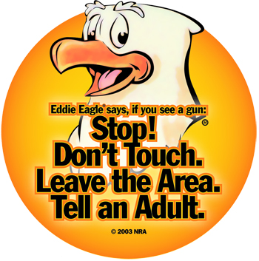
Annabeth Greene
Pre-K - 2 Counselor

