 | Sunday | Monday | Tuesday | Wednesday | Thursday | Friday | Saturday
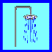  Bath or Shower  AM PM | 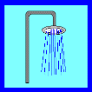  Bath or Shower  AM PM | Bath or Shower  AM PM | Bath or Shower  AM PM | Bath or Shower  AM PM | Bath or Shower  AM PM | Bath or Shower  AM PM | Bath or Shower  AM PM
Put on
deodorant

AM PM
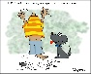
Put on Clean Clothes

AM PM
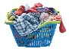
Put dirty Clothes in basket

AM PM
Brush Teeth
AM PM
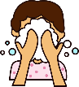
Wash Face

AM PM
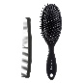
Comb or Brush Hair

AM PM
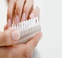
Clean ands/Nails

AM PM

