Graphing

Background

- Scientist _________________________ tables, graphs, and diagrams to _________________________ data, _________________________ relationships in the data, and extend those relationships beyond the data.
- _________________________ graphs can be like reading a foreign language though. It come easy to some and very difficult to others

What Are The Parts of a Graph?

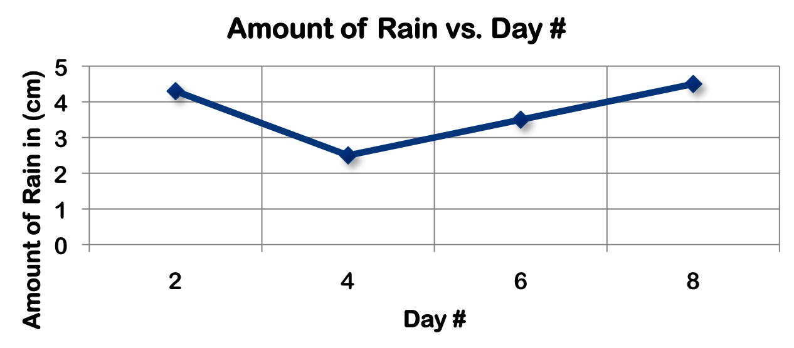

Where Are The Variables Plotted?

Graphing

In Looking At How To Read Graphs, Tables, and Data When It Comes to the ACT….
- First We Need To Understand The Core Elements Of A Graph
    - _____________________________________________________________
    - _____________________________________________________________
    - _____________________________________________________________

- The Importance of Labels
  - ________________________ are VERY important on the ACT Science sections.
  - Each visual is labeled with a ________________________ plus a ________________________.
  - So, if there are three 3 visuals, they will be labeled Figure 1, Figure 2, and Figure 3.

- The _________________________ help you to refer to the correct figure.
** Although many students still don’t look at the right visual**
- Some ___________________________ will often ___________________________ tell you which figure to look at.
** Example: In Figure 2, what percent of captured finches from Island C have a 10mm beak depth?
- To __________________________ answer this question, you need to check the __________________________ and make sure you are looking at Figure 2. Then, identify the __________________________ that shows the finches from Island C.
- THE _______________________ STEP IN MOST ACT SCIENCE QUESTIONS IS TO __________________________________________, BECAUSE IF YOU GET THIS STEP WRONG, YOU WILL GET THE ANSWER WORNG.

- How To Use Axes
- ____________________ are useful to figure out the ___________________________ and the ___________________________(s) in the experiment .
- Graphs we know by definition have an __________________ and __________________.
- The x-axis is the _________________________ line (usually on the bottom), and an y-axis the ______________________________ line (usually on the left side of the graph).
- Although, more challenging graphs on the ACT Science will have one on the left and one on the right.

  - In this graph, the ___________________ doesn’t measure anything (only list the animals).
  - The ___________________ measures the animals’ weights. The animals’ weight would be considered the ________________________ in the research.
  - We can use this graph to compare the 4 elements of only one data set: the _________________________ of the animals.
  - What if the passage that went along with this graph had asked you,
      - What is the weight of the dog? _____________________

- Now let’s look at a slightly more complicated graph you may see on the ACT Science section.
- In this graph, the x-axis measures the ________________________ from the _________________________ of the plot to the nearest _________________________.
- The y-axis measures the ____________________________________________ (it’s not important that we understand what AGTB is)
- Which one of these would be considered the “dependent variable” in the research?
________________________________________
- You can use this graph to ___________________________ the distance from the center of the plot to the nearest clearing to the average change in AGTB
  - What if the passage that went along with this graph asked you
    - What is the average change in AGTB at a distance of 50m from the center of the plot to the nearest clearing?
  - To do this you ____________________ need to find 50 on the axis that defines the _____________________ from the center of the plot to the nearest clearing, which is the _____________________.
  - Next, we look on the y-axis for the value of the ______________________________________ and see that it reads 5t/yr.

- What To Do With Units of Measure
- On ____________________ on the ACT Science section, they will present ____________________________________ for each axis next to the label.
- ____________________ try to understand what the units mean.
- The ACT throws in these ____________________, ____________________ units that you won’t have seen unless you studied very ______________________________ Physics or Chemistry.
- You __________________________ need to know exactly what they refer to in order to answer the questions.
- For example, take the graph previous graph.
- While you probably know that m is _______________, you may be unfamiliar with t/yr.
- For the Science section of the ACT the _____________________are listed in the _________________________________, they _______________________________ to the units shown in one of the visuals or mentioned in the passage.
- So, there is __________ need to ____________________ on them or _________________________ over them.
- Another thing, out of all the ACT Science practice sections I have seen they __________________________ ask you to ________________________ the units form one form of measurement to another.
- The ACT includes these crazy units to make the graphs look more _________________________or to test your ability to ____________________ information that you may not know.
- _________________________ what you don’t need and ___________________ the information to answer the question. Focus on what you can _________________________

- What Types of Data Are Recorded and What Methods Are Used?
- The __________________________ design that a scientist selects depends on what ___________________________ the scientist hopes to ______________________.
- __________________________________ can be classified into one of two main types, ________________________ (numerical) or ___________________________ (descriptive).
- Scientist recognize that ___________________________ of data from experiments helps them to better _____________________________ their results.
- The data may be presented in _________________________, _________________________, _________________________, or _________________________.

- What Are The Steps To Take In Constructing A Graph?
- Determine which variable is the _____________________________ variable and which is the _____________________________ variable.
- A graph consist of two principle lines called ___________________, that lie at _____________________________________to each other. The ____________________________ variable is plotted on the x-axis, and the _________________________variable is plotted in the y-axis.
- __________________your graph and ________________________both axes. The units of measurement ________________________ be shown.
- The axes must be properly ________________________. Numbers increase across the ________________________________ and ____________________________axes from the zero point.
- The numbering scale must include both the ________________________ and ________________________values.

- The Different Types of Graphs on the Science Section
  - ______________________________________________
  - ______________________________________________
  - ______________________________________________
  - ______________________________________________
  - ______________________________________________

- Reading Bar Graphs
- Bar graphs are used to show a ____________________________ of multiple objects.
- Bar graphs tend to be one of the ___________________________ visuals used by the ACT Science section.
- They are easier because there will only be ___________ variable shown.

- In this graph, the x-axis lists the _________________.
- The y-axis measures _____________________________________________, the variable in this research.
- What if the passage that goes along with this graph asked you
    - What is the average beak depth in 1983?
- First, you need to find 1983 on the _______________________.
- Next look on the ________________________ for the value of the average beak depth and see that it reads __________________.
- Bar graphs are really easy, as long as you ________________________________ you have ______________________________ the correct bar, you will find the data you need.

- Scatter Plot
- Scatter plots are graphs of plotted points that show the ___________________________ between two sets of __________________.
- Example: What is the average cumulative percent change in AGTB during Year 2?
- To answer this question what do we need to do?

- Scatter plots can be slightly more ____________________________ if they ask you a question about a point not marked.
- Example: What is the average cumulative percent change in AGTB during year 9?
- When answering these type of trend questions _____________________ out the curve on the graph you are given and then use the __________________________________________.

- Line Graphs
- Line graphs are used to show the relationship between ____________________________.
- Line graphs are one of the ____________________________ types of visuals used on the ACT Science section.
- The reason being is because they show an ________________________number of data points, and you need to be _______________________on which data point you’re looking at.
- Also, the ACT often uses line graphs to show 2 entirely ______________________________________________, one on the left and one on the right with a key to ______________________________ between the two lines.

- Example: This graph has two lines represented and two ____________________________ groups of information. Also, each line has its own range of _____________________________.
- What does the x-axis show? ________________________________
- What is the RCRF in January 1990? _____________________________
- _____________________, you must make sure you are looking at the ______________________ line.
- According to the key, which line represents RCRF? ___________________________
- Next, you need to _______________________________________ to the measurement on either the right or left.
- Which side represents RCRF in %? __________________________________
- In order to ensure you are looking at the _______________________________________ of intersection you may want to use your paper or pencil to create a ___________________________________
.

- Key strategies to remember with line graphs are:
  - ________________________________________________________________
  - ________________________________________________________________
  - _______________________________________________________________

- Accepted Guidelines For Constructing A Table
- The title of the data table should clearly communicate the _________________________ of the experiment.
- The independent variable is recorded in the ____________________ column.
- The dependent variable is recorded in the ______________________ column.
- When repeated trials are conducted, they are recorded in ___________________________ of the _________________________ variable column.
- When recording data in a table, the values of the __________________________ variables are ordered from smallest to largest.

- Tables
- Tables are one of the _________________________ types of visuals provided.
- There are a number of __________________________, and each entry in a column corresponds to the entry directly to the ___________________ or ___________________ of that entry in the same row.
Key strategies to remember with tables:
- Identify the correct ________________________ in question
- Find the correct ____________________________________ in question
- Look to the _______________ or _______________ of it in the same row to find the ________________________ data point
- Some tables on the ACT will have ________________ rows and columns of data, but the technique is ________________________ the same.

- Tricky Graphs
- These graphs are not what they seem
- A lot of lines with _________________________ labels

- Example: Which of the following absorbed the most light across all wavelengths?
A. White S C. Red S
B. Orange S D. Brown S
- First, you need to look at the graph. There are 5 lines and each one represents a different color of _________________________plus ___________________________________.
- Each graph represents the _______________________ at each ________________________.
- This ACT question is asking you for which substance absorbed the most light across all wavelengths.
- If we were to break down this question:
- First, we would need to know that “absorb the most light” means the _______________________ of reflectance, BUT ________________________ is what is graphed.
- Second, “across all wavelengths” means you’re not just looking at ______________ point on the x-axis; you’re looking across _______________ points.
- If you were _________________________ and not ___________________________________ you might answer _______________________ because you see it reflects the most light across all wavelengths.
- However, knowing that ________________________ is the opposite of reflectance and looking across all wavelengths, you would see that _______________________ is reflecting the least across all wavelengths.
- Therefore, it is absorbing the most, so the best answer would be _________________________.

- Other tricky graphs may look like this

- This graph is even more complex. There are intersecting lines of different _________________________ and _______________________ enclosed by lines.
- Although there are a lot of weird things going on in this graph you approach it just like any other graph _______________ thing at a time.
- Let’s say the ACT question asked:
- Example: Which of the following would most likely NOT be found at a pressure of 10kb?
A. Facies A C. Facies G
B. Facies C D. Facies E
- First you need to look at the graph and notice that there are __________ Facies identified.
- The graph shows the ________________________, _________________________, and __________________________ at which these 7 Facies appear.
- The question asked us for which of the following is _____________ found at a pressure of 10kb.
- When you do this you can see that Facies ________, _________, and _________ all are found at 10kb,
- but Facies A is not.
- Again, if you were _____________________ or not __________________________________ you might choose Facies C, G, or E as the answer because you missed the word ____________, or you might accidentally look at a ___________________ of 10km on the right instead of pressure.
- Key strategies to remember with tricky graphs:
- Always _____________________ what you are being __________________________ to what the graph actually shows
- Always make sure you have found the correct ___________________ in question
- Be extra careful when you see a ___________________ or __________________

Scientific Graphing
- Most scientific graphs are made as _____________________graphs. There may be times when other types would be appropriate, but they are ___________________.
- The lines on scientific graphs are usually drawn either ____________________________ or __________________________. These “smoothed” lines ___________________________ have to touch all the data points, but they should at least get close to most of them. They are called __________________________________________.

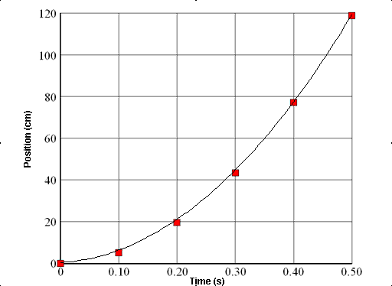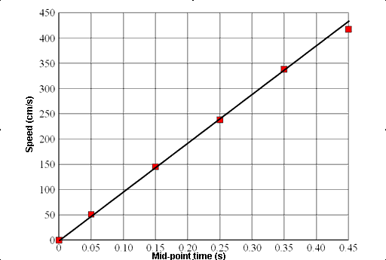

Predicting Data On A Graph
- ___________________________ are a useful tool in science. The visual characteristics of a graph make _______________________ in data easy to see.
- One of the most valuable uses for graphs is to "________________________" data that is not measured on the graph.
- __________________________ extending the graph, along the same slope, above or below measured data.
- __________________________ predicting data between two measured points on the graph.

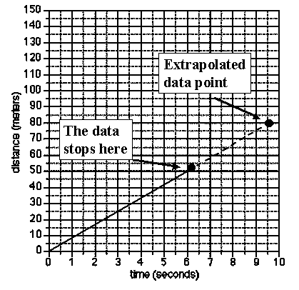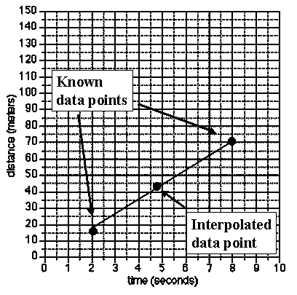

Directly Proportional and Indirectly Proportional Graphs
- _______________________________________________: As the independent variable increases,
the dependent variable increases as well.
- ______________________________________________: As the independent variable increases, the dependent variable decreases
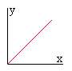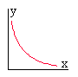
Directly Proportional Inversely (Indirectly) Proportional

Types of Relationships Between Variables
- _______________________________: As X increases Y increases

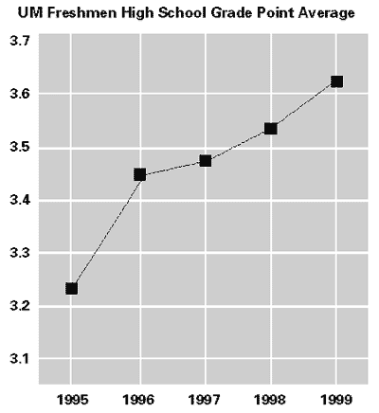

2. _______________________________: As X increases Y decreases

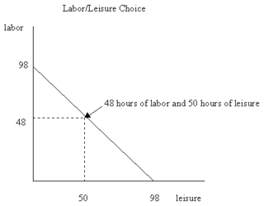

3. _________________________________: As X increases Y remains the same

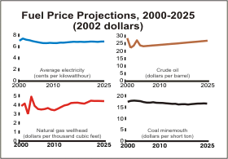
Types Of Graphs
Pie graphs are used to ____________________________ the parts of a whole.

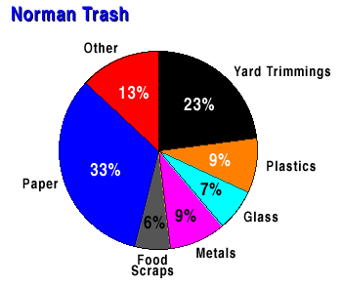

- Recap
- Key strategies to remember:
  - Read ___________________________ very carefully. Make sure you are looking at the _____________________________ Figure
  - Remember the basics: what the ____________________ represent, how the ___________________________________ are depicted, how to go step by step to the __________________________ you need
  - All of the same rules apply to _________________________, ___________________________, ___________________________, ________________________________, and ___________________________
  - Don’t try to _________________________ the units of measure

