HOLLY SPRINGS SCHOOL DISTRICT
5th GRADE SCIENCE HYBRID INSTRUCTIONAL GUIDE
Week of November 16-20, 2020

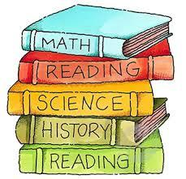

STANDARDS
P.5.5B.1 Obtain and evaluate scientific information to describe what happens to the properties of substances in mixtures and solutions. P.5.5B.2 Analyze and interpret data to communicate that the concentration of a solution is determined by the relative amount of solute versus solvent in various mixtures. November 16-20

STANDARD (S)  P.5.5B.1 Obtain and evaluate scientific information to describe what happens to the properties of substances in mixtures and solutions. P.5.5B.2 Analyze and interpret data to communicate that the concentration of a solution is determined by the relative amount of solute versus solvent in various mixtures.  ESSENTIAL CONCEPTS  - Demonstrate an understanding of how to construct a vessel to transport a dense substances or objects from one side of the container to the other.  STANDARD VOCABULARY  - Mixtures  - Solution  - Solute  - Solvent  - Homogeneous mixture  - Heterogeneous mixture | ACTIVITY/ ASSIGNMENT SCHEDULE  MONDAY, NOVEMBER 16th:  - Pulling in Google Meet through Schoology to reinforce teaching material and additional help.  - Independent Practice, USA Test Prep Worksheet.  TUESDAY, NOVEMBER 17th:  - READ in the SAVVAS eTEXTBOOK, in Schoology complete the I DO, WE DO, YOU DO.  - HOMEWORK: Complete worksheet in Schoology.  WEDNESDAY, NOVEMBER 18th:  - Pulling in Google Meet through Schoology to reinforce teaching material and additional help.  - Independent Practice complete assignment in USA Test Prep through Schoology.  THURSDAY, NOVEMBER 19th:  - Bell ringer in class in USA Test Prep  - Review for Friday's 4 Week Assessment.  - Complete the worksheet in USA Test Prep.  - HOMEWORK: Review worksheet in Schoology.  FRIDAY, NOVEMBER 20th:  - Assessment (Test) in Schoology in all subjects.  - Help or Pulling Session 1-3p.m. on Google Meet for students who were absent during pulling on Wednesday, or who need additional support in Science.  ﻿
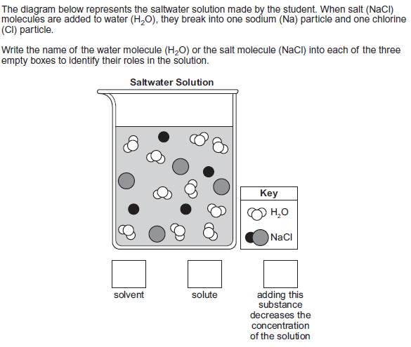 | WEBSITES/SUPPORT MATERIALS  District website – hssdk12.org  School website - intermediate.hssdk12.org  Schoology-schoology.com  Savvas Realize- savvasrealize.com  USA Test Prep- usatestprep.com

