Mrs. Burns’ English Learners
Weekly Lesson/Activities
April 13 – April 17, 2020
Monday | N/A | Student Holiday
Tuesday | Speaking & Writing | Talk About It  How do you feel about being away from school and your teachers?  How do you feel about distance learning (learning online/home)?  How do you feel about the coronavirus?  Find a face on the chart below that shows how you feel; talk about it with your parents:  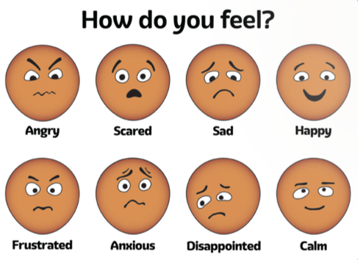  Draw a picture to demonstrate how you feel today. Write 1 or 2 sentences to describe your picture.  Example 1: I feel frustrated because I lost my favorite toy.  Example 2: I am disappointed because it is raining. I could not go outside to play.  *Kindergarten examples (I am sad / I am mad / I am happy)
Wednesday | Listening | Follow this link for this week’s listening practice: https://www.esl-lab.com/easy/family-recreation/
Thursday | Reading | Read your favorite story to your family. If you do not have a book at home, you can find one at this link: https://storyweaver.org.in/  Take turns retelling the story.
Friday | Fun Day! | Visit https://pbskids.org/ for 15 – 20 minutes of fun!

