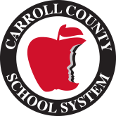
2021-2022 School Supplies List

1st Grade

2 Boxes of 24 crayons
1 pack of sharpened #2 pencils
1 pair of scissors
Earbuds
1 box of large (gallon) Ziploc bags
1 box of quart sized bags
2 composition notebooks
1 3inch binder with dividers
8 glue sticks
1 bottle of Elmer glue
1 box colored pencils
1 pack small 3x5 Index cards
1 pack large 4x6 index cards
Sticky notes 3 pads per student
Small sticky flags (3packs)
Plastic pencil box
2 folders (1blue, 1 green)

