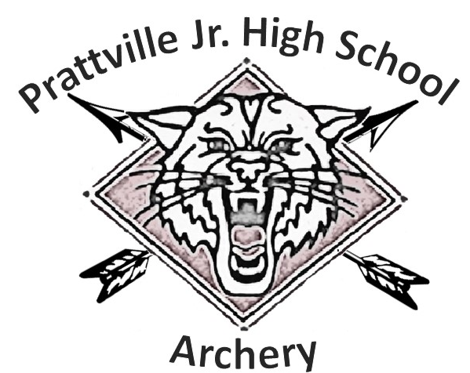
Thank you for considering becoming a sponsor of the Prattville Junior High School Archery Team. The team is made up of 7th and 8th grade students who represent their school in competition. Your sponsorship would help to purchase and maintain equipment, transport students to and from competitions, and to provide any additional resources required to conduct a successful archery team. All contributions are tax-deductible. As a special thank you, we would like to feature our sponsors on the back of our 2019-2020 Season t-shirt. Contributions equal to or exceeding $50 will have the sponsor name featured. Suspense for turn in is 9 Jan 2020

We thank you for your support of PJHS Archery and as always….
GO CATS!
For any questions, please contact:
Coach Hawkins: chester.hawkins@acboe.net

