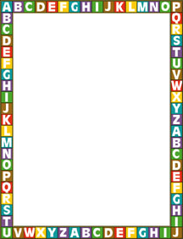
Our 2nd Grade Supply List
2021/22
Mrs. Mayfield and I are so excited to meet all of you
Please make sure all your supplies are labeled.

With your help, we can make this year wonderful and successful! Here is what they will need:

- Backpack
- Labeled pencil box with the following
inside: pencils, crayons, scissors,
glue sticks.
- 1 Spiral Notebook
- 1 black and white composition book
- Pencil sharpener with shaving holder

- White board and eraser
- 2 small personal hand sanitizers
- 2 boxes of tissues
- Dry erase marker pack

Our Class Wish List
Items donated to our classroom, at any time, are GREATLY appreciated!

- White Copy Paper
- Lined Paper
- Hand Sanitizer
- Kleenex
- Baby Wipes or Cleaning Wipes
- Small Prizes for Prize Box
- Pencils
- Dry Erase Markers
- New or Used Books for Classroom Library
- Extra School Supplies for Students in Need

Thank you so much for your cooperation in setting your student up for success! We do not want financial difficulties to hinder your student’s education so please contact us confidentially if there are any needs that cannot be fulfilled and we will do our utmost to help alleviate these concerns. We appreciate and encourage your involvement in your child’s education and we will do all we can to help your student reach his or her full potential.

Please contact us with any questions or concerns:
E-mail:
Mrs. Padelford (mpadelford@nadaburgsd.org)
Mrs. Mayfield (bmayfield@nusd.onmicrosoft.com)

