WIC   
is Growing Healthy Families

WIC is another way to do something good for your family. WIC provides healthy foods – including fresh fruits and vegetables and whole grains ……and much more.

* Nutritional Counseling
* Breastfeeding Counseling and support
* Health Screening
* Referrals to Health Services

If you are pregnant, breastfeeding, just had a baby or have children under the age of 5 years you may qualify.

WIC Income Guidelines*

Effective 4/1/2013 – March 31, 2014

|  |  |  |  |
| --- | --- | --- | --- |
| Household Size | Week | Month | Year |
| 1 person | $ 409 | $1,772 | $21,257 |
| 2 | 552 | 2,392 | 28,694 |
| 3 | 695 | 3,011 | 36,131 |
| 4 | 838 | 3,631 | 43,568 |
| 5 | 981 | 4,251 | 51,005 |
| 6 | 1,124 | 4,871 | 58,442 |
| 7 | 1,267 | 5,490 | 65,879 |
| 8 | 1,410 | 6,110 | 73,316 |

*Persons who receive Medicaid or Food Stamp benefits automatically meet income requirements.

For more information or to make an appointment call your local health department:

HOPKINS COUNTY HEALTH DEPARTMENT—821-5242

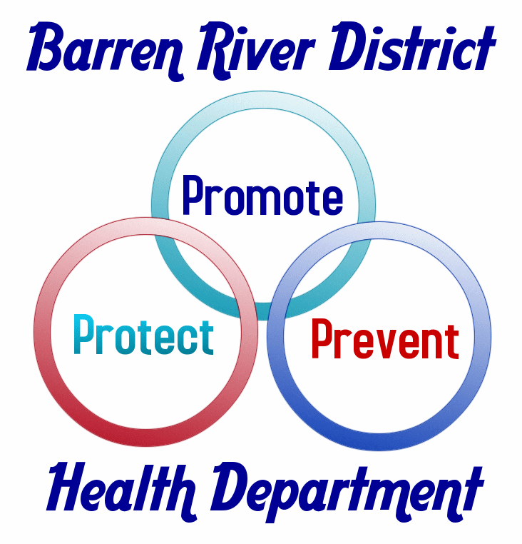

WIC is an equal opportunity provider.

Rev. 4/10/13 RT

WIC   
Crece las familias sanas

WIC es otra manera de hacer algo bueno papa su familia. WIC proporciona alimentos sanos.

– Inclusive frutas y verduras frescas y granos enteros… y mucho más.

* Aconsejar Nutricional
* El Amamantamiento gue aconseja y apoya
* Investigación de Salud
* Las Referencias a Servicios de Sanidad

Si está embarazada, amamantar, dio la luz a un bebé o tiene a niños gajo de la edad de cinco años usetd puede calificar.

Pautas de ingresos de WIC*

Effectivo 1 de Abril 2013 – 31 de Marco 2014

Numero de

|  |  |  |  |
| --- | --- | --- | --- |
| Personas en la casa | Semana | Mes | Año |
| 1 persona | $ 409 | $1,772 | $21,257 |
| 2 | 552 | 2,392 | 28,694 |
| 3 | 695 | 3,011 | 36,131 |
| 4 | 838 | 3,631 | 43,568 |
| 5 | 981 | 4,251 | 51,005 |
| 6 | 1,124 | 4,871 | 58,442 |
| 7 | 1,267 | 5,490 | 65,879 |
| 8 | 1,410 | 6,110 | 73,316 |
|  |  |  |  |

*Las personas que reciben Medicaid o beneficios de cupón de alimentos califique.

Para más información o para hacer una cita llama el departamento de la salud en su lugar:

Barren 651-8321 Logan 726-8341

Butler 526-3221 Metcalfe 432-3214

Edmonson 597-2194 Simpson 586-8261

Hart 524-2511 Warren 781-2490



WIC es una programa igual de oportunidad.

Rev. 4/10/13 RT