***KNOW***

**Optics**

**Absorption**

**Refraction**

**Reflection**

**Diffuse**

**Concave**

**Convex**

**Retina**

**Pupil**

**Cornea**

**Laser**

**Fiber optics**

**Mirrors** form images by reflecting light. Curved mirrors can form images that are distorted in useful ways. **Lenses** form images by refracting light. Lenses have curved surfaces that refract parallel light waves in different amounts. **Convex** lenses bend light inward toward a focal point. **Concave**  lenses spread out light. The eye is a natural optical tool. The eye uses lenses to focus images on the retina. The retina detects images and sends them to the brain. **Optical technology** makes use of light waves. Microscopes, cameras, telescope,are just some optical tools.

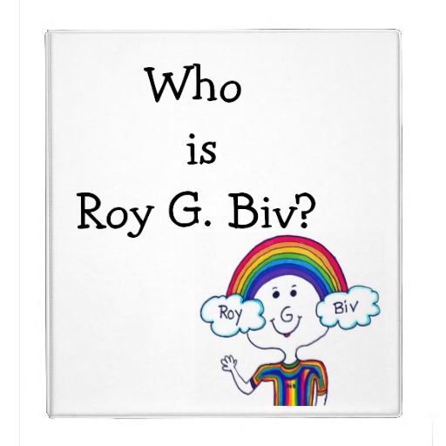

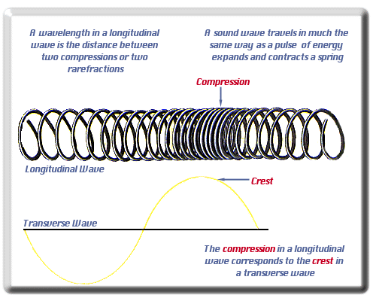

**Amplitude** is a measure of wave energy. Basically it is a wave’s intensity. It is measured in **decibels**. In other words, the louder a sound is the higher the decibels. The softer a sound is the lower the decibels. **\* * \*** Exposing your ears to constant high **volumes** can cause permanent hearing loss. 12% of kids 6 -19 yrs old suffer from permanent hearing loss. 17% of young adults have hearing loss. Cause: **LOUD MUSIC!**

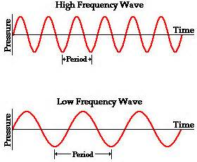

Movement affects our perception of waves. When a police car is moving TOWARDS you, the pitch sounds higher. This is because the wave lengths shorten as the car approaches you. When the police car is moving AWAY from you, the pitch sounds lower. This is because the wave lengths lengthen as the car drives away from you.

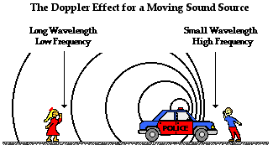

22. sound and light travel at different speeds.

23. high pitched sounds are caused by more vibrations and low pitched sounds are caused by fewer vibrations.

24. the Doppler Effect is the change in pitch as the sound or sound receiver.

25. the electromagnetic spectrum represents energy moving in an electric field and a magnetic field.

26. electromagnetic waves (EM spectrum) consist of gamma, x-rays, ultraviolet, visible, infrared, microwave, and radio.

27. all light is not visible.

28. the colors of visible light are created by electromagnetic energy of various frequencies.

29 light is a form of energy and has qualities of both waves and particles.

30. light waves travel in a straight line unless they meet an obstacle.

31. light travels in waves and is the fastest traveling wave (186,000 miles per second); therefore, we see distant events before we hear the sound they produce.

32. light waves travel at different speeds through different media and change direction when they encounter matter.

33. the characteristics of light waves are affected by the type of medium.

34. light interacts with matter by transmission (including refraction) and absorption (including reflection).

35. the principles of reflection, refraction, diffraction and absorption affect the travel of a light wave.

36 the angle of incidence equals the angle of reflection.

37. waves traveling through the same space at the same time interfere with each other.

38. light rays bend when they pass from air to water or from water to air.

39. mirrors change the direction of light waves.

40. all matter reflects and absorbs light waves.

41. white light is composed of all wavelengths.

42. when white light is refracted, it can be separated into its component colors.

43. a correlation exists between visible light and heat absorption.

44. light from the Sun is made up of a mixture of many different colors of light; even though to the eye, the light looks almost white.

[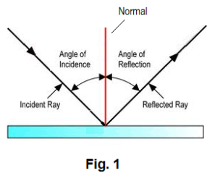](http://www.google.com/url?sa=i&rct=j&q=&esrc=s&source=images&cd=&cad=rja&uact=8&ved=0ahUKEwiwtN6fyLvJAhUFYiYKHQRqCWIQjRwIBw&url=http://www.solitaryroad.com/c1033.html&bvm=bv.108538919,d.eWE&psig=AFQjCNG0yXa6OP5GPv8-wl0N16EWM7H2Mg&ust=1449090316589295)