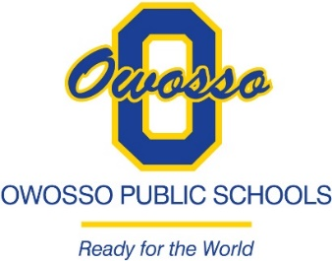

GSRP, HEAD START, ADULT EDUCATION AND YOUNG ADULT SPECIAL EDUCATION COVID-19 GRANTS NOTICE

Owosso Public Schools has created a listing of individuals that are qualified to receive the GSRP, Head Start, Adult Education and Young Adult Special Education COVID-19 grant from the listing of employees that were employed by the District when the Executive Order 2020-35 was enacted on April 2, 2020 and in conjunction with the qualifications published by the Michigan Department of Treasury.

Those employees that are still currently employed with the District on March 18, 2021 received an email with the qualified recipients listing and information to assist them to determine eligibility and the form 5741 that must be returned to the District by April 9, 2021. In order to facilitate access for those current employees that do not frequently access their emails, the listing of qualified employees has also been posted by building secretaries and will remain posted through April 9, 2021.

For all circumstances below or for other questions, please email covidgrant@owosso.k12.mi.us (Please be sure to include all relevant information in your email)
- I am a current or former employee that did not receive a listing of qualified individuals and would like to receive a copy.
- I have received a copy of the qualified listing and would like to appeal that a) I am not on the listing; and/or b) the listed full-time-equivalency (FTE).

If you do not have access to email, please call 989-723-8131. Arrangements can be made for you to obtain a copy of the qualified listing (note: this will only be allowable if you are listed as a current or former employee and can provide verification information). Any requests for appeal related to the qualified listing MUST be in writing and received by 4:30 p.m. on April 9, 2021.

Additional information about this grant can be obtained from the following website:

https://www.michigan.gov/treasury/0,4679,7-121-1751_74806-551784--,00.html

