March 30th Kindergarten Goal Sheet
Phonics/ Language Arts
Students will be able to read sight words learned to date.
Students will be able to read short sentences.

Handwriting
Students will be able to write with correct letter formation.
Students will be able to write with correct sentence structure.

Numbers/ Math
Students will be able to recognize and count coins.
Students will be able to add and subtract.

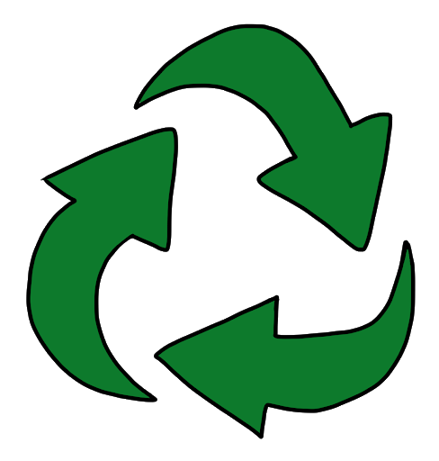
Social Studies/ Science
God’s Creation, Recycling

Bible
Elisha and the Prophet

