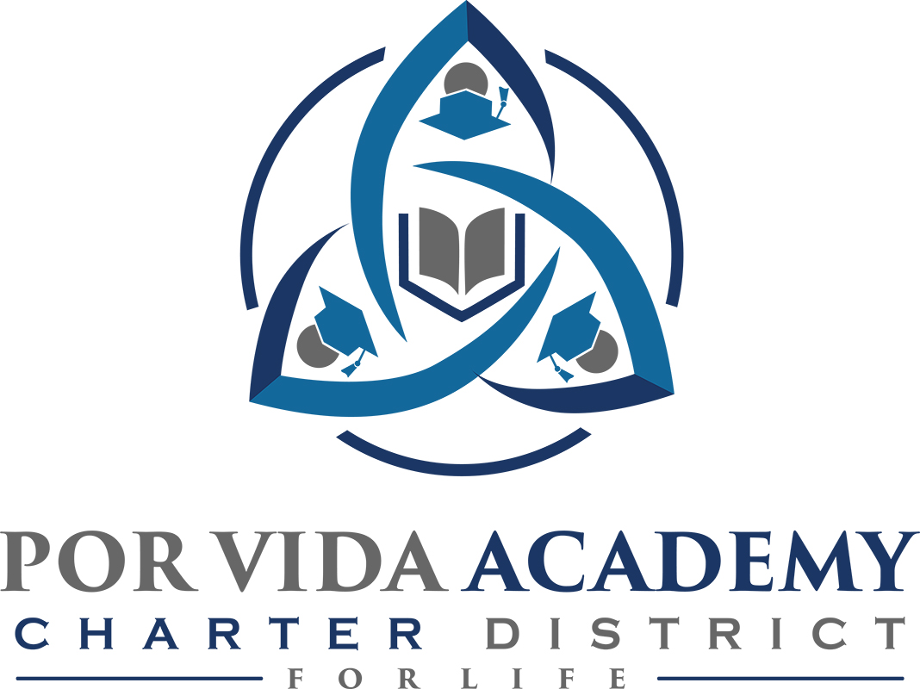

Friday, August 24, 2018 at 12:00pm 1135 Mission Road, SA TX 78210

Minutes of Regular Called Board Meeting

- Call to Order and Establishment of Quorum
  - Roll Call & Recording of Board Members Present - Declaration of Quorum Present
    - Sr. Odilia Korenek, Edie Cogdell
  - Recording of the Executive Director/Superintendent and Staff Members Present.
    - Joseph Rendon, Stephanie Rodriguez, Danette Salazar, Loren Franckowiak, Mary Alice

- Close Session: Personnel discussion of former employees. NONE

- Pledge of Allegiance

- Salute to the Texas Flag- “Honor the Texas Flag; I pledge allegiance to thee, Texas, one state under God, one and indivisible.”

- Public Testimony

- Approval of Minutes: August 3, 2018

  - Sister Odilia moves to approve, Edie Cogdell seconded. August 3, 2018 minutes approved as presented.

- Superintendent Items:
- FIRST Ratings. Failed our 2017-2018 Charter FIRST Rating. Score was 50 out of 100. Earned zero points for indicator numbers 6, 7, 9, 10 and 12. Not appealing rating. We had a tough year, expenses were super high and ADA shot down, it was too late in the year and simply couldn’t cut enough. Our expenses exceeded revenues and our balloon payment didn’t help. However, we met with our auditor, Mike Del Toro, for a better understanding of the rating and feel more confident about next year.

- Campus reports. For our latest outreach, flyer mailouts were created and mailed out for each campus. PVA focused on a ten mile radius while Corpus went by zip codes.

- Guardian Plan. Allows employee to carry a concealed weapon. Superintendent’s school marshal license has expired. Board Resolution plan creates a policy and sister will sign a letter of authorization to carry. Information was provided last board meeting. Can be rescinded by the board at any time for any reason. We awarded $10,000 for school safety training to use any way we chose to. Principals interested in having an active shooter preparation training. Edie is on board with everything discussed. Edie moves to approve and sister Odilia seconded. All in favor. Guardian plan approved as presented.

- Accountability ratings. Is a district grade, Por Vida received an “F” rating, scored 59 out of 100. There are three domains, student achievement, school progress and closing the gap. Student Achievement we met standard, scored 66 out of 100. Mrs. Franckowiak feels confident this domain will go up. All three campuses had a rough year.School progress met standard as well, scored 71 out of 100. This domain compares students and how the score from test to test., with a set target. Mrs. Franckowiak said students progress has increased each year. Closing the gap scored 30 out of 100. State of TX looks at 14 sub groups, state will take the best 2 and this counts up to 70% Students have to be enrolled by snapshot (Oct) and stay within the districts four snapshots in a row, any students who come in in Nov. we will not earn any points for. Our high mobility hurts us. We are working with our attorneys regarding all the data to try to get us from an F to a D. With a D score it is still considered a strike but we will deal with less intervention.

- Local Government Officer. Superintendent invited to go on a dove hunt. Our attorney advised him to create a board policy allowing that, and to fill out a local government officer form. Board will have to approve. Superintendent will work with the attorney to write the policy for accepting gifts over $100, Edie suggested to put a threshold.

- Financials
  - Budget Approval. Edie Cogdell moves to approve, Sister Odilia seconded. Budget for 2018-2019 school year approved as presented, by fund and function.

  - Current Financials. Edie Cogdell moves to approve, Sister Odilia seconded. Current financials/final budget amendment as of August 24 approved as presented, by fund and function.

- Board Items: None

- Adjournment

Sr. Odilia Korenek adjourned meeting at 1:08 pm.

_____________________________ _____________________
Sr. Odilia Korenek Date Edie Cogdell Date
President Secretary

