Week of April 1st-7th
- Everyday go through the circle time routine!
- Hello Hello!
- __ Is here today! (After this video, have your child look for their name in a list of 3 different names OR find their picture from at least 3 pictures.
- ABCs
- AM class BOOK PM class BOOK
- Monthly Song
- Ask a question of the day. It’s so important to ask questions and discuss with your child daily. Questions
- Letter Bb:
- Listen to the fun letter song Letter Bb Song
- Complete 1, 2, or all the practice sheets Worksheets
- Try to make the letter B using beans!
- Blow Bubbles!
- Color with the color Blue!
- Number 2:
  - Sort out items (Ex. Cheerios and Fruit loops, colors, Cups and bowls, the color of veggies straws, etc)
  - Count out objects while using your pointer finger to touch the object (Ex. Count how many baby dolls, cars, etc.)
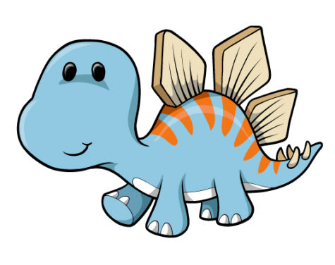
  - Complete 1, 2, or all the practice sheets Worksheets
- Story Time!
Listen to the story: Twinkle Twinkle Dinosaur
Do one of these fun activities: Dinosaur Feet
Coloring Sheet
Line Tracing
- Social Skill: Handwashing
Print off this sequencing worksheet. Help your child complete the sequence of handwashing. Handwashing
- Movement Break!
  - Dinosaur Stomp
  - Count to 100!

Ask me for a Starfall Code for 4 months free access!
Check out my Pinterest Page for some fun ideas to do at home! Mrs. Alex’s Class Pinterest Page
