Mrs. Clapsadle’s Newsletter
October 7th-10th, 2019
Reading/Language
Selection: The Ugly Vegetables
Skills:
- Drawing conclusions
- Double consonants and ck
- Double consonants and cvc
- Homophones
- Proper noun
The students will………………
- Demonstrate grammar usage
- Demonstrate capitalization, punctuation, and spelling
- Read with fluency and accuracy
- Apply phonics and word analysis skills
- Demonstrate understanding of characters, setting, and plot
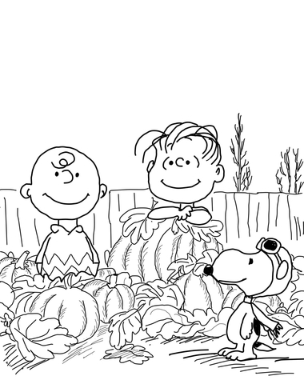
Math
- Place value test
- Measurement
The student will………….
- Measure the length of an object.
- Be able to determine the appropriate tool for measuring different objects.
- Estimate lengths using different units of measure.
Science/Social Studies
- We will be working on fire safety activities this week
- Fire safety program rescheduled for Tuesday the 8th.
- Please dress appropriately!
Important events and dates this week!
October 7-10 Book Fair
October 7- PTO Breakfast with a Loved One PreK-2 grade students 9:30-10:30
October 8- PTO Breakfast with a Loved One 3 rd -6 th grade students 9:30-10:30
Fire prev. program
October 10-Parent Teacher Conferences
October 11- No School
October 14- No School
October 15- Staff PD/No school for students

Lesson 7 word lists/The Ugly Vegetables
Spelling Words/lesson 7/double consonants and ck
- dress 9. rock
- spell 10. black
- class 11. trick
- full 12. doll
- add 13. will
- neck 14.off
- stuck 15. across
- kick 16. pocket

Vocabulary
- shovels-garden tool used for lifting, digging, and moving soil
- blooming- having flowers
- scent-a smell
- nodded-moving the head up and down
- wrinkled- folded up in a messy way
- plain- simple, not fancy
- muscles- parts of the body used to help you move and do things
- tough- hard, thick on the outside

High Frequency Words
air car cried funny he
pictures pretty told try window

