1.

1. Carbon-based molecules found in all living things are called…

9.

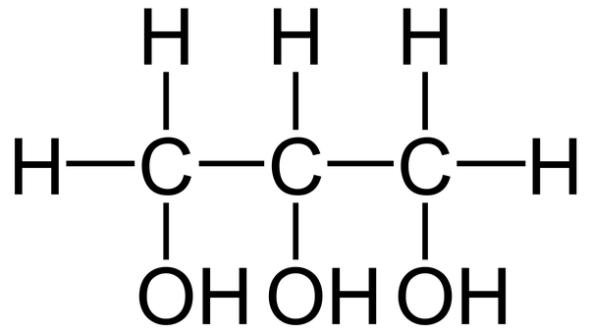

8. Lipids are made of ____________.

(subunit or monomer)

7. List 3 job of a lipid.

3. List 5 examples of a lipid.

2. What are the 4 different groups of macromolecules?

6. What elements are lipids made up of?

5. What is hydrophobic?

Hydrophilic?

4. What is a phospholipid?

Draw it.

1.

10. List 4 examples of a

carbohydrate.

18. What’s the job of a protein?

(It’s also the definition of an enzyme.)

17. List 4 examples of proteins.

16.

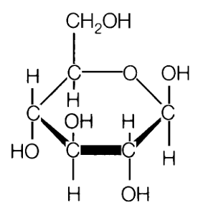

12. What is the formula for sugar?

11. What elements are carbohydrates made of?

15. What is another name for cellulose?

Where do you find it?

14. List 3 jobs of a carbohydrate.

13. Carbohydrates are made of _____________.

(subunit or monomer)

1.

19. What elements are proteins made of?

27.

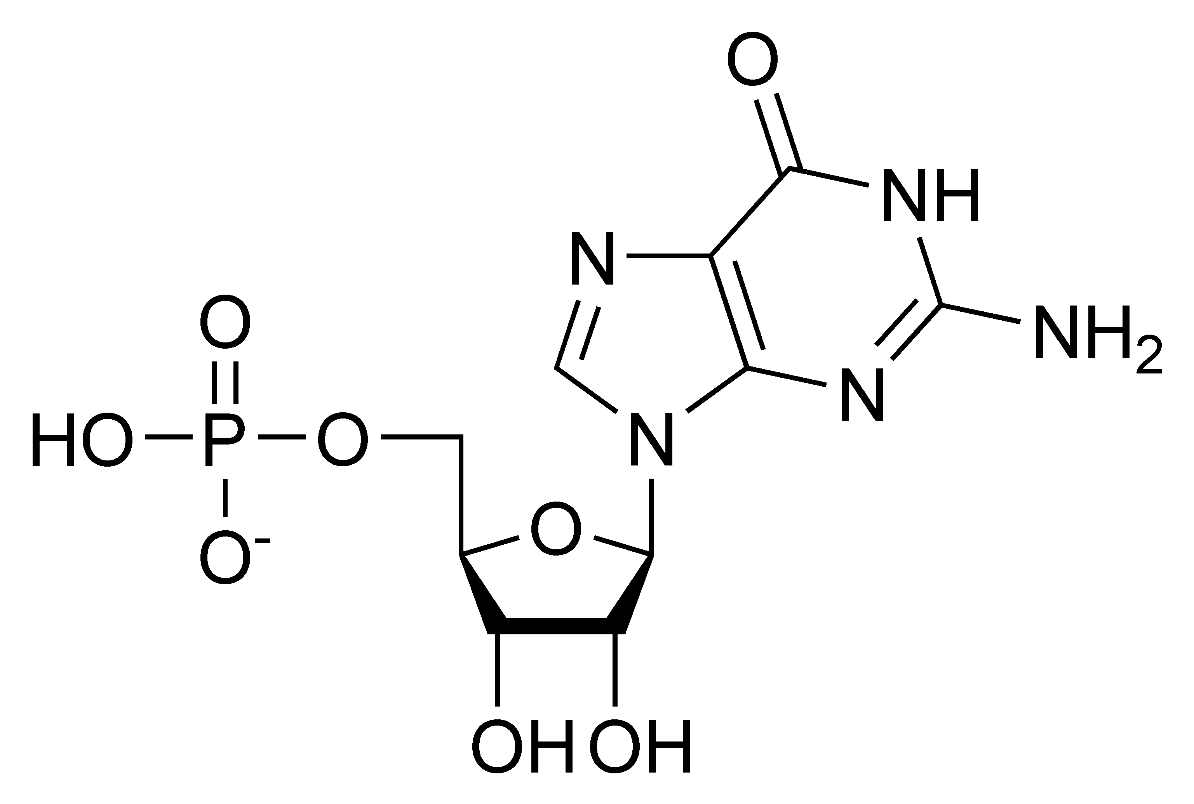

26.

Draw (or describe) a nucleotide.

25. Nucleic acids are made of _______________.

(subunit or monomer)

21.

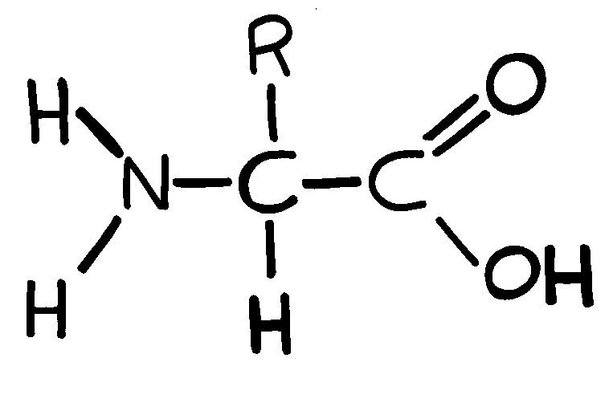

20. Proteins are made of __________.

(subunit or monomer)

24. What elements are nucleic acids made of?

23. List 2 jobs of a nucleic acid.

22. List 2 examples of a nucleic acid.

1.

1.

9.

8.

7.

3.

2.

6.

5.

4.