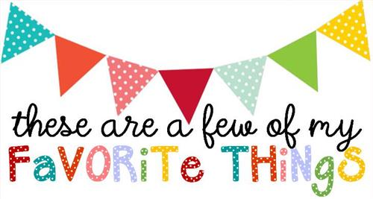

Name: Brittany Purnell
T-shirt Size: M
Birthday: 6/18/85
Monogram: B P S
Favorite Color: Green
Favorite Flower: Daisy
Favorite Scent: Clean
Favorite Candy: Chewy, tarty, sour
Favorite Drink: coffee, tea, mt. dew
Favorite Food: Deli sandwiches
Favorite Snack: beef jerky
Favorite Fruit: pineapple
Favorite Restaurant: Deli (newks, peppers, mcalisters
Favorite Places to Shop: local boutique
Things I collect: Click or tap here to enter text.
Favorite Author/Book Series for my own personal reading: Click or tap here to enter text.
Wish List for Classroom: candy, air wicks scents, colored paper

