Revopay donation instructions: (All donations are subject to a 3% convenience fee. This fee is charged and collected by Revopay)
Go to…
https://web2-vm.revopay.com/bridegwaypaymentssystems-school/properties/hernandohillselementary1/login and select “Make a Quick Payment”

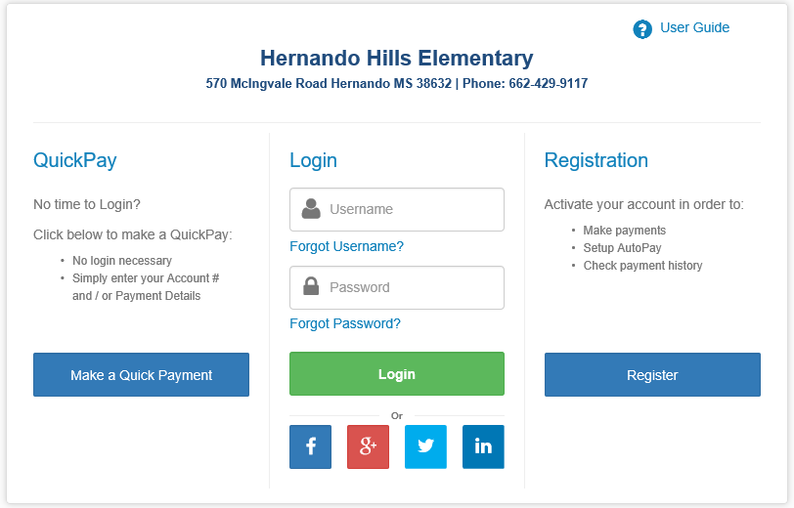

On the Hernando Hills Elementary “Make a QuickPay” page, select Playground Donation by checking the box to the right and enter the amount of your donation.

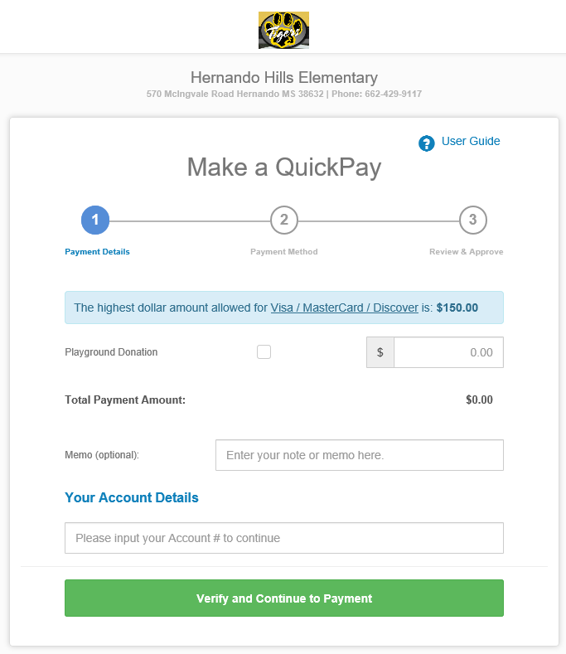

Enter donor’s name in the Memo field (optional), and PLAYGROUND DONATIONS in “Your Account Details”.
Account detail is required. Your payment will not be processed without the account information = PLAYGROUND DONATIONS.
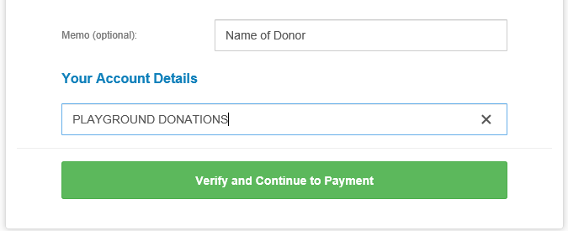
Click “Verify and Continue to Payment”

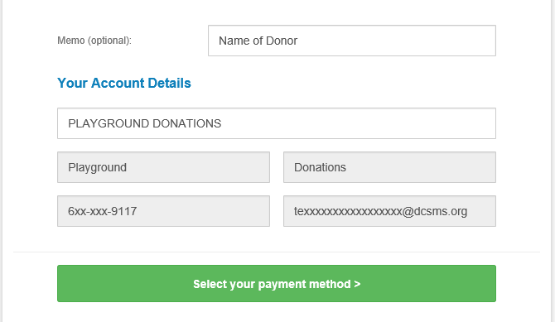
Click “Select your payment method”

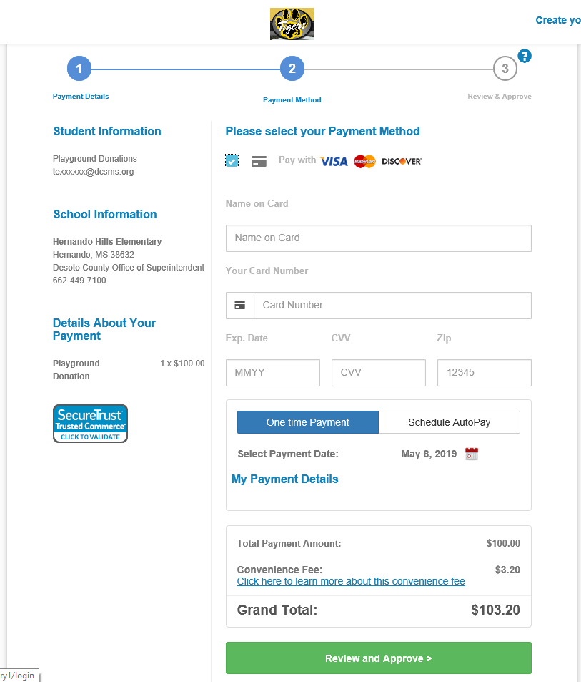

Select from the credit card options by clicking the appropriate icon. Enter your payment information and click “Review and Approve”

**Revopay charges a 3% fee to the donor.

