Mrs. Cook’s Messages
May 17-21, 2021
Grammar (commas) and
Reading Skills (sequence) Tests: Thursday
Vocabulary, Spelling (suffixes: -ness, -less), and Topic 12 Math Tests: Friday
Awards Day for 2nd grade will be on Friday, May 28th. There will be two classes at a time in the lunchroom. Each student will receive 3 tickets for 3 people to attend. At 8:15-8:30 am Bowles/Cook class, 8:45-9:00 am Daniel/Rowell, 9:15-9:30 am Sharpe/Turner. Please refer to the sheet I am attaching to this newsletter about awards day for other information. The students will stand when their name is called and the award will be placed with their report card. This will make the ceremony go quicker and smoothly. You may check your child out after their awards are given but please have proper ID. Thanks.
Story:  “Cowboys” by Lucille Recht Penner  Phonics/Fluency:  suffixes –  -ness, -less, -able, -ible  Text-Based Comprehension:  sequence,  text structure  Grammar:  commas | Selection Vocabulary Words (Students will be tested on these):  - cowboy – a person who works on a cattle ranch  - cattle – animals raised for their meat, milk, or skins  - campfire – an outdoor fire used for cooking or staying warm  - galloped – to run very fast  - herd – a group of the same kind of animals  - railroad – a system of trains, tracks, stations, and other  property run by a transportation company  - trails – paths across fields or through the woods  Amazing Words  climate, occupation, drover, legend,  livestock, buckaroo, lariat, rawhide
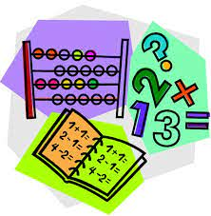  Topic 12: Geometry  Lesson 4: Making New Shapes  Lesson 6: Dividing Rectangles  into Equal Squares  Lesson 7: Wholes and Equal Parts  Lesson 8: Problem Solving, Use Reasoning  * Plane Shapes and Solid Figures  Quiz on Monday! *  * Topic 12 Test on Friday! * |  | Social Studies/Science  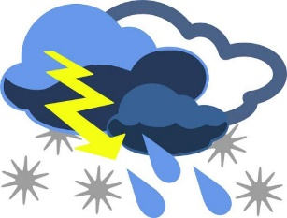  This week we will discuss the  various types of weather that  happen on Earth. We will learn  about safety procedures to  follow during severe weather  conditions. We will also discuss the water cycle.
Spelling Words:
- kindness  - careless  - goodness | - useless  - fearless  - darkness |  | - sadness  - sickness  - helpless | - thankless  - fitness  - weakness

