Welcome to the 2020-2021 digital school year at Huntington Middle School!

We are very happy to have your child in our school this year. We look forward to getting to know you and your child as the year progresses and for the opportunity to teach your child and to watch him or her grow as a learner. Please take some time to look over the information in this brochure about digital learning procedures and expectations. This year will be especially different so the information provided will help you understand what will be expected of your child.

If you have any questions, please feel free to contact us. The school number is (478) 542-2240. Please feel free to leave a message, and we will get back to you as soon as possible.

Again, we look forward to the opportunity to teach your child digitally. We are excited for this opportunity and unique experience.

Sincerely,
Dr. Gwendolyn Taylor
Principal Huntington Middle School

Our Daily Schedule

Your child will have a required schedule that they will receive. Attendance will be taken in each class and this is how they will be counted present for the day. They will need to make sure they sign into the Odysseyware class they are assigned to at the time on their schedule. They will need to make sure they are completing all the assigned lessons in the time set for them. There will be a teacher assigned to help monitor and help your student with each of their classes.

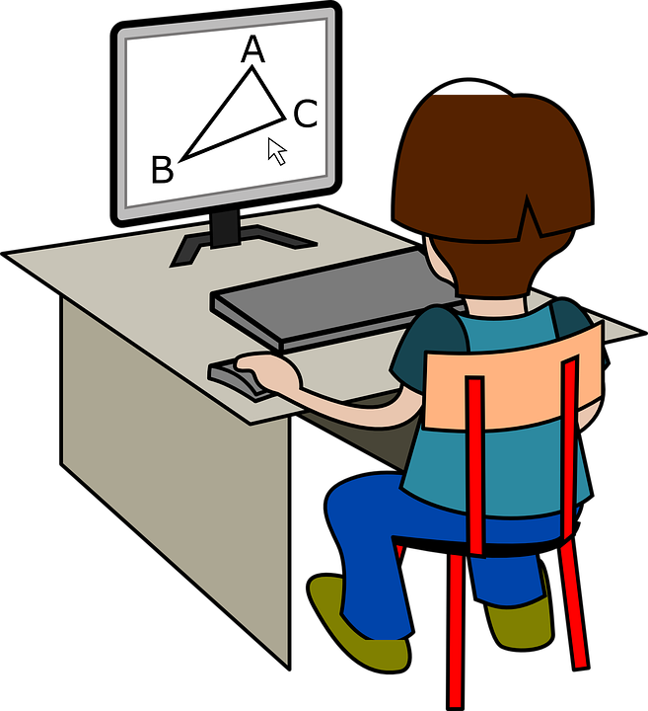

Welcome to Digital
Learning!

Attendance
We will be taking daily attendance in each class each day. Your child is expected to be on time and present in each of their scheduled classes. If your child has an appointment or misses a class due to an illness, please provide a doctor’s note to one of the following:
Miranda.mercer@hcbe.net
Sonja.Gibson@hcbe.net
Sandra.Howard@hcbe.net

Parent Involvement
Naturally, as a parent, you want your child to succeed. However, learning takes place when students are given healthy struggles. We ask that during this time of digital learning you allow your child to work through their assignments as independently as possible.
Ways you can support your child:
- Provide technology support when needed
- Encourage routine
- Provide a place free from distraction
- Help clarify misunderstandings without completing work for them

Technology
Students must have a device that can access the internet every day to participate in digital learning.

Student Involvement
Every day students will have class work in Odysseyware daily that needs to be completed independently. We ask that you allow your child to complete the work on their own. Your role as the parent/guardian is to provide support only when needed.

Zoom Etiquette
When a Zoom meeting is needed, you will act just like you would in the classroom! Just like in the classroom, there will be rules and expectations for Zoom meetings so that we create the best possible learning environment.
- Be on time for the meeting
- Have your camera turned on and facing yourself at all times. Please do not change your background
- Mute your volume while the teacher and/or classmate is talking
- If you have a question, raise your hand so your teacher can unmute you
- Stay on task and pay attention to your teacher or whoever is talking
- Be kind to everyone!
Remember even though you are learning at home you are still a Huntington Hawk!

Our Mission
In partnership with students, parents, and the community, is committed in thoughts, words, and deeds to empower our students to become lifelong learners, and productive, responsible citizens.

Our Vision
To become an institution that produces students who are academically, emotionally and socially prepared to succeed in all facts of life.
