“Lifted Text” from Various Dr. Seuss Books

The Cat in the HaT
Then our mother came in  And she said to us two,  “Did you have any fun?  Tell me. What did you do?”  And Sally and I did not  know what to say.  Should we tell her  The things that went on  there that day?  Well... what would YOU do  If your mother asked you? | 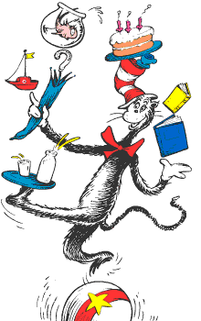 | Look at me!  Look at me!  Look at me NOW!  It is fun to have fun  But you have  to know how.

Horton Hatches the Egg
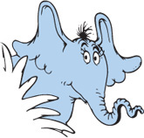 | I meant what I said  And I said what I meant….  An elephant’s faithful  One hundred per cent!  And it should be,  it should be, it SHOULD be  like that!  Because Horton was faithful!  He sat and he sat! | “My goodness! My gracious!”  they shouted. “MY WORD!  It’s something brand new!  IT’S AN ELEPHANT-BIRD!!”

Green Eggs and Ham
Do you like green eggs and ham?  I do not like them, Sam-I-am.  I do not like green eggs and ham!  Would you like them here or there? | I would not like them here or there.  I would not like them anywhere.  I do so like green eggs and ham!  Thank you! Thank you,  Sam-I-am! | 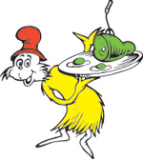

One fish two fish red fish blue fish
Oh me! Oh my!  Oh me! Oh my!  What a lot of funny things go by. | 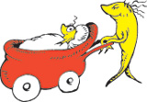

Yertle the Turtle
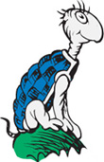 | I’m Yertle the Turtle!  Oh, marvelous me!  For I am the ruler  of all that I see! | Your Majesty. Please…  I don’t like to complain.  But down here below,  we are feeling great pain.

Horton Hears a Who!
“I’ll find it!” cried Horton.  “I’ll find it or bust!  I SHALL find my friends  on my small speck of dust!” | We’ve GOT to make noises in greater amounts!  So, open your mouth, lad!  For every voice counts! | 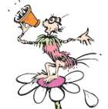

The Lorax
I am the Lorax.  I speak for the trees.  I speak for the trees, for the trees have no tongues. | 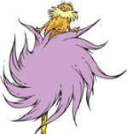 | I meant no harm.  I most truly did not.  But I had to grow bigger.  So bigger I got.

Oh, the Places You'll Go!
You have brains in your head.  You have feet in your shoes.  You can steer yourself  Any direction you choose.  You’re on your own. And  you know what you know.  And YOU are the guy who’ll  decide where to go. | You’ll get mixed up,  of course, as you already know.  You’ll get mixed up with  many strange birds as you go.  So be sure when you step.  Step with care and great  tact and remember that  Life’s A Great Balancing Act. | And will you succeed?  Yes! You will, indeed!  (98 and ¾ percent guaranteed.)  KID, YOU’LL MOVE  MOUNTAINS!

How the Grinch Stole Christmas!
The Grinch hated Christmas!  The whole Christmas season!  Now, please don't ask why.  No one quite knows the reason. | 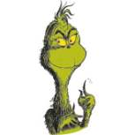 | “Maybe Christmas,” he thought, “doesn’t come from a store.  Maybe Christmas… perhaps…  means a little bit more!”

Happy Birthday To You!
If we didn’t have birthdays,  you wouldn’t be you.  If you’d never been born,  well then what would you do?  If you’d never been born,  well then what would you be?  You might be a fish!  Or a toad in a tree!  You might be a doorknob!  Or three baked potatoes!  You might be a bag full of  hard green tomatoes. | Or worse than all that…  Why, you might be a WASN’T!  A Wasn’t has no fun at all.  No, he doesn’t.  A Wasn’t just isn’t. He just  isn’t present. But you…  You ARE YOU!  And, now isn’t that pleasant! | 