WEEK 7 (May 4-May 8) – read the passage and do the following TWO things:
- Determine your Words Per Minute (WPM). Set a timer for one minute as you read. When the timer ends, stop reading and count how many words you read in one minute. Use this chart to help you find out how many WPM your grade level can read:
Grade 5 = 130 Grade 6 = 140
Grade 7 = 150 Grade 8 = 160
Grade 9 = 170 Grade 10 = 180
Grade 11 = 190 Grade 12 = 200

- Answer the seven questions that follow the passage.
- Email completed assignments to robert.brown@dcsms.org
- Your email should include the following:
- The week’s number for that assignment (Week 3, Week 4, etc…) can go in the “Subject line”.
- The student’s name and a list of the letter choices you pick as answers to the multiple-choice questions that follow the passage can go in the body.
EXAMPLE e-mail:
To: robert.brown@dcsms.org
Subject: Week 4
Johnny Brown – ACDBCAC
__________________________________________________________
SCROLL DOWN TO SEE THE PASSAGE and 7 QUESTIONS

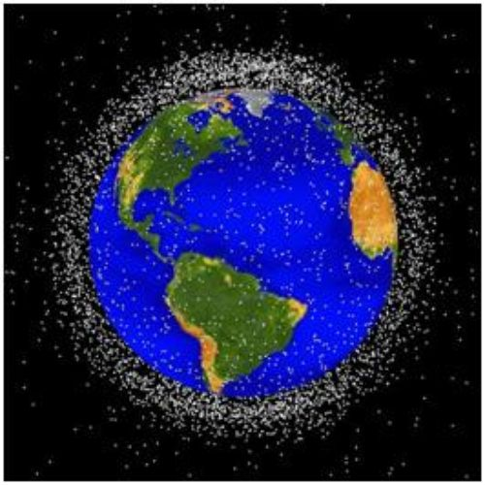

Many people know that trash is a big problem on planet Earth. What many people don’t know is that trash has become a problem in outer space too. Years of space exploration have left tons of “space junk” in orbit around the planet.
According to BBC News, there are more than 22,000 pieces of junk in space around the earth. And these are just the items that we can see from the surface of the earth by telescopes or radars. There are also millions of smaller pieces of junk that we can’t see.
Objects, like bits of old space rockets or satellites, move around the planet at very high speeds, so fast that even a very small piece can break important satellites or become dangerous to people, particularly astronauts. If the tiniest piece of junk crashed into a spacecraft, it could damage the vehicle. That’s because the faster an object moves, the greater the impact if the object collides with something else.
To make things worse, when two objects in space collide, the two objects break into many smaller pieces. This happened in 2009 when a working United States satellite collided with a Russian satellite that was no longer functioning. The collision caused the satellites to break into more than 2,000 pieces, increasing the items of space junk.
To help minimize additional space junk, countries around the world have agreed to limit the time their space tools stay in orbit to 25 years. Each tool must be built to fall safely into the earth’s atmosphere, or the mass of gases that surround the earth, after that. In the upper parts of the atmosphere, it will burn up.
Many scientists are also proposing different ways to clean up space junk. In England a metal harpoon is being tested that can be fired into space trash, grip the trash, and then pull the space junk into the earth’s atmosphere where it would burn up.
The Germans have been planning a space mission with robots that would collect pieces of space trash and bring them back to Earth so that they can be safely destroyed.
In 2007 the Chinese tried to blow up one of its older satellites with a missile. Unfortunately, the explosion only created thousands of smaller pieces, adding junk in space!
"In our opinion the problem is very challenging, and it's quite urgent as well," said Marco Castronuovo, an Italian Space Agency researcher who is working to solve the problem. One reason that it’s urgent is that countries are sending more and more objects into space. Many of these objects are tools that help people use their cell phones or computers.
"The time to act is now; as we go farther in time we will need to remove more and more fragments," he says.
_____________________________________________________

1. What has left tons of “space junk” in orbit around the earth?
- robots sent on space missions
- years of space exploration
- lack of recycling
- missiles in outer space

2. Countries around the world have agreed to limit the time their space tools stay in orbit to 25 years. As explained in the passage, what problem does this solution address?
- the increasing amount of space junk in orbit around the earth
- space agencies exploring space
- Chinese efforts to blow up a satellite
- objects moving around the planet at very high speeds

3. Trash has become a problem in outer space too.

What evidence from the text best supports this statement?
- The Chinese tried to blow up one of its satellites with a missile in 2007.
- In England, a metal harpoon is being tested that can be fired into space, gripping space trash and pulling it back into the earth’s atmosphere to burn up.
- The Germans have been planning a space mission with robots to collect some space trash and bring it back to Earth.
- According to BBC News, there are more than 22,000 pieces of junk in space around the earth.

4. Why have countries agreed to build space tools that must fall safely into the earth’s atmosphere?
- so that the tools can remove pollution from the atmosphere after returning from space
- so that the tools burn up in the atmosphere and don’t become space junk
- so that the tools pollute the atmosphere instead of outer space
- so that the tools can analyze the different gases that make up the atmosphere after returning from space

5. What was the passage mostly about?
- different missions scientists are trying in space
- the effects that tiny pieces of space junk could have on the earth
- the problem of space junk and scientists’ attempts to solve this problem
- the problem of trash on planet Earth

6. Read the following sentences: “‘In our opinion the problem is very challenging and it's quite urgent as well,’ said Marco Castronuovo, an Italian Space Agency researcher who is working to solve the problem. One reason that it’s urgent is that countries are sending more and more objects into space. Many of these objects are tools that help people use their cell phones or computers.”

What does the word urgent most nearly mean?
- easy to solve
- unnecessary
- needs immediate attention
- minor

7. Choose the answer that best completes the sentence below.

Years of space exploration have left tons of “space junk,” _______ many scientists are trying to find a way to clean up outer space.
- so
- instead
- because
- similarly

