**International Baccalaureate Program • Murphy High School**

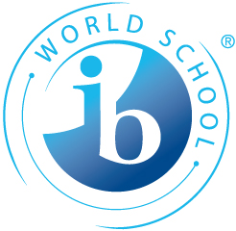

**100 S. Carlen Street • Mobile, AL 36606 • 251/221-3187 • 251/221-3201 (fax)**

EXTENDED ESSAY

Subject Area Choice Contract

The subject area chosen must be a course/subject area offered by the Murphy IB Program. Following this requirement affords you the best supervision and allows your extended essay to serve a dual purpose; to fulfill an IB Diploma requirement and to serve as a preparation for an IB examination. It also means that you have an extensive background in the subject area before you begin your paper.

Subject area chosen: ________________________________

Student’s name: __________________________________________________________________

Academic mentor’s name: __________________________________________________________

Parent’s name: ___________________________________________________________________

Address: ________________________________________________________________________

Work phone #: ___________________________ Home phone #: _________________________

Student email address: _____________________________________________________________

We understand that:

1. the extended essay is a requirement of the International Baccalaureate Program and that failure to complete and submit an extended essay means that a student is ineligible to receive the International Baccalaureate diploma.
2. “… 28 points overall will be required to be eligible for the diploma if a student attains an “E” grade in either the extended essay or theory of knowledge. …. a grade “A” in one of the requirements earns an extra point even if the other is a grade “E”. Attaining a grade “E” in both the extended essay and theory of knowledge continues to represent an automatic failure.”
3. the student must meet all deadlines.

___________________ ___________________________________

Date Student’s signature

___________________________________­­­­__________

Parent’s signature