DRAWING STUDIO 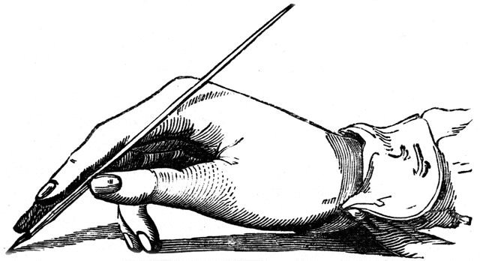 Instructor: Mrs. Vicki Maddox
Vicki.maddox@dcsms.org

Welcome to Drawing! Whether you are a beginner or advanced art student, you will enjoy learning the basics of drawing in various mediums. We will review the major periods of art history to better understand various art styles and qualities to assist you in find your ‘niche’ in art.

Textbook-Discovering Drawing- Reference only. We will use a classroom set of books. You ARE responsible to taking care of these texts.

Materials to bring to class. Purchase these at Wal-mart, Dollar Tree, Hobby Lobby, Target, etc. MATERIALS MUST BE BROUGHT TO CLASS IN NEXT WEEK. LABEL all items and keep in your backpack (except for the posterboard).

QUANTITY ITEM

_____1 9” x 12” sketchbook (50 or 100 pages)
_____1 12 count colored pencils (any brand)
_____1 Set of markers (any brand) at least 10 in package
_____1 Black gel ink pen
_____1 Drawing pencil set
(must include 2B, 2H, layout pencil, 2 charcoal pencils, eraser, & sharpener)
_____1 Twin tip Sharpie (fine point and ultra fine point ends)
_____1 22” x 28” poster board (white or color) your choice

DAILY ROUTINE-
BELL WORK – Beginning journal drawing first 10-15 minutes of class. (10% of total grade)

LAB CONDUCT/TECHNIQUE/DEMOS- Daily techniques of drawing and demonstrations of art skills. (15% of total grade)

DRAWING PROJECTS- (55% of grade) Weekly assignments. A grading rubric will be followed. Criteria includes: Attitude toward project, participation, completion, neatness, and display of the art principle taught. Abide by school policy on subject matter of artwork. Unacceptable subject matter will result in a grade of zero the first time and administrative discipline afterwards.

Nine Weeks Exam- 20% of total grade. Non-exempt students will have a final project to produce during exam time.

ALL WORK IS DUE ON THE DEADLINE DATE, unless the student has been absent. Makeup requirements are listed in the student handbook.
Sufficient time is given each day during Lab time to complete all assignments. Any work that is not completed in class will become homework during that week.

STUDENT SUCCESS

*Be on time for class. Two or more absences-non-exempt for this nine weeks course.
*Be prepared to learn each day- Have materials ready. Take restroom break BEFORE class.
*Be inspired to do great things-Listen to directions, learn from other artists, and treat others with respect. Each drawing will be original. You must do your own work.
*Be curious-Ask questions if you don’t understand.
*Be diligent-Make use of your time in class. Take care of all materials and equipment in the classroom. Clean tools and work area daily. Turn work in on time!
LATE WORK (other than for absences) WILL RECEIVE A ZERO!

Consequences- If the offense disrupts classroom instruction, you will be written up for administrative intervention, immediately.

- First offense- Student-Teacher Conference
- Second offense-Parent Phone call or email
- Third offense-Administrative discretion of consequence.

Drawing Projects-
Week One- Basics of Drawing Learning to Shade Basic Shapes (Still Life of Shapes)
Week Two- Turning spheres, cones and cubes into an imaginary creature.
Week Three- Drawing a still life of items from your backpack.
Week Four- Drawing caps and athletic equipment
Week Five- Drawing a still life of shoes and connecting to animation
Week Six- Drawing metal objects to study reflection
Week Seven- Drawing people to study facial features
Week Eight- Drawing animals
Week Nine- Drawing in one-point perspective.
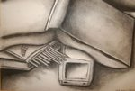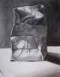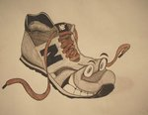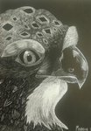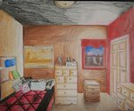

TEACHER WISH LIST

KLEENEX
HAND SANITIZER
CLOROX WIPES
MAGAZINES
ITEMS FOR STILL LIFE PROPS

EMPTY TIN CANS
EMPTY, CLEAN SOUR CREAM CONTAINERS OR LARGE COOL WHIP CONTAINERS
OLD SPORTING EQUIPMENT (BALLS, GLOVES, CAPS)
USED MIRRORED SUNGLASSES (the earpieces can be broken)
METAL POTS, PANS, UTENSILS, VASES
USED SHOES
CLEAN AND DRIED COW, DEER, SQUIRREL, ETC. SKULLS
PLASTIC TOYS
USED DRAPES OR LARGE SCRAPS OF FABRIC

Thank for you donating any items to our Drawing class!

Please sign and return the bottom portion to Mrs. Maddox. It is a homework grade.
_ _ _ _ _ _ _ _ _ _ _ __ __ _ _ _ _ _ _ _ _ _ _ _ _ _ _ _ _ _ _ _ _ _ _ _ _ _ _ _ _ _ _ _

Student/Parent/Guardian Contract- We have read the requirements for Drawing 1 and will strive to be successful throughout the course. Materials will be purchased and brought to class daily.

Student-_________________________________________________________________________date signed

Parent/Guardian_______________________________________________________________date signed

Please contact me by email, if there is any problem with the purchase of the drawing supplies for the class.

