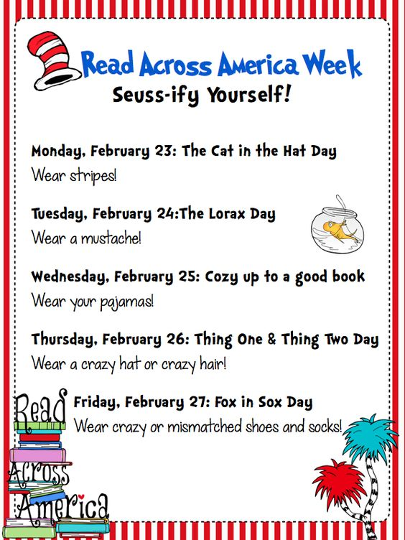

**Tape Mr. Folsom to the wall!**

**Kids earn tape by reading.**

**Then we have a**

**“Taping Assembly!”**

**Friday, March 3: Favorite Friday**

Dress as your favorite Dr. Seuss character

Coloring Sheet Contest Winners Announced

**Thursday, March 2: Fox in Socks**

Wear crazy socks

Sing “Happy Birthday” in morning announcements

**Wednesday, March 1: Green Eggs & Ham**

Wear green

Lunchroom serving green eggs

**Tuesday, February 28: One Fish, Two Fish**

Wear red or blue

Fish Bowl Game in Library

**Monday, February 27: The Cat in the Hat**

Wear your favorite hat

Coloring Sheet Contest