Week of April 15th-21st
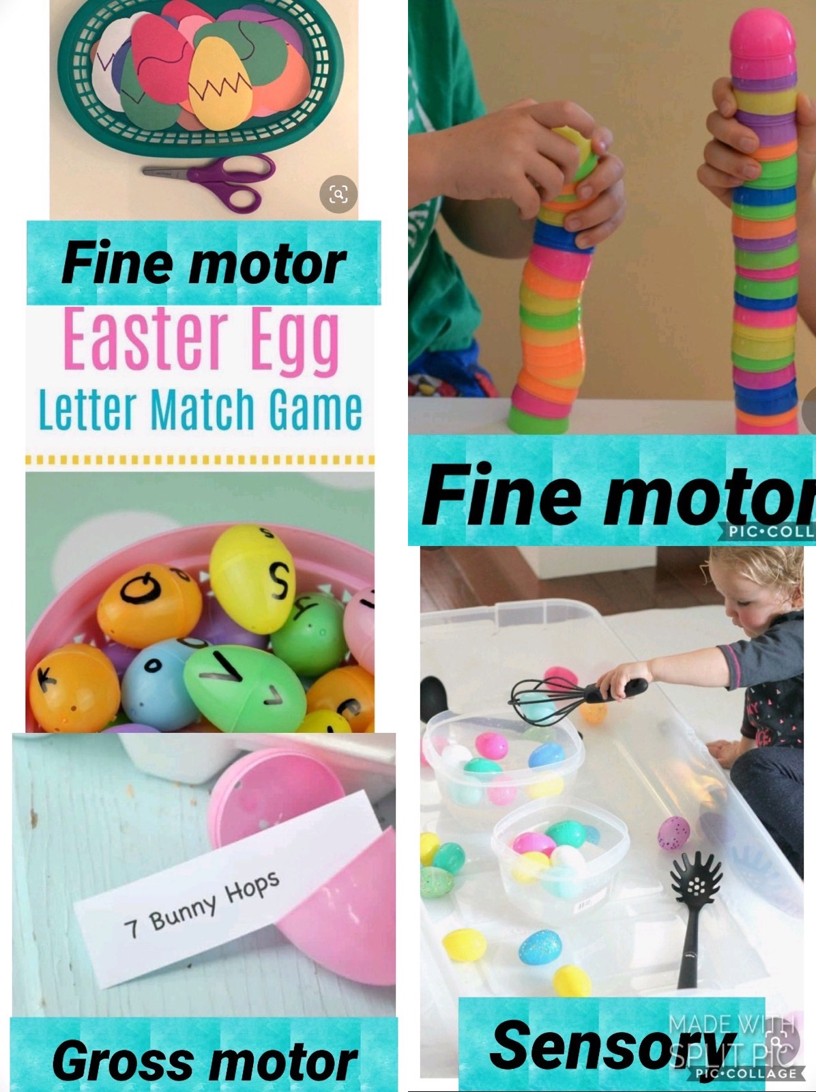
Easy activities to do with left over Easter Eggs:

Boom Cards:
Download the Boom Cards APP or go to https://wow.boomlearning.com/
Login using your child’s personal login. Password is PHES

Our pinterest has lots of fun activities and ideas to work on at home
https://www.pinterest.com/alexandriawolfdcs/

Circle Time stays the same!!!
It’s so important to keep a routine. Work on the same circle time activities/songs!
Check our my NEW YouTube Channel for easier access to my videos!!
https://www.youtube.com/channel/UCK1t9UDm1TMZdtUm5LJYn1w?view_as=subscriber

Questions of the day:
questions week 4.docx

Number 3:
Number 3.docx
Count out any items up to 3.
Lunch would be a super easy way to practicing counting!!

Letter Cc:
Letter Cc.docx
Practice tracing the letter C
Talk about the sound it makes and find things that start with a Cc.

