Week of April 29th-May 6th
Random Acts of Kindness Bingo
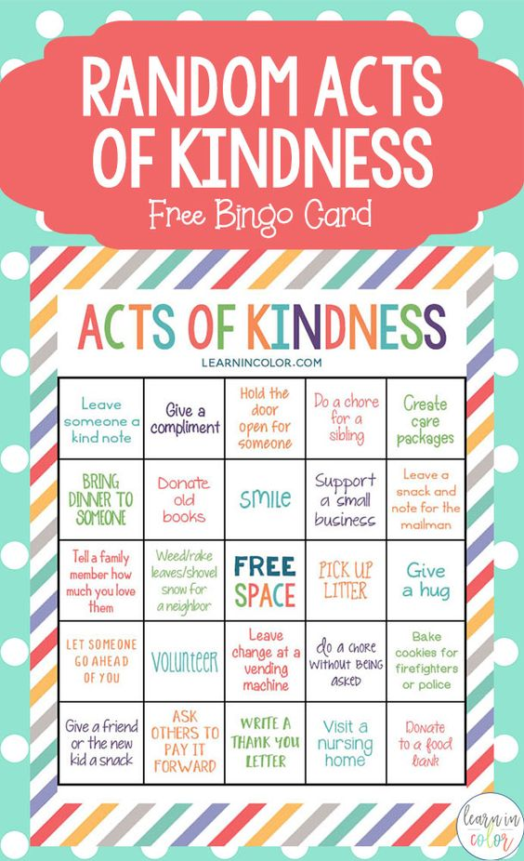

Boom Cards: at least 2-3 times a week. I change them
Download the Boom Cards APP or go to https://wow.boomlearning.com/
Login using your child’s personal login. Password is PHES, unless Ive given you a new one.
StarFall is another GREAT resource. Message me for the Code
Our pinterest has lots of fun activities and ideas to work on at home
https://www.pinterest.com/alexandriawolfdcs/

Circle Time stays the same!!!
It’s so important to keep a routine. Work on the same circle time activities/songs!
Check out my NEW YouTube Channel for easier access to my videos!!
https://www.youtube.com/channel/UCK1t9UDm1TMZdtUm5LJYn1w?view_as=subscriber

Questions of the day:
Week 6 Questions

New Videos to watch:
Kindness Song
The Alphabet Chant

Worksheets
Catepillar Counting
Line Tracing

*******To access links Press CTRL and the link

