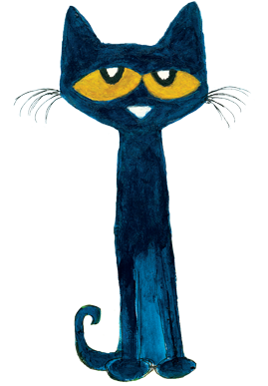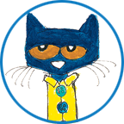



January

Important Reminders

Work with your child on proper handwashing. We will be washing hands frequently throughout the day to cut down the spread of germs. Send a snack and plastic water bottle with your child daily!

What are we learning?

Welcome back! We are learning so much at school! As we learn new things, we ask that you would work with your child on the following skills:

* Recognizing and writing first name
* Identifying letters in first name
* Counting to 15
* Touching one object at a time when counting
* Rules and procedures
* Winter and winter animals
* Goals
* Identifying basic shapes (circle, square, triangle, rectangle)
* Taking care of their own needs (putting on own mask, operating own clothes for bathroom, putting on own jacket, etc.)

\****We go outside every day that weather permits. Please send a jacket with your child if it is chilly in the morning. Our first outdoor time is 9:00.***

Mark your calendar

* Tuesday, Jan. 5th: Welcome back!
* Monday, Jan. 18th: NO SCHOOL
* Friday, Jan. 29th: Special snack/spirit day

*We will be setting learning goals this week. Goals will be posted in your child’s folder for you to help keep track of progress. *

Covid Reminders

Please let us know if your child tests positive for or is exposed to a Covid positive. Keep your child home if he/she isn’t feeling well.