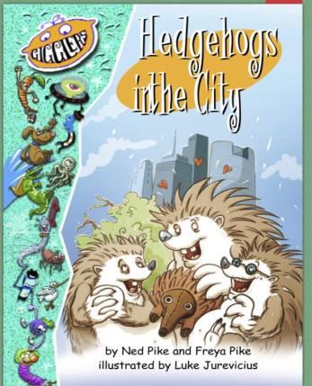

2ND GRAD
DCPS
E NEWS
May 11th -15th

Math Skills

We want to keep things as simple as possible for all students. We have created the 3 R’s. This is what Did you get a green light on Reflex your child with internet at home can do every day.
today?

This week your teacher will post on their website:
3 R’s: Read/Reflex/ReadingEggspress

• Word Problem of the Day Reading Eggspress. This week we have books for you
• 9
Box Review

to read and online quizzes to complete.
Remem
notebook
ber you can do this on

paper too.

Fiction Book: Hedgehogs in the City

Comprehension Questions Parents

Can Ask:
1. Pretend you are interviewing the Writing Prompt

main character of the story. What two questions would you ask them?

If you had a hedgeho g what 2. Can you retell the story to your family? Who was in the story? What would you name it? Where did they want? But what happened, would it live, what w ould So… Then how did the story end.
you feed it Phon
, ho
ics
w wo

uld you

care for it, and what would Non-Fiction Book: You Have a Pet Wh at?! HEDGEHOG
you do together?
Comprehension Questions Parents Can Ask:

1. Did you find an interesting Don’t forget to include an word? What was it? Use a opening and a closing.
dictionary to find its meaning.

2. What are two new pieces of information that you learned Remember me

from your reading?
Please remember these are only suggestions to help maintain Vid eos for kids:
information that was previously
https://www.youtube.com/watch?v=_mv-RfDVafY: YouTube: taught in class. Your child can 8 facts you should know
always choose a different book or
https://youtu.be/dWg-7xysy3I: Animal Planet 101 Hedgehog activity from home to complete.
facts Website/Facebook:

Please look at your teacher’s website
https://youtu.be/Dy68-bxlAxl: Animal Wonders: Hedgehogs!
for more links and information. We What, Where, and How
have also created a DCPS 2nd Grade Facebook group that you can follow
http://youtu.be/AMOdUJww6EQ: How to Draw a Hedgehog Easy
for more ideas and websites.

http
;//youtu.be/bYEU8faurls: How to Draw Sonic the

Hedgehog Easy

