Mrs. Cook’s Messages
February 22-26, 2021
Grammar (adverbs that tell how) on Thursday
Reading Skills (plot and theme) Test,
Vocabulary and Spelling (oo, ue, ew, ui) Tests: Friday
 |  |  |  |  | Friday will be special snack and Spirit Day. Wear something with our
 |  |  |  |  | school colors.
 |  |  |  |  | We are back to taking our tests on paper. There maybe times when
 |  |  |  |  | we have to take them online.
Story:  “The First Tortilla”  by Rudolfo Anaya  Phonics/Fluency:  vowel digraphs  oo, ue, ew, ui  Text-Based Comprehension:  plot and theme,  monitor and clarify  Grammar:  adverbs that tell  how |  |  |  | Selection Vocabulary Words (Students will be tested on these):  - awaken – cause to stop sleeping  - prize – something given to someone as a reward  - volcano – a cone-shaped mountain with a hole in the top that sends out melted rock and gases  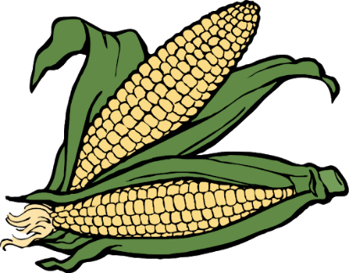  - cliffs – steep rock faces, like those at the edge of the sea  - rainbow – a display of many colors  - mountain – a high, steep hill that is often rocky  - suffer – to experience something bad or unpleasant  Amazing Words  condition, terrifying, whip, funnel,  predict, breeze, sparkle, swirl
Math: Topic 11  3-Digit Addition and Subtraction  Lesson 6: Exploring Subtracting Three-Digit  Numbers  Lesson 7: Mental Math (Ways to Find Missing Parts)  Lesson 8: Estimating Differences  Lesson 9: Models for Subtracting with Three-Digit  Numbers  Lesson 10: Subtracting Three-Digit Numbers |  |  |  |  |  |  | Social Studies/Science  We are looking at Space.  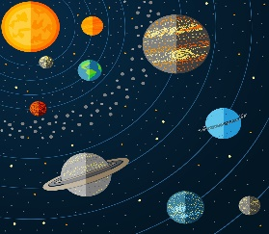
Spelling Words:
- too  - new  - fruit |  |  | - blue  - true  - fool |  |  | - suit  - spoon  - clue |  | - juice  - drew  - flew

